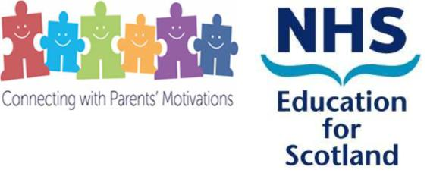

**Connecting with Parents’ Motivations – a briefing paper**

**What is Connecting with Parents’ Motivations (CwPM)?**

CwPM is a strength-based communication skills training system. It is designed to enhance the abilities of the early years and the wider children and families workforce, so that they can have more of the kinds of conversations with parents that facilitate uptake of support.

The manualised training programme is geared towards:

* the promotion of non-judgemental, empowering partnerships between practitioners and parents
* encouraging greater use of specific strength-based communication skills that have been scientifically demonstrated to increase engagement in other therapeutic contexts. In particular, the micro-skills and broader understandings from Motivational Interviewing approaches feature prominently in CwPM.

**Why was CwPM developed?**

CwPM was developed by the Psychology of Parenting (PoPP) team within the Psychology Directorate of NHS Education for Scotland through funding from the Scottish Government. It complements other strategies incorporated into the PoPP implementation plan aimed at improving parents’ enrolment in evidence-based parenting groups. It has contributed to over 7,000 families and 8,000 parents/caregivers enrolling in PoPP-supported groups.

**How is CwPM delivered?**

The CwPM manualised training is designed to be delivered as a 1-day face-to face training event for groups of up to 20 participants. A variety of adult learning approaches including video-guided group discussions, modelling, skills rehearsal and role-plays are used. These help to make the learning experience interactive, experiential and practice-relevant. A range of attractive materials have been developed to support the consistent delivery of the training and participants’ ability to transfer the training into their own practice.

All practitioners delivering PoPP-supported parenting groups receive CwPM training. In addition, a "Train the Trainer " system has been developed so that the benefits of the training can be cascaded to other practitioners from across all sectors who have regular contact with parents but who are themselves, not directly involved in running groups.

CwPM has been very well-received by a large number of multi-sector professionals and their managers. A cohort of 249 trainers has been established and, in pairs, these individuals have now delivered the training, in a low-cost way to practitioners across sectors drawn from multiple agencies and professional backgrounds in their own localities.

Statistical improvements in these practitioners’ familiarity and confidence in using all of the skills covered in the training have been demonstrated. Qualitative feedback also confirms that this training was valued by the majority of participants. Comments on their evaluation forms include:

*“****Training was engaging and interactive and pitched at the appropriate level.”***

***“The training has contributed to learning and reflection on practice”***

***“(I feel) more confident in connecting with parents”***

***“Really useful to break skills down and see how they can be put together to help parents commit to making a change****”*

**How is CwPM being taken forward?**

Several requests for continued support from the PoPP team to ensure cascade trainings occur regularly in PoPP sites have been forthcoming. With on-going funding from the Mental Health Directorate of Scottish Government, for the PoPP scheme to continue, CwPM is now incorporated into the current phase of the PoPP work plan and many more practitioners are expected to receive this training in coming years. The PoPP team updated training materials in 2019.

Other than the training provided within the Family Nurse Partnership programme, the PoPP team is unaware of any other training available in Scotland that specifically applies a motivational interviewing informed-approach to parent engagement. With some slight modifications, CwPM could have broader applicability and fill a gap in the educational resources that are currently available in this important skill area.

**Recent progress**

The training has recently been adapted for online delivery to meet the challenges faced from the impact of working throughout the Covid pandemic, as this meant it was not possible for our trainers to deliver face to face training. This has been delivered by a few of our trainers with good feedback from participants.

We have made slight modifications to the training, directed to meet the training needs of the infant mental health workforce. We have also included additional content to make the training more father inclusive.

**Headline CwPM Cascade Data (September 2023)**

|  |  |
| --- | --- |
| **Number of cascades delivered since 2015** | **158** |
| **Number of CwPM trainers trained since 2015** | **249** |
| **Number of Practitioners trained since 2015** | **2,326** |
| **Number of NHS boards that have participated in training** | **11** |

If you would like further information about PoPP or CwPM, please contact

[louise.kelly4@nhs.scot](mailto:louise.kelly4@nhs.scot)