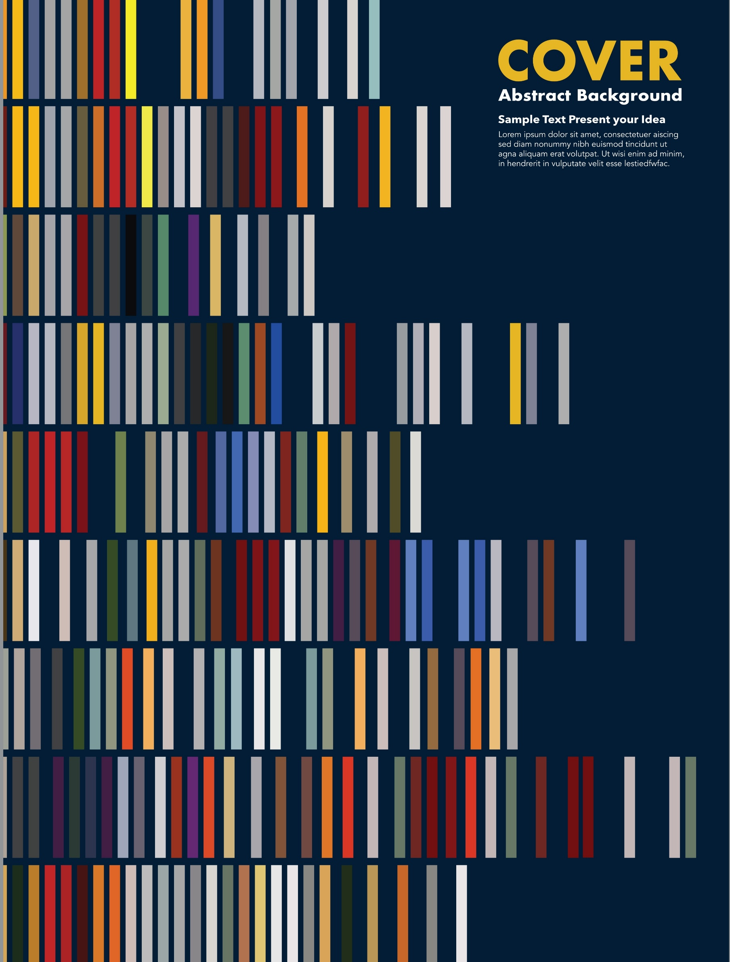


2025/26
EMPLOYMENT EQUALITY AND DIVERSITY MONITORING REPORT
CONTENTS

1. INTRODUCTION 3
2. WORKFORCE COMPOSITION 4
2.1 Sex 4
2.2 Ethnic Origin 7
2.3 Disability 10
2.4 Age 11
2.5 Religion or Belief 13
2.6 Sexual orientation 14
2.7 Gender Reassignment 17
3. RETENTION 17
4. STAFF DEVELOPMENT 19
4.1 Promotions 19
4.2 Training 20
5. RECRUITMENT AND SELECTION 20
5.1 Attraction 20
6. PAY GAP 21
6.1 Gender Pay Gap 21
6.2 Disability Pay Gap 23
6.3 Ethnicity Pay Gap 24
7. 7. Progress on recommendations 26

INTRODUCTION

This is NES’s annual employment equality and diversity monitoring report covering the period from 1 April 2025 to 31 March 2026. We have a specific duty as part of the Public Sector Equality Duty in Scotland to gather information on the composition of our workforce and on the recruitment, retention and development of our employees by each of the protected characteristics. We gather and analyse this data annually and publish the report at Employment equality monitoring and equal pay | NHS Education for (scot.nhs.uk)

From 1 April 2026, PSD Scotland was established, bringing together NHS National Services Scotland (NSS) and NHS Education for Scotland (NES) to support the health and care workforce and enable the delivery of safe, effective services across Scotland. This is therefore the last annual equality monitoring report for NES. To find out more, please visit Public Services Delivery Scotland (PSD Scotland).

NES’s commitment to creating an inclusive organisation for our people and our learners is set out in the Equality, Diversity and Inclusion Strategy (2025–2029). This includes the NES Equality Outcomes. In relation to our role as an employer, we have set the following outcome:

- By March 2029 the NES workforce will be representative of people from a minority ethnic background, disabled people and younger people to reflect the diversity of the health and social care workforce.

The actions we have identified to work towards this outcome are:
- NES will ensure all staff involved in recruitment are trained on inclusive recruitment practices and are aware of bias and how to mitigate it.
- Working towards Positive about Disability Leader Status and applying in 2026.
- Our support for career progression will be reviewed to make recommendations for improved recruitment and retention of minority ethnic, disabled and younger people.

We collect and analyse data on the protected characteristics of age, disability, race, gender reassignment, marriage and civil partnership, pregnancy and maternity, religion or belief, sex, and sexual orientation.

The report relates to employees who are directly employed by or on secondment to NES for the financial year 1 April 2025 to 31 March 2026. The report will set out the following by protected characteristic:
- Workforce composition
- Staff retention
- Staff development
- Recruitment and selection
- Gender, Disability and Ethnicity pay gaps

Data on Resident Doctors and Dentists in Training (RDDiT) analysed in this report is limited to the trainees employed by NES. NES is one of four lead employers for resident doctors in Scotland.

WORKFORCE COMPOSITION
As of 31 March 2026, NES employed 1,333 core[2] staff and 2,128 Resident Doctors and Dentists in Training (RDDiT). NES is the lead employer for Doctors in Training in General Practice, Public Health and Occupational Health Specialty Training, Dental Core Training (DCT), Specialty Training (STRs) and Vocational Dental Practice (VDP) trainees.
RDDiT work in placement settings across NHS Scotland and are recruited through national recruitment processes. Unless otherwise noted, this report records data on NES-employed RDDiT separately from our core staff[3].

Sex
As of 31 March 2026, the sex of the total employed workforce at NES is the same as it was in March 2025:
- 67% female.
- 33% male

NES Core Workforce is 73% female and NES Employed RDDiT is 63% female. This is set out in Figure 1 and 2. Working pattern by grade is shown in Figure 3 and by sex and grade in Figure 4.

Figure 2: Sex by grade (Core and RDDiT staff)
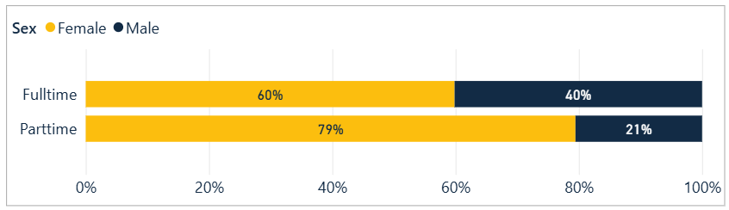

Figure 3: Working pattern across grades
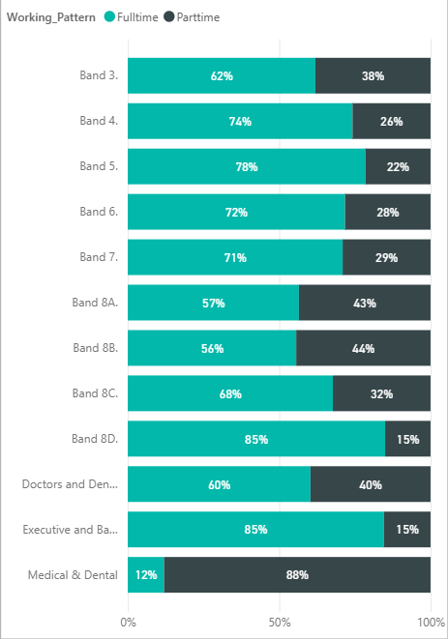

Figure 4: Working pattern by grade and sex for Males (Core and RDDiT staff)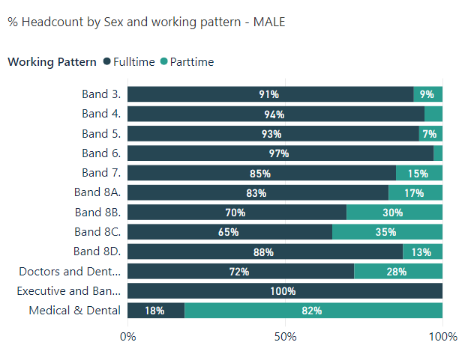
Figure 4: Working pattern by grade and sex for Females (all staff)
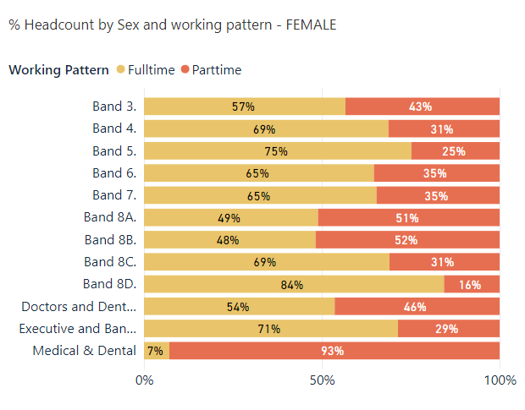

- For core staff, 37% (491 members of staff) work part-time, similar to 2024–2025 (36%). A higher proportion of women (82%) work part-time compared to men (18%).
- Part-time workers are represented across most grades.
- 88% of staff on Medical and Dental terms work part-time. However, this is due to sessional staff who work part-time for NES in an educational capacity but who also have clinical roles.
- Full-time work is over 70% in bands 4 – 7, 8D and at Executive and Band 9. This is unchanged from 2024-2025.
- The Directorates with the fewest part-time (under 10%) workers are in Finance and in NES Technology.

Ethnic Origin
The majority of our core staff identify as White (87.9%), while 6.4% are from Black, Asian, Other ethnic backgrounds, or Mixed Ethnic Backgrounds. This demographic pattern has shown a consistent increase over the past five years.
Of the 87.9% who identified as White, 67.2% are White Scottish and 13.8% are Other British.
The ethnic origin of 5.7% of NES Core staff is unknown, which has increased since last year (2%). This includes those who answer ‘Prefer not to say’ or where the data is blank. The NHS Scotland comparator is 22%, though it will vary across individual NHS Boards.
For certain types of workers, we do not have full data e.g. those on secondment agreements where we only have sex and age for payroll purposes, and staff on agency contracts.
- 44.7% Minority Ethnic staff are represented in bands 5 to 7.
- 20% Minority Ethnic staff are represented in bands 2 to 4.
- 16.5% of Minority Ethnic staff are on a Medical and Dental contract.
- In Bands 8A-D, 16.5% report to be from a Minority Ethnic background, an increase from 8.1% in 2023-2024 and a slight increase from 2024-2025 (15.4%).
- 100% of the Executive and Band 9 cohort are White.

Figure 6: Ethnicity (core staff) 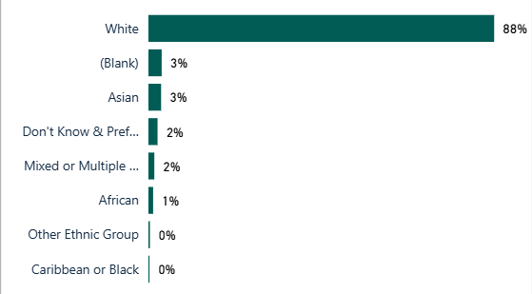

Figure 7: Ethnicity (Resident DDiT)

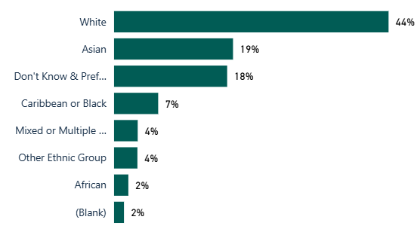
36.2% of RDDiT staff have identified as being from Black and Minority Ethnic, Mixed, or other ethnic backgrounds. This figure compares to 44.7% reported in last year's annual report, 30% in 2023-24, and 22% in 2022-2023. Additionally, 19.5% of respondents did not disclose their ethnicity (selecting either ‘Prefer not to say’ or ‘Not known’), a trend consistent with other protected characteristics within this staff cohort. These data are sourced from the national recruitment system for RDDiT.

Figure 8: Ethnicity by Grade (Core and RDDiT staff)
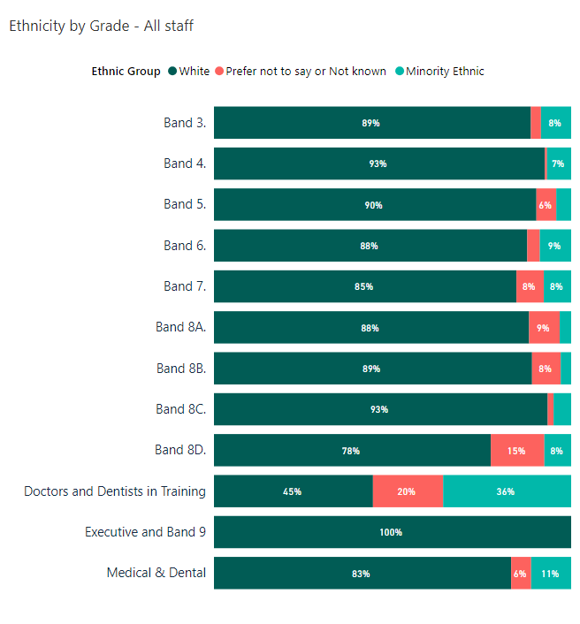
To put our workforce ethnicity data in context, the wider NHS Scotland and Scottish Social Services Council’s ethnicity data is included below:

- NHS Scotland’s workforce ethnicity as of March 2025 (excluding Prefer not to say and Unknown) is 91.5% White and 8.5% Minority Ethnic background. 22% declined to answer or are not known.

However, these figures vary across job roles and Health Board areas with varying levels of completion rates across NHS Boards. The data from March 2026 will be available at Official Statistics on the workforce of NHS Scotland.

- Scottish Social Services Council’s workforce data, based on a snapshot from January 2024, has 5.4% of staff who identify as belonging to a minority ethnic background.

Disability
As shown in Figure 9:
- 5.2% of core staff reported being disabled, a figure rising annually.
- 88.5% indicated no disability.
- 6.3% did not respond or data was missing.
Figure 10 shows the percentage of disabled staff in each age cohort. 31.9% of staff who have disclosed a disability are in age cohort 25-34. We have reason to believe that our disability data reflects under-reporting despite it increasing year on year. Over 24% of the working-age population as of 2021 are disabled. We will continue to encourage staff to update their equality and diversity employment information on an annual basis.

Figure 9: Disability (core staff)
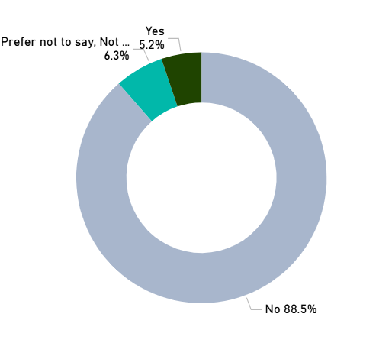
Figure 10: Disability by Age Group (core staff)
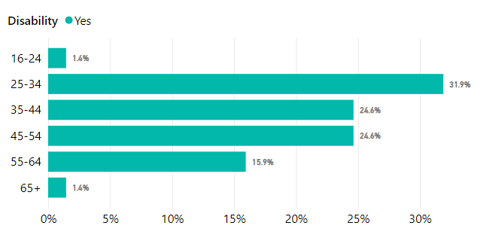

For NES employed Resident DDiT, 1.4 % have disclosed a disability. The actual figure is likely to be higher given that 61.2% of Resident DDiT have not provided information about disability status. This is higher than non-disclosure about ethnicity.

Age
- 80% of core staff are aged between 35 and 64
- The lowest proportion of core staff are aged 16–24 (2%), slightly higher than last year’s figure of 1.3%.
- 67.3% of Resident DDiT are aged 25-34 (Figure 11c)
This data is similar to the age profile of the workforce in 2023-2024. This is likely due to NES requiring specialist skills or knowledge across various professional fields which may be a factor in low numbers under age 35. As a comparator, the age profile of NHS Scotland staff from the same period (31st March 2025) is set out in Figure 11b.
Figure 11a: Age (core staff)
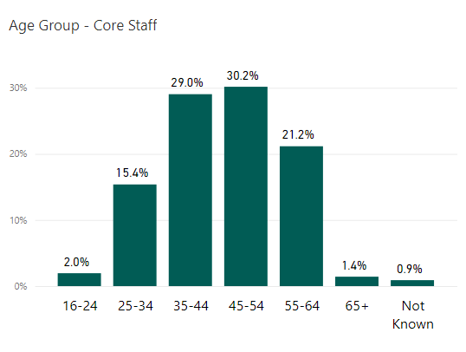
Figure 11b: Age (NHS Scotland)
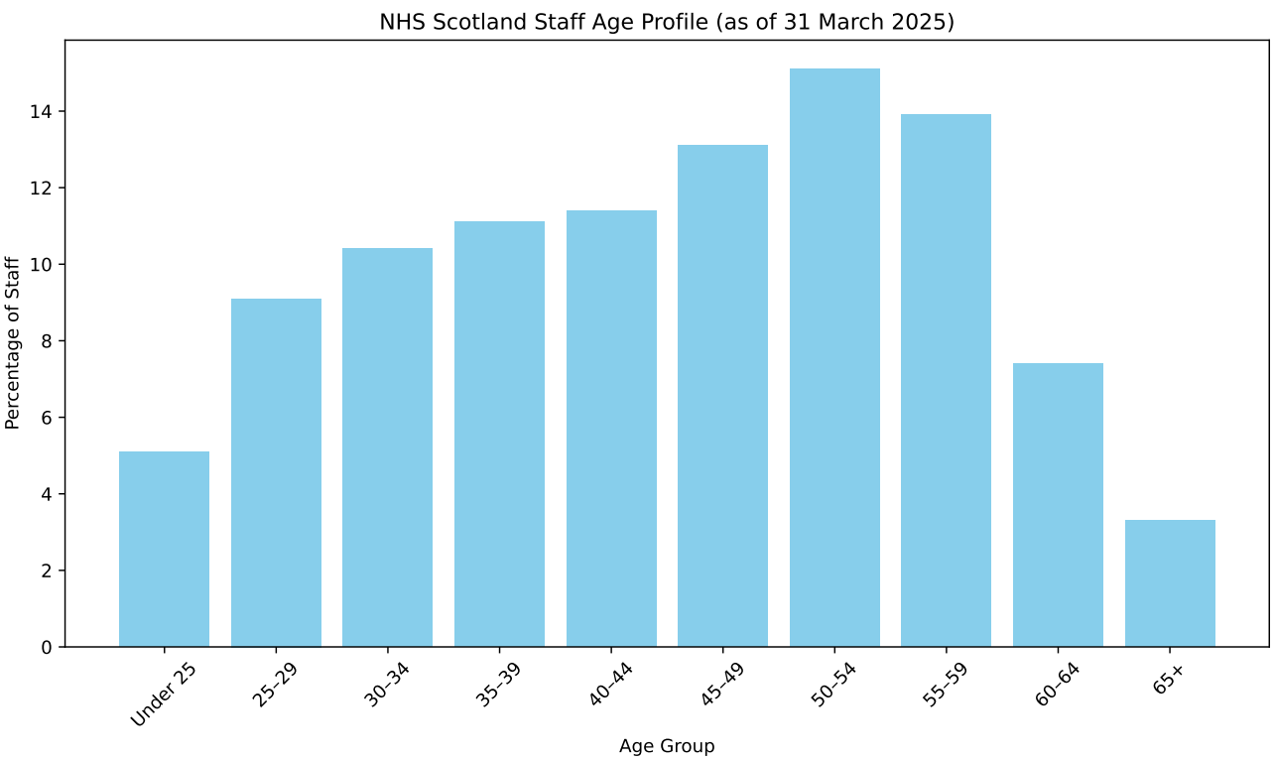

Figure 11c: Age (Resident DDiT)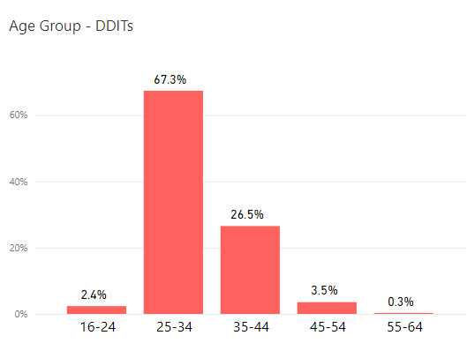

Religion or Belief
Figures 12a (core staff) and 12b (RDDiT) set out our employee data on religion and belief. NES’s core staff reflects a range of religious affiliations, although 'No religion' is the most common identification in NES Core staff at 50.3%. This reflects the recent publication on Scotland’s census data on religion, with 51.1% of people having no religion.
Figure 12a: Religion (core staff)

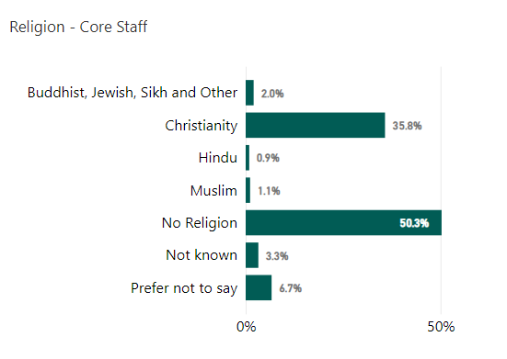

Figure 12b: Religion (Resident DDiT)
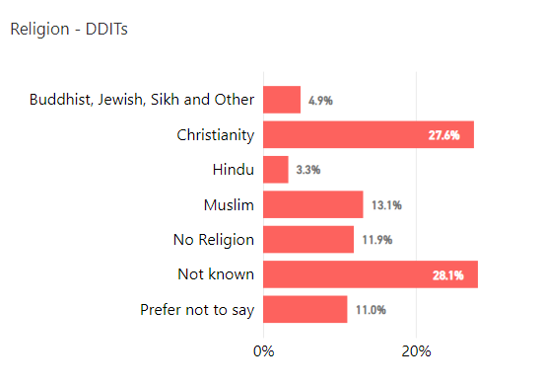

Sexual orientation
- 6.3% of core staff identify as Lesbian, Gay or Bisexual, similar to last year’s figure of 6% (Figure 13a)
- 5.0% of Resident DDiT identify as Lesbian, Gay or Bisexual (Figure 13b)
- The non-disclosure (Preferred not to answer or not known) rate for core staff is 9.5%, an increase from 7.2% last year. For DDiT this is 24.4%, a slight decrease from 26.1% last year, 28.1% in 2023 and 30.5% in 2023.
Scotland’s census asked about sexual orientation and Trans status for the first time in 2022. The findings were published in June 2024 and reported 4% of the population identified as Lesbian, Gay or Bisexual.

Figure 13a: Sexual orientation (core staff)
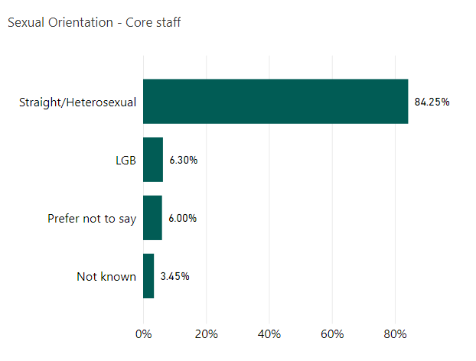

Figure 13b: Sexual orientation (Resident DDiT)
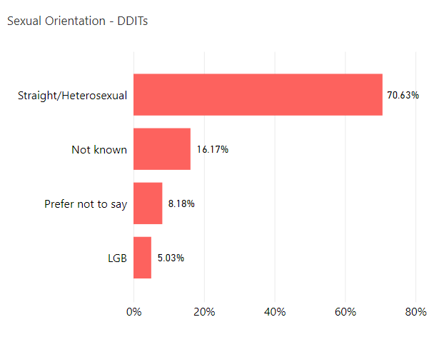

Gender Reassignment
We do not have sufficient numbers to allow reporting of this figure.

RETENTION
Employment related casework is classified as formal management of a range of employee relations activities, including attendance management, disciplinary, grievance, bullying and harassment, capability and dismissal. We collect and analyse data on a range of activities.
There were 47 formal employee relations casework events recorded for NES employees (see Table 1). For core staff, twenty-four related to attendance, seven for grievance, a small number for bullying and harassment, and three for capability. For trainees, thirteen formal cases were recorded, including five relating to conduct/disciplinary matters, a small number for grievance, and a small number pertaining to dismissals relating to removal of National Training Number (NTN) or Right to Work. The following table illustrates these, and numbers under five are represented by *.
Employee relations casework
Policy | Core | Resident DDiT
Attendance | 24 | 8
Grievance | 7 | *
Bullying & Harassment | * | *
Capability | * | 0
Investigation/Conduct | * | 5
Other - Dismissal due to National Training Number removal or Right to Work | 0 | *
Total | 34 | 13

Our approach remains aligned to the Once for Scotland workforce policies, ensuring that all employee relations matters are managed fairly, consistently, and in a person-centred manner. The increase in overall activity, particularly within trainee casework, will continue to inform our focus on early intervention, strengthened manager support, and ongoing development of consistent national approaches to complex employee relations scenarios.
While the increased volume of formal casework represents an opportunity to further develop reporting by protected characteristic, small numbers within specific policy areas continue to present a risk of identification, and therefore disaggregation by protected characteristics must be considered carefully to ensure compliance with confidentiality and disclosure standards.
Between 1 April 2025 and 31 March 2026, 109 employees left NES and 39 completed the exit questionnaire. See Appendix 1 for a breakdown of our leavers profile. The reasons for leaving are set out in Figure 14.

Figure 14: Leaving reasons (core staff)
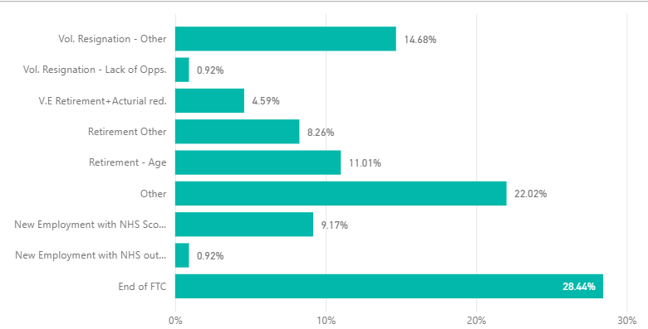
In the exit questionnaire, leavers are asked a range of questions concerning their experience working for NES. As part of exit interviews, we also ask how fairly the respondents felt they were treated, how respected they felt, what the attitude to diversity was like in NES and their satisfaction with the organisation when leaving.
74% of respondents did not feel that they had been disadvantaged on account of a protected characteristic. This is lower than last year’s response (83%).
Departing NES staff continue to hold positive views, with data consistent with past years. 74.4% of staff said they were either very satisfied or fairly satisfied towards the end of their employment with NES. 18% said they were fairly or very dissatisfied. Of those who said they were fairly or very dissatisfied:
- 28.6% female; 71.4% male
- 28.6% disabled
- None from a minority ethnic background
- 12.5% on fixed-term contracts and 87.5% on permanent contracts
- 85.7% in the 55-64 age group
We have looked at leavers who reported dissatisfaction upon leaving the organisation by protected characteristic to ensure there are not patterns that highlight wider issues.
Those leaving the organisation continue to represent under 10% of the core workforce and 59.6% of the leavers were on temporary contracts. See Appendix 1 for an overview.
- The sex distribution among staff leaving matches the overall workforce.
- Staff aged 16–34 represent 31.2% of those leaving, which is higher than their 17% share of the workforce. This trend may be linked to typical career progression at these ages.
- Minority ethnic staff made up 6.4% of leavers, down from past years and matching their proportion in the NES Core workforce.
- Among LGB staff, 10.1% left the organisation, exceeding last year’s rate (2.3%) and their 6.7% representation within the workforce.
- Of those who left, 36.7% identified as Christian, while the largest group—45.9%—said they have no religion. These figures closely mirror the broader NES Core workforce profile.
To promote workforce diversity and equality for under-represented groups, we analyse staff turnover by protected characteristic. Reviewing data across multiple years helps reveal trends, as annual figures may fluctuate due to small sample sizes.

STAFF DEVELOPMENT
This section relates to our core staff only. Education for Resident DDiT is governed through their foundation, core or higher specialty training programmes and follows the curricula written by the Medical Royal Colleges and the Faculty of Dental Surgery and is approved and published by the General Medical Council and General Dental Council.
We analyse access to development for core staff by reviewing data on promotions, secondment or internal attachment, 'acting up' or temporary promotion and data on training. Although our systems enable us to disaggregate all the data by protected characteristics, some datasets (promotions, secondment/internal attachment, acting up) are quite small and permit only limited analysis.

Promotions
A promotion within NES is defined as a staff member moving to a higher grade/band on a permanent contract. This report also includes temporary arrangements which provide a development opportunity for staff. By looking at promotions by protected characteristic we can identify if any groups are not experiencing equity in opportunity for career progression. This section does not include Resident DDiT.
From April 2025 to March 2026, there were 87 promotions. A breakdown of promotion by protected characteristics is illustrated in Appendix 2. Trends should be looked at as annual figures may fluctuate on an annual basis
- 67.8% of promoted staff were female and 32.2% were men. This reflects the higher proportion of females in the organisation (73% of NES Core staff are female and 27% are male).
- Males progressed more quickly than females with an average of 7.2 years of service compared to 8.6 for females. This is a similar pattern to last year.
- Promotion rates were higher for staff aged 25–54, and lower for those aged 16–24 and 55–64.
- Fewer staff from minority ethnic backgrounds are promoted compared to their representation in the workforce.
- 8% of staff with a disclosed disability were promoted, higher than the % of staff in the core workforce who have declared a disability (5.2%)
- 65% of employees promoted identified as having 'no religion', higher than the % of staff in the core workforce who have ‘No religion’ (50.3%).
- 3.4 % of employees promoted identified as LGB, which is lower than the proportion of LGB staff in the workforce (6.3%).
- 22.7% of employees promoted work part-time. This is a lower proportion of part-time employees in NES (36.34%) but is higher than last year (17%).
There are both similarities and differences in promotion data by protected characteristic compared with last year. For example, there were higher proportions of disabled staff and part-time employees being promoted relative to their representation in the total core workforce, but lower proportions of LGB staff and women. There was no change in the proportion of staff from a minority ethnic background. However, the numbers are small.

Training
We provide a range of staff development opportunities including work-based learning, e-Learning, attendance at conferences, staff panels and specialist learning events alongside a range of development courses and mandatory (essential) learning via our digital learning platform, Turas Learn. All courses housed on this system provide attendance/completion data and this is summarised in Appendix 3. We also provide a range of self-directed learning as well as webinars and other digital learning offered directly to staff members via Microsoft Teams. These sessions are currently not logged against the individual learning record in Turas and we do not monitor rate of participation by protected characteristics.

RECRUITMENT AND SELECTION
The outcomes for recruitment and selection of core staff are analysed in this section. Resident DDiT are recruited through a national recruitment process for appointment to training posts across NHS Scotland (excludes Locum Appointments for Training). The standards and criteria for this process are set at UK level. Outcomes from this process are analysed separately at a national level. This is available at Equality and diversity 2024 recruitment data | Medical Hub.
Appendix 4 summarises the overall number of applications by protected characteristic during the period 2025/26.

Attraction
Our vacancies continue to be considered for internal advertisement in the first instance (i.e. to existing workers, including agency staff and those on secondment) before being advertised externally. All vacancies pass through a robust corporate establishment control approval process prior to advertisement, with data monitored at each stage of the recruitment cycle.
We received 11,236 applications from 8,335 candidates across 388 adverts and recruited 109 people during this financial year. Of the 4,744 applications from candidates who reported a White ethnicity, 94 resulted in appointment. This represents a success rate of 1.98% from application to appointment, or approximately 1 in every 51 applications. We received 3,347 applications from Minority Ethnic candidates, of which 12 resulted in appointment. This represents a success rate of 0.36% from application to appointment, or approximately 1 in every 279 applications. Applicants from Black, Asian and Minority Ethnic backgrounds had a lower rate of progression from interview to appointment than White applicants (5.7% compared with 13.1%).
However, 82% of Minority Ethnic applicants require permission to work in the UK compared to 6% of applicants with a White ethnicity. We have therefore looked at success rates from interview to appointment and by permission to work in the UK to look at the differential likelihood of applicants being successful through the recruitment process. When we look at the success rate for those with permission to work in the UK and from a Minority Ethnic background, the success rate from interview to appointment was 15.4% (13.1% for those with a White ethnicity). When those who were interviewed from a Minority Ethnic background, including those who did and did not require a work permit, the success rate to interview was 6.5%.
The diversity of applicants for posts varies across the organisation, with the greatest diversity of applicants for posts in NES Technology Services, and Finance Directorates. Applicant ethnic diversity was lower for posts in the Psychology and Planning. Performance & TransformationDirectorates.

Fourteen per cent of applicants identified themselves as disabled, an increase from 11% in 2024/25 and 8% in 2023/24. 9.3% of applicants identified as LGB or ‘other’, which is broadly comparable with Stonewall Scotland’s estimate of the LGB population of working age and represents a slight increase on last year. The success rate for LGB applicants from application to appointment is 0.8%, compared with 1.3% for applicants who are heterosexual.
Our applications represent a range of religious backgrounds, with those identifying as having no religion being the most prevalent at 40.3%, followed by 36.2% identifying as Christian.
Women accounted for 66.4% of appointments, a slight increase from the 64% reported in last year’s report. Women accounted for the majority of appointments across the organisation (72 appointments) and across most grades. Appendix 4 illustrates the age distribution of applications for core NES posts. 17.6% of applicants did not complete information on age.

PAY GAP
The Equality Act 2010 (Specific Duties) (Scotland) Regulations 2012^{[9]} require public authorities to report the gender pay gap as the percentage difference between men’s average hourly pay (excluding overtime) and women’s average hourly pay (excluding overtime). The formula used is that set out in Close the Gap guidance^{[10]}: (A – B)/A x 100, where A is the average hourly rate of pay of men and B is the average hourly rate of pay of women. We also publish the median pay gap. While the mean provides an overall indication of the size of the pay gap, the median provides an indication of the typical position.
Our Equal Pay Statement and data on the pay gap and occupational segregation were published in April 2025 to meet the Public Sector Equality Duty reporting requirements. This is available at nhs_eps_april_2025.docx
We also report the Gender, Disability and Ethnicity Pay Gaps to the NES Board as part of the Board’s Strategic Key Performance Indicators.

Gender Pay Gap
As of 31 March 2026, NES’s overall gender pay gap is 4%. If Resident DDiT are removed from the calculation, on the basis that recruitment is undertaken at UK level rather than by NES, the gender pay gap for NES core staff is 14%, a reduction from 17% last year. The overall average hourly pay for all staff (core staff and Resident DDiT) is £27.61 for women and £28.71 for men. NES’s overall gender pay gap is below the Scottish public sector average of 8.8%[11].

TABLE 1: Gender pay gap
Pay scale | As of March 2021 | As of March 2022 | As of March 2023 | As of March 2024 | As of March 2025 | As of March 2026
Agenda for Change | 8.43% | 6.02% (893) | 5.60%  (1069) | 9.66% (1084) | 7.31%  (1107) | 6.97%  (1179)
Executive Managers Cohort | -2.19% | -6.99% (7) | -2.34%  (7) | -6.04% (7) | -14.38%  (5) | -7.65%  (6)
GP/GDP Eds, CRUMP and Consultants | 5.67% | 1.85% (121) | 2.72%  (130) | 2.70% (130) | 2.07%  (129) | 0.89%  (135)
DDiT | -1.26% | -1.30% (1727) | -2.63%  (1926) | -1.96% (1855) | -1.61%  (1871) | -0.62%  (2139)
Pay Gap | 7.0% | 5.4% | 2.7% | 4.3% | 4.0% | 4.0%

In presenting the gender pay gap information, the nature of the calculations (based on average pay figures) means that the data is very susceptible to being skewed by large numbers of outlying pay levels. This is very relevant for the profile of the NES workforce.
Figure 15: Gender Pay Gap (All Staff) - Median
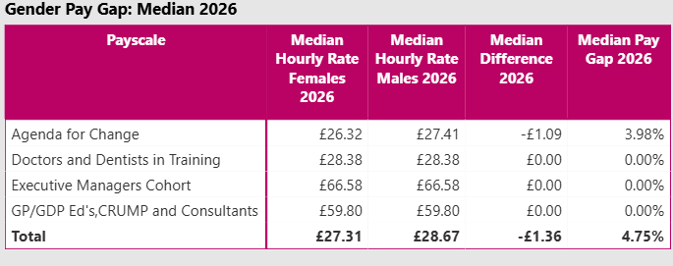
Figure 16: Gender Pay Gap (NES Core Staff) - Median
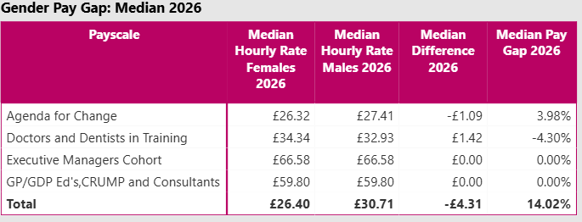
When the mean and median are broadly similar, the data is less likely to be skewed and suggests that men and women are paid within a similar income range. Where they differ more substantially, the distribution is likely to be influenced by very high earners (where the mean is above the median) or very low earners (where the mean is below the median).
The mean and median gender pay gaps for all NES employees, including resident doctors and dentists in training, are similar at 4% and 4.8% respectively. Excluding Resident DDiT, the mean and median for NES core staff are also closely aligned at 14%. This close alignment suggests that pay differences are relatively consistent across the organisation and are not being driven by a small number of very highly paid roles. It points instead to structural factors, such as occupational segregation and grade distribution, as key contributors to the gap.
Our work this year to achieve Equally Safe at Work accreditation is informing our approach to addressing occupational segregation. Women are proportionately more represented in Bands 3 to 6, and slightly more represented in Bands 8a and 8d. Men are proportionately more represented in Band 7, Bands 8b to 8c, Band 9, Executive level, and Medical and Dental grades. The time taken to progress to a promoted post is also slightly shorter for men than for women. The concentration of men in higher-paid posts, together with shorter average time to progression (7.2 years for men compared with 8.6 years for women), are likely contributors to the gender pay gap. We also consider the job roles held by men and women across the organisation, referred to as horizontal segregation, where men and women are disproportionately represented in different job families. Women are more represented in administrative roles, education roles (Agenda for Change and non-AfC), and communications. Men are more represented in technology services, reflecting the wider UK picture.

Disability Pay Gap
We have used the same method to calculate the disability pay gap. This is set out in Table 2 below.
TABLE 2: Disability pay gap
Pay scale | As of March 2023 | As of March 2024 | As of March 2025 | As of March 2026
Agenda for Change | 16.7% | 9.63% | 8.48% | 10.33%
Executive Managers Cohort | - | - | - | 10.94%
GP/GDP ED’s, CRUMP and Consultants | 2.5% | -0.31% | -0.31% | 4.20%
Doctors and Dentists in Training | 0.9% | -2.31% | -2.87% | -6.50%
Disability Pay Gap | 9.2% | 6.4% | 6.2% | 7.0%

As of March 2026, the overall disability pay gap is 7%, a slight increase from 2025 following reductions in previous years. Removing RDDiT, the disability pay gap for NES core staff is 16.6%, up from 14.5% reported last year. We recognise that under-reporting of disability by staff is likely to affect the accuracy of this calculation. The latest estimate indicates that Scotland’s disability pay gap was 16.2% in 2019.[14]

The median disability pay gap for all staff and core staff is set out below in Figures 17 and 18. Comparing the mean and median helps indicate whether the distribution of pay differences is skewed. For all staff, the mean disability pay gap is 7.0% and the median is 3.7%, suggesting that the typical pay gap is lower than the overall average and that the overall figure is influenced by larger pay differences at the higher-paid end of the organisation. For NES core staff, the mean disability pay gap is 16.6% and the median is 10.9%. This indicates that disabled staff experience lower pay across much of the organisation, with the gap becoming more pronounced at higher salary levels. This pattern suggests that disabled staff may be under-represented in senior and higher-paid roles, alongside broader structural inequalities.
Figure 17: Median Disability Pay Gap – All Staff
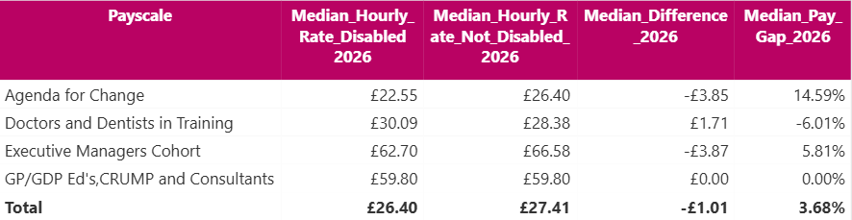

Figure 18: Median Disability Pay Gap – Core Staff
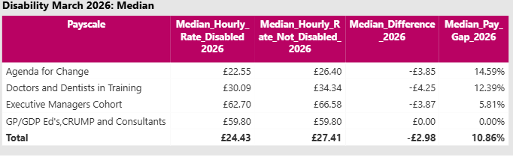
We have also considered disability vertical segregation. However, as numbers are below five across most job families, it is difficult to draw robust conclusions about the distribution of disabled staff across grades and roles. The findings should therefore be interpreted with caution, and the small numbers also reflect the continuing challenge of under-reporting of disability within the workforce.

Ethnicity Pay Gap
The same method has been used to calculate the ethnicity pay gap. This compares the hourly pay of the reference group (White employees) with that of minority ethnic employees.
This is set out in Table 3 below.

TABLE 3: Ethnicity pay gap

Payscale | As of March 2023 | As of March 2024 | As of March 2025 | As of March 2026
Agenda for Change | 17.2% | 18.20% | 9.66% | 8.58%
Executive Managers Cohort | - | - | - | 100%
GP/GDP Ed's, CRUMP and Consultants | -1.5% | -0.26% | -0.47% | -0.05%
Doctors and Dentists in Training | 4.20% | 4.42% | 4.66% | 3.22%
Ethnicity pay gap | 11.1% | 9.5% | 8.8% | 6.4%

As of March 2026, the ethnicity pay gap is 6.4%, a reduction from previous years. Removing RDDiT, the pay gap for NES core staff is 0.3%, down from 2% reported last year. This represents a positive trend. The latest estimate indicates that Scotland’s ethnicity pay gap was 10.3% in 2019.[15]

The median ethnicity pay gap for all staff and core staff is set out in Figures 19 and 20 below. Comparing the mean and median helps indicate whether the distribution of pay differences is skewed. For all staff, the mean ethnicity pay gap is 6.4% and the median is 4%, suggesting that the typical pay gap is lower than the overall average and that the overall figure is influenced by larger pay differences at the higher-paid end of the organisation. For NES core staff, the mean ethnicity pay gap is 0.3% and the median is 3.7%. This suggests that, while the average gap across core staff is very small, the experience of the middle earner is less favourable and that smaller gaps, or pay patterns at higher salary levels, are reducing the overall average.

Figure 19: Median Ethnicity Pay Gap – All Staff
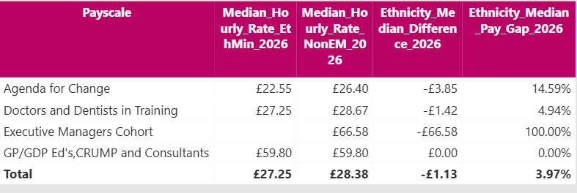

Figure 20: Median Ethnicity Pay Gap – Core Staff
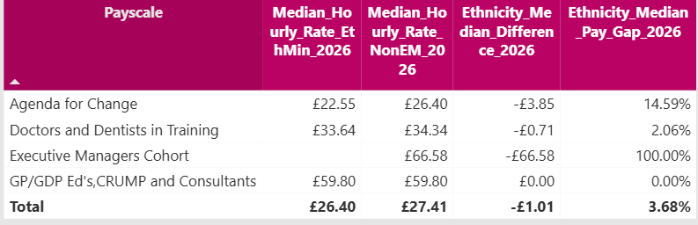

We also gather information to examine vertical and horizontal ethnicity segregation. The data this year indicates that minority ethnic staff are represented across a range of grades, particularly within Bands 5 to 7, and there has been some improvement in representation within Bands 8A to 8D. However, the absence of minority ethnic staff within the Executive and Band 9 cohort suggests that representation decreases at the most senior levels of the organisation. This pattern is consistent with vertical segregation, where staff from minority ethnic backgrounds are less likely to be represented in the highest-paid and most senior posts.

Looking at job roles, the data suggests some evidence of horizontal ethnicity segregation. Minority ethnic staff are slightly over-represented in technology roles, while there are no minority ethnic staff in communications or director-level roles. However, the numbers in other job families are below five, which limits the conclusions that can be drawn. The findings should therefore be interpreted with caution, although they suggest that minority ethnic staff are not evenly distributed across all parts of the organisation.

Progress on recommendations
Employee monitoring is part of wider work at NES to progress equality, tackle discrimination and create an inclusive workplace for our staff. This is set out in our Equality, Diversity and Inclusion Strategy for 2025-2029.
The following actions were identified through our analysis last year, and an update is provided below:
Action 2025-26 | Progress
- Continue to remind staff about how to update personal details on the system, with a specific focus on disability, including targeted communication to resident doctors which is part of the Addressing Equity in Medical Education Group’s work plan. | Complete – This will continue to be an area for improvement as part of PSD Scotland.
- Continue to report annually on Gender, Disability and Ethnicity pay gap as part of Board strategic KPI reporting. | Complete
- Improve and monitor the number of panel members and hiring managers utilising the Line Manager handbook and the ‘bias in recruitment’ learning. | Complete
- Explore disaggregation of data by protected characteristic for employment related casework. | Complete. Small numbers within specific policy areas continue to present a risk of identification, and therefore disaggregation by protected characteristics must be considered carefully to ensure compliance with confidentiality and disclosure standards.

As this is the concluding report for NHS Education for Scotland, no new actions based on this data are included here. Initiatives to advance workplace equality and create an inclusive and diverse organisation will be taken forward through Public Services Delivery Scotland.

APPENDIX 1: Leavers profile (core staff) 2025-2026

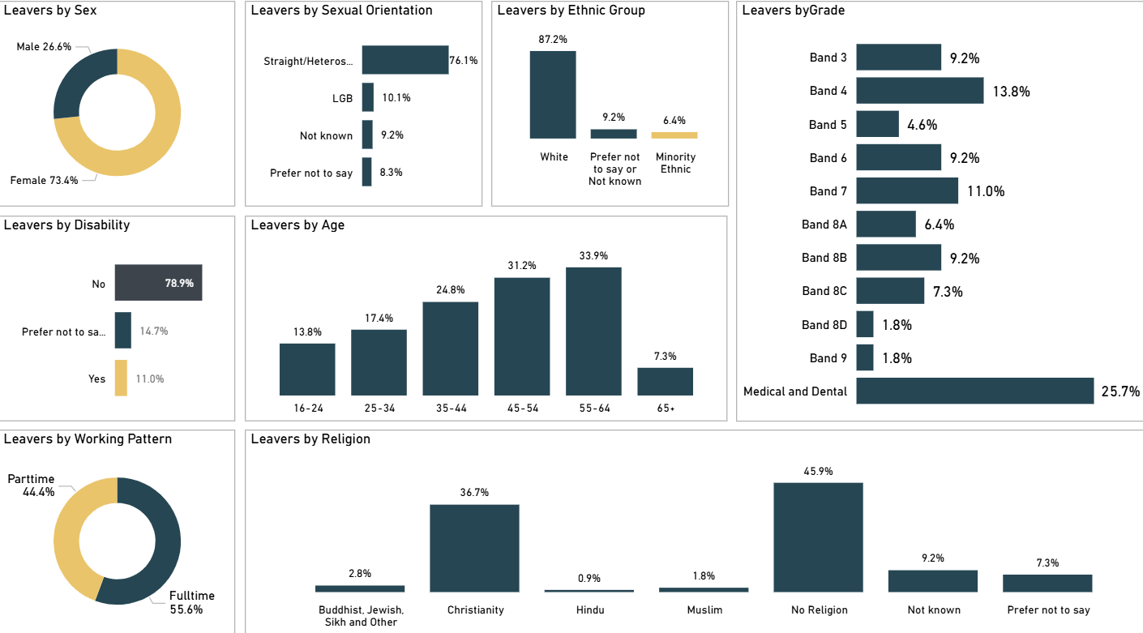

APPENDIX 2: Promotions profile (core staff) 2025/26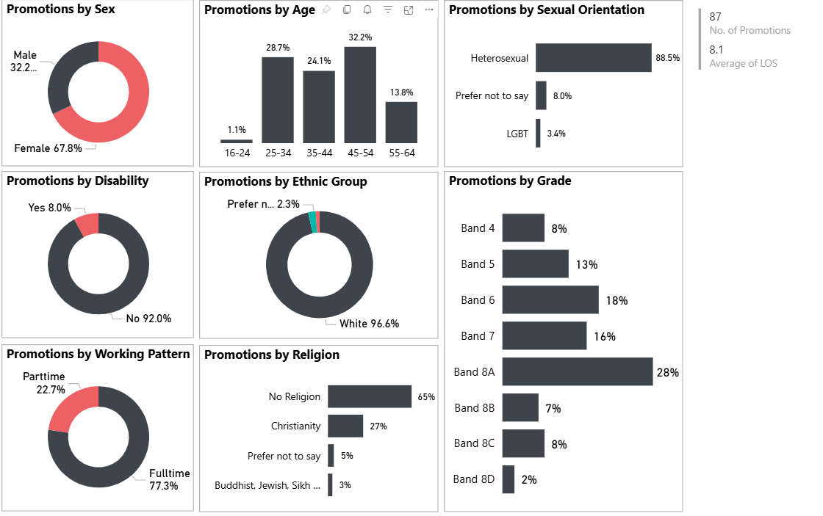

APPENDIX 3: Training completed on Turas Learn application (core staff) 2025/26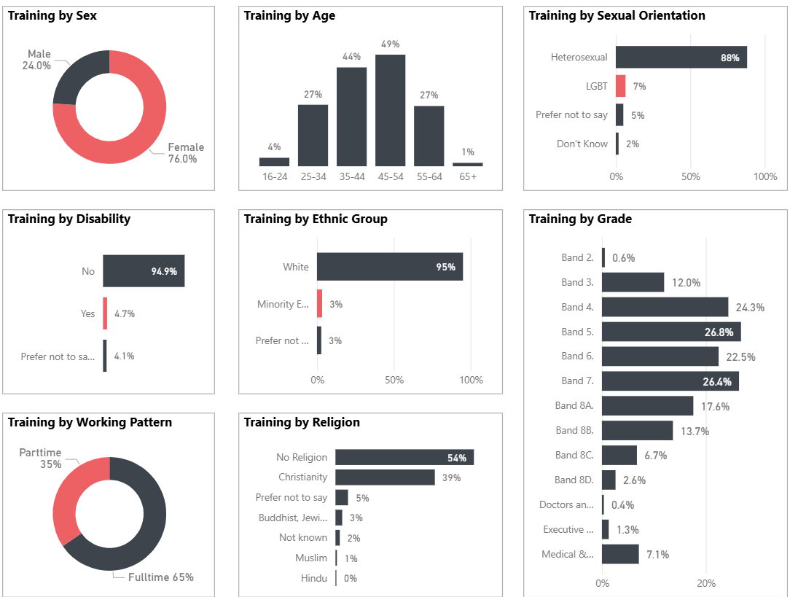

APPENDIX 4: Recruitment - Candidate profile (core staff) 2025/26
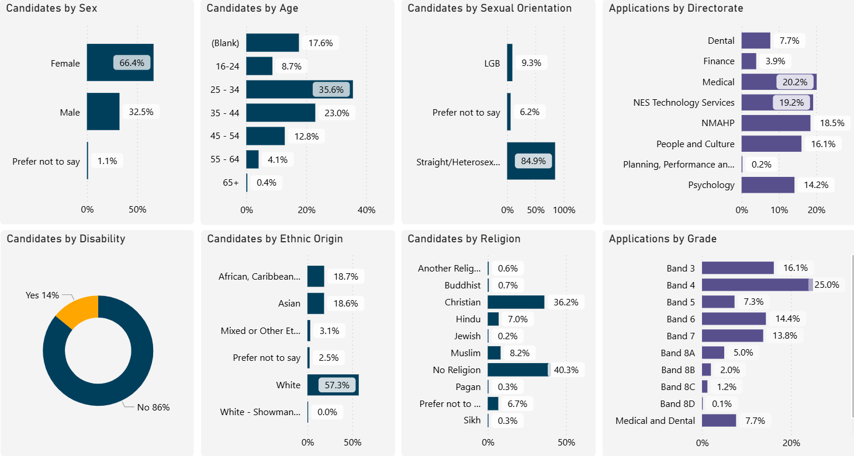

© NHS Education for www.nes.scot.nhs.uk Scotland [2023]. You can copy or reproduce the information in this resource for use within NHSScotland and for non-commercial educational purposes. Use of this document for commercial purposes is permitted only with the written permission of NES
NHS Education for Scotland
Westport 102
West Port
Edinburgh
EH3 9DN
This resource may be made available, in alternative formats and community languages. Please contact us on 0131 656 3200 or email altformats@nes.scot.nhs.uk to discuss how we can best meet your requirements.

For Data Protection reasons we are not allowed to report on any categories if there are under five staff present in that category.
NHS Scotland workforce | Turas Data Intelligence
Analysis of diversity data and research report November 2024 | Scottish Social Services Workforce Data
Guest blog – Disability Employment in Scotland: Initial Findings – SPICe Spotlight | Solas air SPICe (spice-spotlight.scot)
Scotland’s Census – religion, ethnic group, language and national identity results | Scotland's Census (scotlandscensus.gov.uk)
Scotland’s Census 2022 - Sexual orientation and trans status or history | Scotland's Census (scotlandscensus.gov.uk)

