
Annual Employment Equality and Diversity Monitoring Report 2024/25


CONTENTS

1. INTRODUCTION 3
2. WORKFORCE COMPOSITION 4
2.1 Sex 4
2.2 Ethnic Origin 6
2.3 Disability 9
2.4 Age 11
2.5 Religion or Belief 12
2.6 Sexual orientation 13
3. RETENTION 14
4. STAFF DEVELOPMENT 17
4.1 Promotions 17
4.2 Training 18
5. RECRUITMENT AND SELECTION 18
5.1 Attraction 18
6. PAY GAP 19
7. Progress on recommendations 22
8. Recommendations 23

INTRODUCTION

This is NES’s annual employment equalities monitoring report covering the period form 1 April 2024 to 31st March 2025. We have a specific duty as part of the Public Sector Equality Duty in Scotland to gather information on the composition of our workforce and information on the recruitment, retention, and development of our employees by each of the protected characteristics. We gather and analyse this data annually and publish the report at Employment equality monitoring and equal pay | NHS Education for (scot.nhs.uk)

NES published its Equality, Diversity and Inclusion Strategy in April 2025. This sets out our commitment to creating an inclusive organisation for our people and our learners. The strategy sets out our refreshed Equality Outcomes for the next 4 years. In relation to our role as employer we have set the following outcome:

- By March 2029 the NES workforce will be representative of people from a minority ethnic background, disabled people and younger people to reflect the diversity of the health and social care workforce.

The actions we have identified to work towards this outcome are:
- NES will ensure all staff involved in recruitment are trained on inclusive recruitment practices and are aware of bias and how to mitigate it.
- Working towards Positive about Disability Leader Status and applying in 2026.
- Our support for career progression will be reviewed to make recommendations for improved recruitment and retention of minority ethnic, disabled and younger people and applicants

We collect and analyse data on the protected characteristics of age, disability, race, gender reassignment, marriage and civil partnership, pregnancy and maternity, religion or belief, sex, and sexual orientation.

The report relates to employees who are directly employed by or on secondment to NES for the financial year 1 April 2024 to 31 March 2025. The report will set out the following by protected characteristic:
- Workforce composition
- Staff retention
- Staff development
- Recruitment and selection
- Gender, Disability and Ethnicity pay gaps

Data on Doctors and Dentists in Training (DDiT) analysed in this report is limited to the trainees employed by NES. NES is one of four lead employers for trainee doctors in Scotland.

WORKFORCE COMPOSITION

As of 31st March 2025, NES employed 1219 core and 1994 Doctors and Dentists in Training (DDiT). NES is the lead employer for Doctors in Training in General Practice, Public Health, and Occupational Health Speciality Training, Dental Core (DCT), Speciality Training (STRs) and Vocational Dental Practice (VDP) trainees.
DDiT’s work in placement settings across NHS Scotland and are recruited through national recruitment processes. Unless otherwise noted, this report will record data on NES employed DDiT separately from our core staff.

Sex
As of 31 March 2025, the total employed workforce at NES is
- 67% female.
- 33% male
The breakdown of core staff and DDIT by Sex is set out in Figure 1.

Figure 2: Sex by grade (Core and DDiT staff)
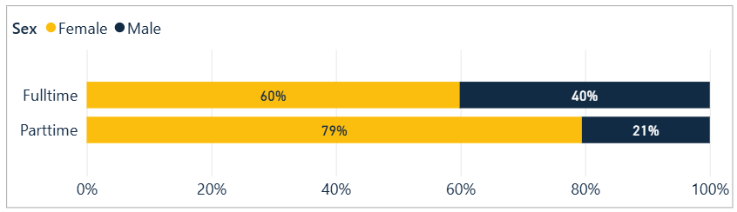

Figure 3: Working pattern by grade and sex for Males (Core and DDiT staff)
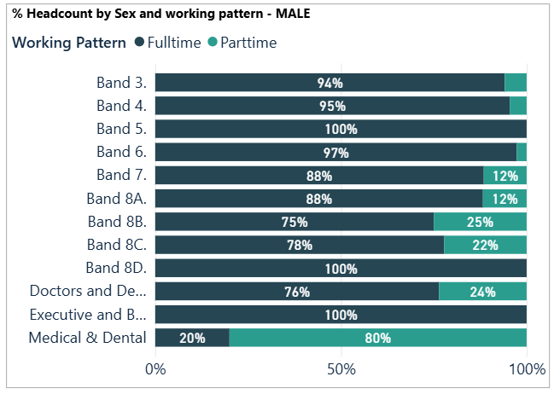

Figure 4: Working pattern by grade and sex for Females (all staff)
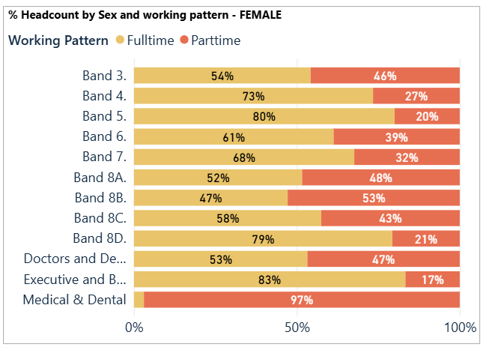

- For core staff, 36% of the workforce work part-time, and a higher proportion of women (84% or 366 members of staff) work part-time compared to men (16% or 71 members of staff).
- Part-time workers are represented across most grades.
- 89% of staff on Medical and Dental terms work part-time. However, this is due to sessional staff who work part-time for NES in an educational capacity but who also have clinical roles.
- Full-time work is over 70% in 4 – 7, 8D and at Executive and Band 9.
- The Directorates with the fewest part-time workers are in Finance and in NES Technology.

Ethnic Origin
Our core staff are primarily White (91.06%) with 5.33% of staff identifying as being from Black, Asian, Other ethnic backgrounds, or Mixed Ethnic Background. Of the 91.06% who identified as White, 69.98% are White Scottish and 14.36% are Other British.

Figure 5: Core NES Staff Ethnicity from 2021-2025
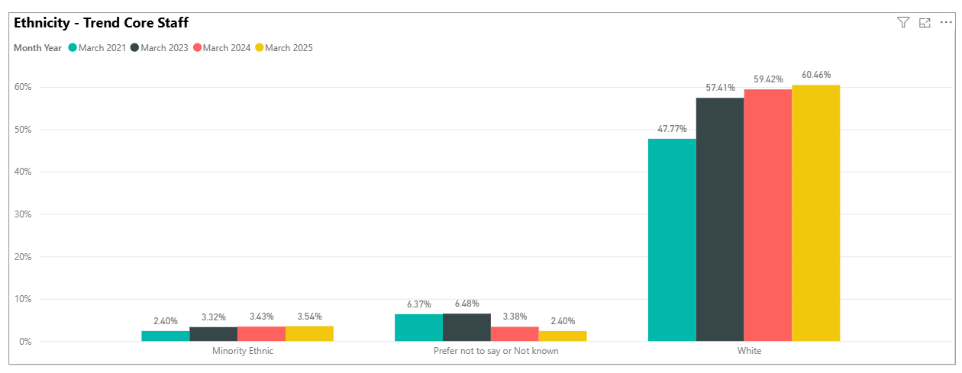
The ethnic origin of 2.05% of NES Core staff is unknown. This includes those who answer ‘Prefer not to say’ or where the data is blank. The NHS Scotland comparator is 22%, though it will vary across individual NHS Boards.
For certain types of workers, we do not have full data e.g. those on secondment agreements where we only have sex and age for payroll purposes, and staff on agency contracts.
- 41.54 % Minority Ethnic staff are represented in bands 5 to 7.
- 24.62% Minority Ethnic staff are represented in bands 2 to 4.
- 16.92% of Minority Ethnic staff are on a Medical and Dental contract.
- In Bands 8A-D, 15.38% report to be from a Minority Ethnic background, an increase from 8.1% in 2023-2024.
- 100% of the Executive cohort are White.

Figure 6: Ethnicity (core staff)
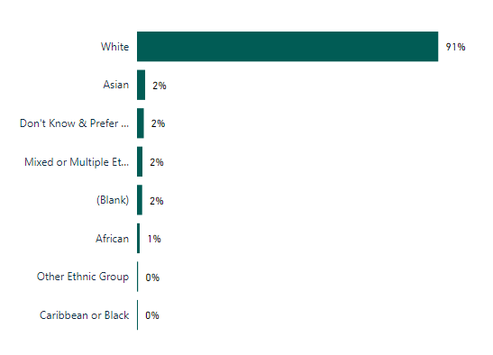

Figure 7: Ethnicity (DDiT)
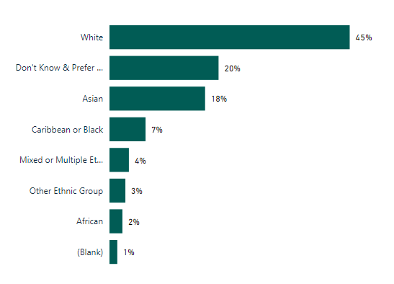

44.73% of DDiT have disclosed to be from Black and Minority Ethnic, mixed or other ethnic backgrounds. This has increased from 22% in 2022-20232 and 30% in 2023-4. 21.77 % have not provided data on ethnicity (‘Prefer not to say’ and ‘Not known’), a pattern that is seen across the protected characteristics in this cohort of staff. This information is provided to us from the national recruitment system for DDiT.
Figure 8: Ethnicity by Grade (Core and DDiT staff)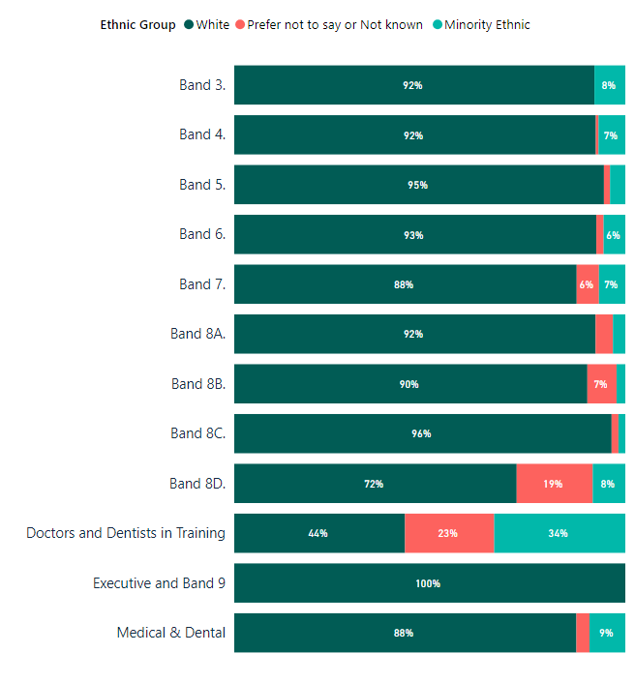
To put our workforce ethnicity data in context, census data for the Scottish population, the wider NHS Scotland and Scottish Social Services Council’s ethnicity data is included below:

- According to the 2022 census Scotland's population was 87.1% white and 12.9% are from a minority ethnic background. The working age minority ethnic background population in Scotland is estimated to be around 5% of the overall working-age population.

- NHS Scotland’s workforce ethnicity as of March 2025 is:
- 71.4 % - White
- 3.3% - Asian, Asian Scottish or Asian British
- 1.7 % - African
- 0.3% - Caribbean or Black
- 0.6% - Mixed, Multiple or Other ethnicity
- 22% declined to answer or are not known.

However, these figures vary across job roles and Health Board areas with varying levels of completion rates across NHS Boards. This data can be accessed at NHS Scotland workforce (phase one) | Turas Data Intelligence.

- Scottish Social Services Council’s workforce data, based on a snapshot from January 2024, has 5.4% of staff who identify as belonging to a minority ethnic background.

Disability
As shown in Figure 9:
- 4.8% of core staff identified themselves as disabled, an increase from 3.8% last year.
- 91.6% identified as not having a disability
- 3.61% preferred not to answer or data was unavailable.
Figure 10 shows the percentage of disabled staff in each age cohort, showing higher disability in age cohorts 25-54. We have reason to believe that our disability data reflects under-reporting. Over 24% of the working-age population as of 2021 are disabled. We will continue to encourage staff to update their equality and diversity employment information on an annual basis.

Figure 9: Disability (core staff)
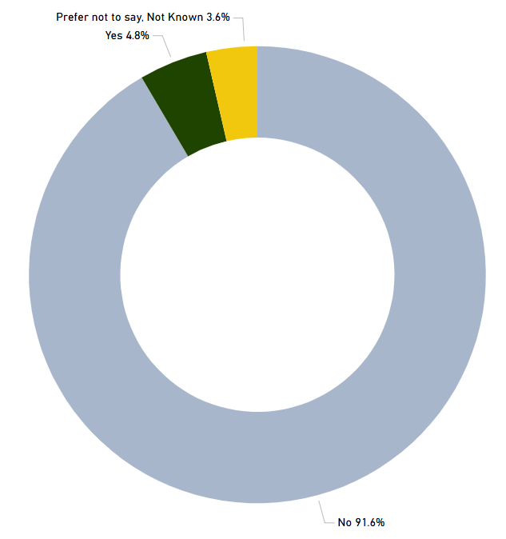

Figure 10: Disability by Age Group (core staff)

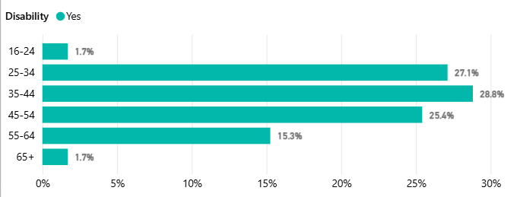

For NES employed DDiT, 1.5 % have disclosed a disability. The actual figure is likely to be higher given that 57.3% of DDiT have not provided information about disability status. This is higher than non-disclosure about ethnicity.

Age
- 82% of core staff are aged between 35 and 64
- The lowest % of core staff are aged 16-24 at 1.3%
- 66.4% of DDiT are aged 25-34
This data is similar to the age profile of the workforce in 2023-2024. This is likely due to NES requiring specialist skills or knowledge across various professional fields which may be a factor in low numbers under age 35. As a comparator, the age profile of NHS Scotland staff from the same period (31st March 2025) is set out in Figure 9b.
Figure 11a: Age (core staff)

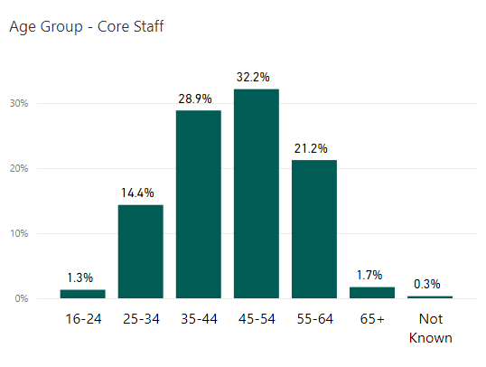

Figure 11b: Age (NHS Scotland)

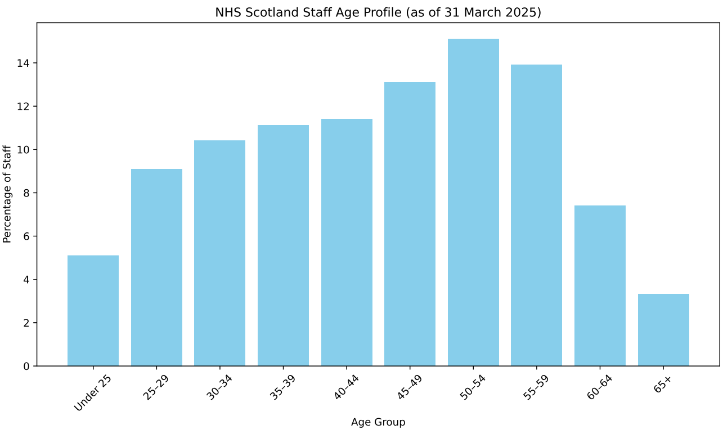

Figure 11c: Age (DDiT)

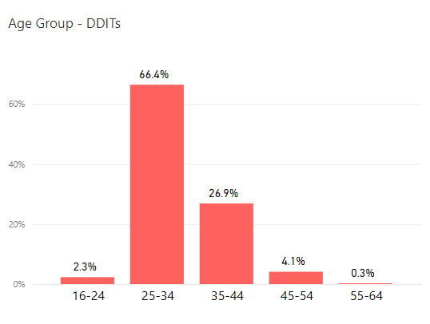

Religion or Belief
Figures 10a (core staff) and 10b (DDiT) set out our employee data on religion and belief. NES’s core staff reflects a range of religious affiliations, although 'No religion' is the most common identification in NES Core staff at 47.9%. This reflects the recent publication on Scotland’s census data on religion, with 51.1% of people having no religion.
Figure 12a: Religion (core staff)

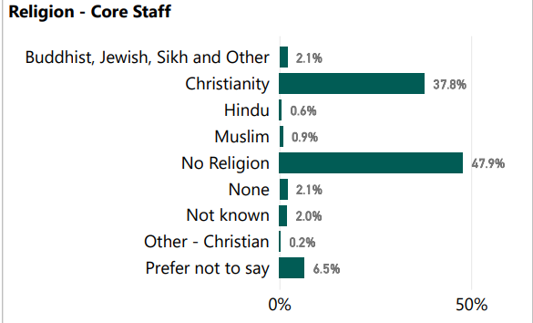

Figure 12a: Religion (DDiT)

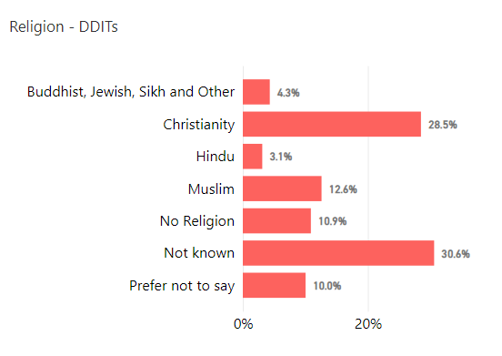

Sexual orientation
- 5.7% of core staff identify as Lesbian, Gay or Bisexual.
- 4.1% of DDiT identify as Lesbian, Gay or Bisexual.
- The non-disclosure (Preferred not to answer or not known) rate for core staff is 7.21%. This has steadily decreased from 13.3% in 2023 and 8% in 2024. For DDiT this is 26.1%, again a slight decrease from 28.1% in 2023 and 30.5% in 2023.
Scotland’s census asked about sexual orientation and Trans status for the first time in 2022. The findings were published in June 2024 and reported 4% of the population identified as Lesbian, Gay or Bisexual.

Figure 13a: Sexual orientation (core staff)
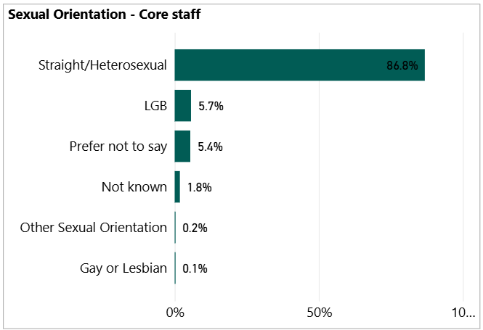

Figure 13b: Sexual orientation (DDiT)

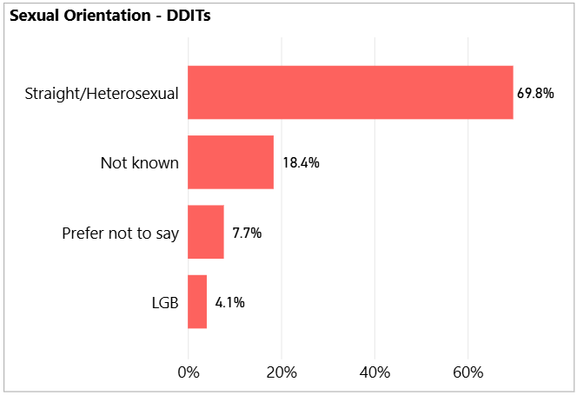

Gender Reassignment
We do not have sufficient numbers to allow reporting of this figure.

RETENTION
Employment related casework is classified as formal management of a range of employee relations activities, including attendance management, disciplinary, grievance, bullying and harassment, capability and dismissal. We collect and analyse data on a range of activities.
There were 40 formal employee relations casework events recorded for NES employees. For core staff, sixteen related to attendance, six for grievance, two for bullying and harassment, and three for capability. For trainees, thirteen formal cases were recorded: two for conduct/disciplinary, three for grievance and seven pertaining to dismissals relating to removal of National Training Number (NTN) or Right to Work. The following table illustrates these and numbers under 5 are represented by *
Policy | Core | Trainee
Attendance | 16 | *
Grievance | 6 | *
Bullying & Harassment | * | 0
Capability | 3 | 0
Investigation/Conduct | 0 | *
Other - Dismissal due to National Training Number removal or Right to Work | 0 | 7
Total | 27 | 13
Our approach is to support early and informal resolution of issues where possible, which may involve advice to staff or managers around specific issues or policies, endeavours to resolve prior to escalation into formal policy stages.
We have previously reported that the number of formal cases is too small to permit disaggregated reporting by protected characteristics. However, given the four fold increase from 10 cases in 23/24 to 40 cases in 24/25, this will now be explored, to review and assess whether we can report formal cases by protected characteristics.
Between 1 April 2024 and 31 March 2025, 131 (162 in previous period) employees left NES and 54 (78 in previous period) completed the exit questionnaire. Of the leavers, 44.27% (58 staff) and 55.73% (73 staff) were on fixed-term contracts. See Appendix 1 for a breakdown of our leavers profile. The reasons for leaving are available in Figure 14.
We collect and analyse data on NES core staff who leave the organisation. In the exit questionnaire, leavers are asked a range of questions concerning their experience working for NES. As part of exit interviews, we also ask how fairly the respondents felt they were treated, how respected they felt, what the attitude to diversity was like in NES and their satisfaction with the organisation when leaving.
- 83% of respondents did not feel that they had been disadvantaged on account of a protected characteristic. This is similar to last year’s data.
The attitudes of people leaving NES remain largely positive towards the organisation and data is similar to previous years. 65.8% of staff said they were either very satisfied or fairly satisfied towards the end of their employment with NES. 17.8% said they were fairly dissatisfied. Of those who said they were fairly dissatisfied:
- 57% were female
- None were disabled
- 5.4% were from a minority ethnic background
- 66.7% were on fixed term contracts and 53.3 % were on permanent contracts

We have looked at leavers who reported dissatisfaction upon leaving the organisation by protected characteristic to ensure there are not patterns that highlight wider issues.

Figure 14: Leaving reasons (core staff)
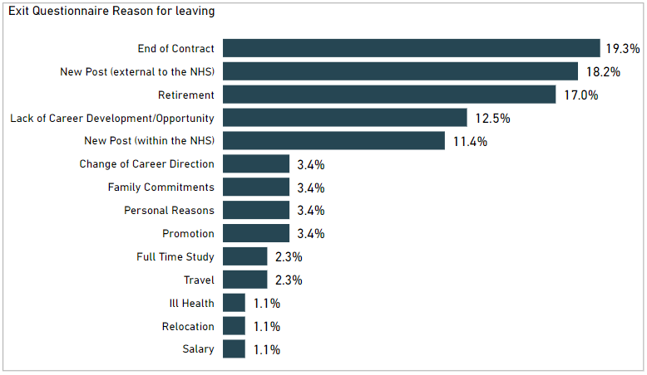

Those leaving the organisation represent under 10% of the core workforce. See Appendix 1.
- Males as a proportion of the workforce are more likely to leave the organisation than females (25.4%). This was a reduction from last year’s figure of 34.2%.
- There is a higher proportion of staff in age groups 35-44 (34.4%), a similar figure to last year. This may reflect the stage in career in these age brackets.
- 8.4% of leavers are from a minority ethnic background. This is a reduction from 11.7% last year but still higher than the overall proportion of minority ethnic staff in the workforce.
- 55.73% of the leavers were on temporary contracts.
- 2.3% of LGB staff left the organisation, which is a lower proportion than in the workforce and lower than last year’s data.
- 35.9% (was 37.7%) of staff who left the organisation advised they are Christian which is slightly lower than the % last year. The largest proportion of leavers advised they have no religion at 35.9%.
As we seek to increase the diversity of our workforce and progress equality for under-represented population groups, analysis of the proportion of staff who leave the organisation by protected characteristic to investigate possible reasons for this is important.

STAFF DEVELOPMENT
This section relates to our core staff only. Education for DDiT is governed through their foundation, core or higher specialty training programmes and follows the curricula written by the Medical Royal Colleges and the Faculty of Dental Surgery and is approved and published by the General Medical Council and General Dental Council.
We analyse access to development for core staff by reviewing data on promotions, secondment or internal attachment, 'acting up' or temporary promotion and data on training. Although our systems enable us to disaggregate all of the data by protected characteristics, some datasets (promotions, secondment/internal attachment, acting up) are quite small and permit only limited analysis.

Promotions
A promotion within NES is defined as a staff member moving to a higher grade/band on a permanent contract. This report also includes temporary arrangements which provide a development opportunity for staff. By looking at promotions by protected characteristic we can identify if any groups are not experiencing equity in opportunity for career progression. This section does not include DDiT.
From April 2024 to March 2025, there were 92 promotions. A breakdown of promotion by protected characteristics is illustrated in Appendix 2.
- 62% of promoted staff were female and 38% were men. This reflects the higher proportion of females in the organisation (67% of NES Core staff are female).
- Males progressed more quickly than females with an average of 6.7 years of services compared to 8.5 for females. This is a change from last year where females progressed more quickly.
- Staff aged between 45-54 accounted for 38% of promotions. Employees aged 35-44 accounted for 27.2% of promotions. Employees aged 55-64 account for 10.9% of the promotions and employees aged 24-34 account for 23.9%.
- 3.3% of staff promoted were from a minority ethnic background. This is lower than the proportion of staff in the workforce who have advised they are from a minority ethnic background (5.33%).
- 66% of employees promoted identified as having 'no religion'.
- 5.4% of the employees promoted identified as being disabled. This is higher than the proportion of staff currently declaring a disability in the workforce (4.8%).
- 6.5% of employees promoted identified as LGB, which is higher than the proportion of LGB staff in the workforce (5.7%).
- 17% of employees promoted work part-time. This is a lower proportion of part-time employees in NES (36.05%).

Training
We provide a range of staff development opportunities including work-based learning, e-Learning, attendance at conferences, staff panels and specialist learning events alongside a range of development courses and mandatory (essential) learning via our digital learning platform, Turas Learn. All courses housed on this system provide attendance/completion data and this is summarised in Appendix 3. We also provide a range of self-directed learning as well as webinars and other digital learning offered directly to staff members via Microsoft Teams. These sessions are currently not logged against the individual learning record in Turas and we do not monitor rate of participation by protected characteristics.

RECRUITMENT AND SELECTION
The outcomes for recruitment and selection of core staff are analysed in this section. DDiT are recruited through a national recruitment process for appointment to training posts across NHS Scotland (excludes Locum Appointments for Training). The standards and criteria for this process are set at UK level. Outcomes from this process are analysed separately at a national level. This is available at Equality and diversity 2024 recruitment data | Medical Hub.
Appendix 4 summarises the overall number of applications and number of individuals shortlisted, interviewed and appointed to our core staff and applications by protected characteristic during the period 2024/25.

Attraction
Our vacancies will continue to be considered for internal advert in the first instance (i.e. to existing NES workers, including agency and secondments) before consideration is given to advertise externally. All vacancies pass through a robust corporate establishment control approval process prior to advertising, with data monitored at each stage of the recruitment cycle.
We received 3259 from a total of 7129 (45.7%) applications from applicants from Black, Asian and minority ethnic backgrounds. The diversity of applicants for posts varies across the organisation, with the greatest diversity of applicants for posts in the Workforce, Technology Services, and Medical Directorates. Applicant ethnic diversity was lower for posts in the Psychology and Planning & Corporate Resources Directorates.
Applicants from Black, Asian and minority ethnic backgrounds have a differential likelihood relative to those of white ethnicity of progressing from interview to appointment (4.2% vs. 12.9%). In 2023/24, it was 11.1% vs. 19.4%. From application to appointment, the percentage of applicants from a Black, Asian and Minority ethnic background was 0.28%. Of the 3259 applicants, 2645 (81%) advised that they required a work permit and therefore many of the applicants were not eligible to take up a post. This was 61% last year so has increased and we will continue to monitor this.
11.04% of applicants identified themselves as disabled, an increase from the 8% in 2023/24. 8.23% of applicants identified as LGB or ‘other’ which compares with Stonewall Scotland's estimate of LGB people in the working age population and is a similar figure to last year. The success rate for LGB applicants to appointments is 1.02% compared to 1.34% of applicants who are heterosexual.
Our applications represent a range of religious backgrounds, and those identifying with no religion are most prevalent at 35.6%. We attract a similar percentage of applications from those identifying as Roman Catholic or Church of Scotland in the overall total number of applications. There is no significant difference in appointment rates between those identifying as Roman Catholic. The number of individual applications in most of the minority religions is too small for statistical analysis (less than 10%). 7.3% of applicants chose 'Prefer not to say' and 39.9% chose ‘No religion’.
75% of our appointments in 2024/25 were women, which is an increase from the 63% reported in last year’s report. Women formed most appointments across the organisation and at most grades. Appendix 4 illustrates the age distribution of applications for core NES posts. 21.3% of applicants did not complete information on age.

PAY GAP
The Equality Act 2010 (Specific Duties) (Scotland) Regulations 2012 specify that public authorities must report the gender pay gap in the form of ‘information on the percentage difference among its employees between men’s average hourly pay (excluding overtime) and women’s average hourly pay (excluding overtime)’. The specific formula used for this calculation is the formula for the average pay gap set out in the guidance published by Close the Gap. The specific formula is (A – B)/A X 100, where A = average hourly rate of pay of men and B = average hourly rate of pay of women.
Our Equal Pay Statement and data on the pay gap and occupational segregation was published in April 2025, to meet the Public Sector Equality Duty reporting requirements. This can be accessed at nhs_eps_april_2025.docx
Using this method of analysis, as of 31 March 2025 NES’s overall gender pay gap is 3.98%. However, if we extract DDiT from the pay gap calculations (given recruitment is undertaken at a UK level rather than by NES), NES’s gender pay gap is 16.82%. Both these % have reduced slightly from 2024. The overall (Core and DDiT) average hourly pay for women is £27.88 and for men is £29.03. Our overall gender pay gap is below the Scottish public sector average of 8.8%

TABLE 1: Gender pay gap
Pay scale | As of March 2021 | As of March 2022 | As of March 2023 | As of March 2024 | As of March 2025
Agenda for Change | 8.43% | 6.02% (893) | 5.60%  (1069) | 9.66% (1084) | 7.31%  (1107)
Executive Managers Cohort | -2.19% | -6.99% (7) | -2.34%  (7) | -6.04% (7) | -14.38%  (5)
GP/GDP Eds, CRUMP and Consultants | 5.67% | 1.85% (121) | 2.72%  (130) | 2.70% (130) | 2.07%  (129)
DDiT | -1.26% | -1.30% (1727) | -2.63%  (1926) | -1.96% (1855) | -1.61%  (1871)
Pay Gap | 7.0% | 5.4% | 2.70% | 4.30% | 3.98%

In presenting the gender pay gap information, the nature of the calculations (based on average pay figures) means that the data is very susceptible to being skewed by large numbers of outlying pay levels. This is very relevant for the profile of the NES workforce.
We have used the same method to calculate our Disability and Ethnicity Pay Gaps. These are set out below in Table 2 and Table 3. We now also report to the Board on our Gender, Disability and Ethnicity Pay Gap as part of the Board’s Strategic Key Performance Indicators.

TABLE 2: Disability pay gap
Payscale | As of  March 2023 | As of  March 2024 | As of  March 2025
Agenda for Change | 16.7% | 9.63% | 8.48%
Executive Managers Cohort | - | - | -
GP/GDP Ed's,CRUMP and Consultants | 2.5% | -0.31% | -0.31%
Doctors and Dentists in Training | 0.9% | -2.31% | -2.87%
Disability pay gap | 9.19% | 6.36% | 6.18%

The overall disability pay gap is 6.18%, a reduction from 2024 and 2023. If we extract DDiT from the pay gap calculations NES’s disability pay gap is 14.82%, also a reduction from previous years. We recognise that under-reporting of disability from staff will affect our disability pay gap calculation.
TABLE 3: Ethnicity pay gap
Payscale | As of March 2023 | As of March 2024 | As of March 2025
Agenda for Change | 17.2% | 18.20% | 14.59%
Executive Managers Cohort | - | - | -
GP/GDP Ed's, CRUMP and Consultants | -1.5% | -0.26% | 0%
Doctors and Dentists in Training | 4.20% | 4.42% | 4.31%
Ethnic Origin pay gap | 11.11% | 9.50% | 4.31%

As of March 2024, the Ethnicity pay gap is 4.31%, a reduction from 2023 and 2024. If we extract DDiT, the pay gap for NES Core Staff is 1.94%5.9% in 2024. The higher pay gap at Agenda for Change pay grades may be due to an increase in staff joining NES on entry-level pay banding. The latest estimate show that Scotland's ethnicity pay gap was estimated to be 10.3% in 2019. The Disability pay gap is has been calculated to be 16.2% in Scotland in 2019.

Update on Actions 2024 and Recommendations
Employee monitoring is part of wider work at NES to progress equality, tackle discrimination and create an inclusive workplace for our staff. This is set out in our Equality, Diversity and Inclusion Strategy for 2025-2029.
The following actions were identified in our analysis from last year and an update is provided:
Action 2024-25 | Progress | Continue to 2025/6
- Deliver a campaign to improve our workforce equality and diversity data following relevant system changes being completed nationally following approval of new monitoring questions. This data will follow through if appointed for new recruits, but we recognise that data may change for staff in post e.g., disabilities may develop over time in the organisation. | Communication was sent to all staff to encourage staff to update their equality and diversity information on the system and why this information is asked for. This was sent from the Employee Director and Chair of the NES Disability, Long-term conditions, Mental health and Neurodivergence staff network, recognising the under-reporting on disability in the workforce. | Yes
- Explore how NES can improve Doctors and Dentists in Training workforce diversity data (UK national data) via Turas TPM. | We have continued to improve the completeness of records with information from the General Medical Council Register and continue to send information to resident doctors to explain why this data is asked for and what it is used for. | Yes.
- Evaluate the uptake of recruitment e-learning modules, continue to promote the ‘bias in recruitment’ resource for panel members and ensure recruiting line managers are trained appropriately. | Since the launch of the NES line manager handbook in September 2024, the following visitors have accessed the following pages:  Recruiting, onboarding, movers and leavers introduction – 3845  Values based recruitment – 165  Onboarding – 129  Moving within the organisation – 727  Leaving the organisation – 59  Retirement - 290  The e-learning modules are scheduled for review by ODLL colleagues in partnership with HR. Figures show that uptake of the modules has been low.  The Equality Team has updated the ‘Bias in recruitment’ guidance and will continue to promote this via line manager’s network and the Equality, Diversity and Human Rights Hub. | Yes
- Continue to report annually on Gender, Disability and Ethnicity pay gap as part of Board strategic KPI reporting. | This data is provided to the Board annually and was included in our Equal Pay Statement and Occupational Segregation report | Yes

8.2 Actions for 2025/6
- Continue to remind staff about how to update personal details on the system, with a specific focus on disability, including targeted communication to resident doctors which is part of the Addressing Equity in Medical Education Group’s work plan.
- Continue to report annually on Gender, Disability and Ethnicity pay gap as part of Board strategic KPI reporting.
- Improve and monitor the number of panel members and hiring managers utilising the Line Manager handbook and the ‘bias in recruitment’ learning.
- Explore disaggregation of data by protected characteristic for employment related casework.
Further actions are being progressed in the NES Equality, Diversity and Inclusion Strategy 2025-2029, including work toward the Equality Outcome to:
By March 2029 the NES workforce will be representative of people from a minority ethnic background, disabled people and younger people to reflect the diversity of the health and social care workforce.

We will do this by:
- NES will ensure all staff involved in recruitment are trained on inclusive recruitment practices and are aware of bias and how to mitigate it.
- Working towards Positive about Disability Leader Status and applying in 2026.
- Our support for career progression will be reviewed to make recommendations for improved recruitment and retention of ethnic minority, disabled and younger people and applicants

The Board is provided with biannual progress reports on NES’s equality, diversity and inclusion strategy.

APPENDIX 1: Leavers profile (core staff) 2024/25
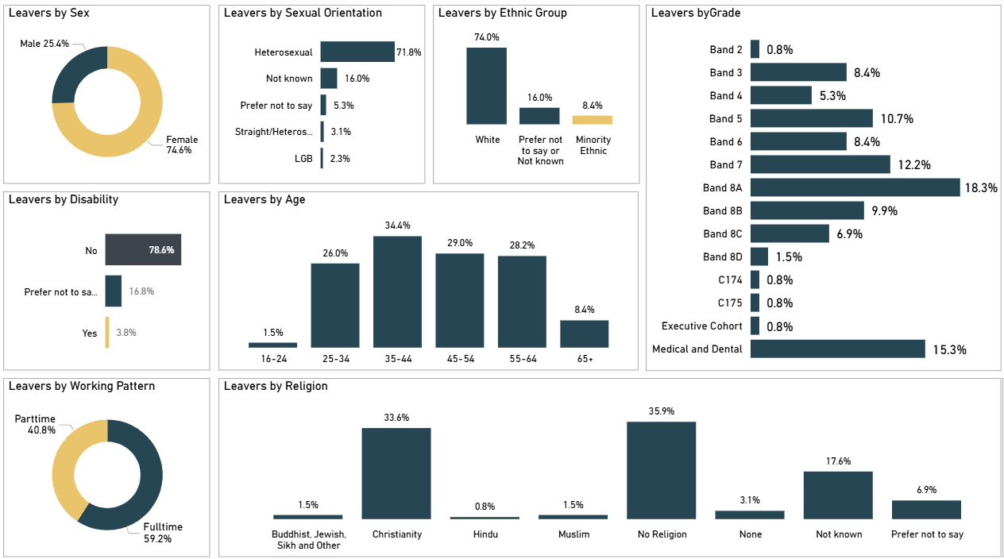

APPENDIX 2: Promotions profile (core staff) 2024/25
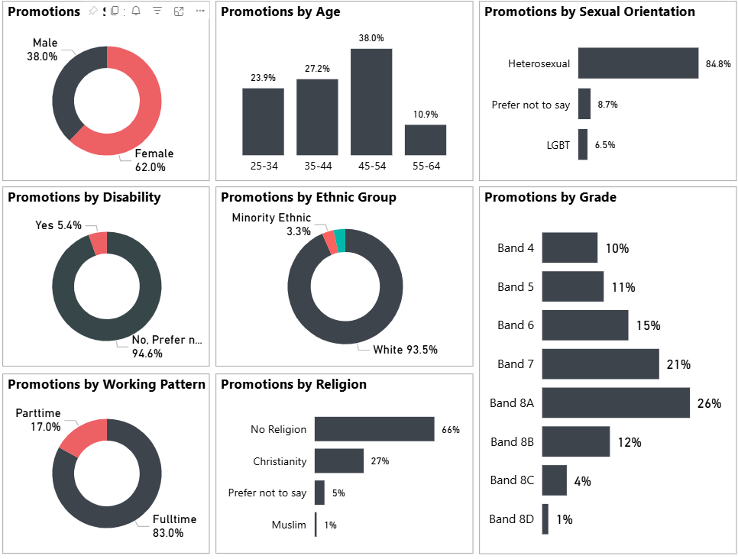

APPENDIX 3: Training completed on Turas Learn application (core staff) 2024/25
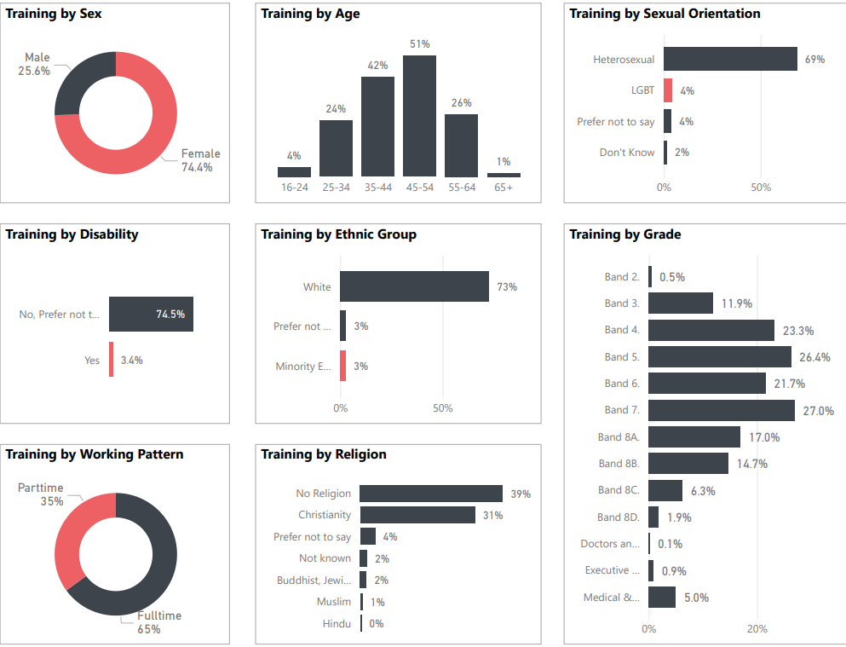

APPENDIX 4: Recruitment - Candidate profile (core staff) 2024/25
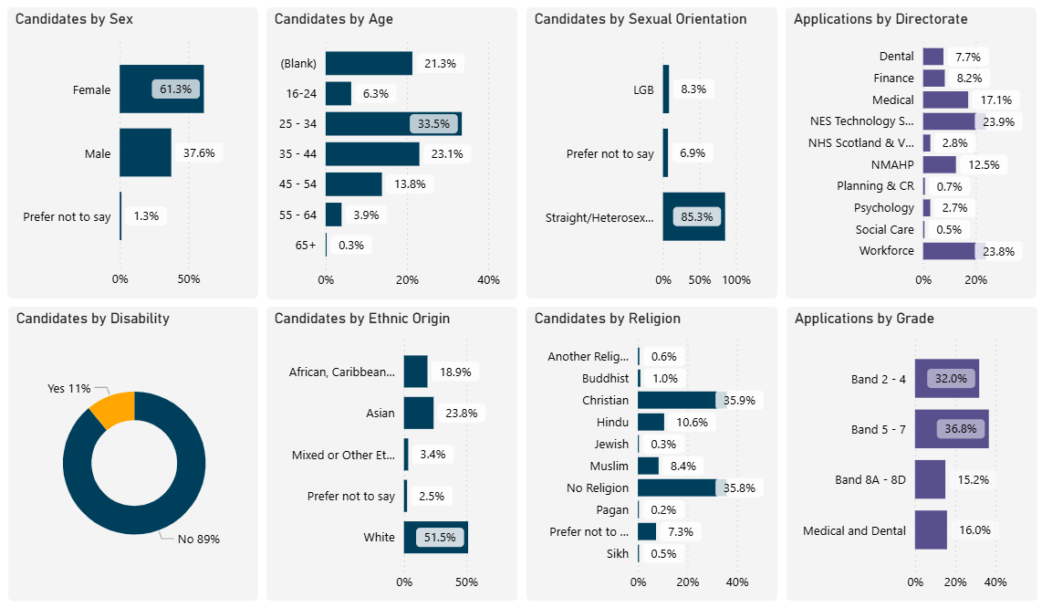

© NHS Education for www.nes.scot.nhs.uk Scotland [2023]. You can copy or reproduce the information in this resource for use within NHSScotland and for non-commercial educational purposes. Use of this document for commercial purposes is permitted only with the written permission of NES
NHS Education for Scotland
Westport 102
West Port
Edinburgh
EH3 9DN
This resource may be made available, in alternative formats and community languages. Please contact us on 0131 656 3200 or email altformats@nes.scot.nhs.uk to discuss how we can best meet your requirements.

For Data Protection reasons we are not allowed to report on any categories if there are under five staff present in that category.
We refer to all staff employed by NES who are not employed as Doctors or Dentists in Training and working in NHS Boards as part of their training as core staff. This includes a variety of roles across our organisation.
NES is one of four Lead Employers across NHS Scotland that employ Doctors and Dentists (DDiT) in training. We only include data on those trainees where NES is the employer.
Scotland’s Census 2022 - Ethnic group, national identity, language and religion | Scotland's Census (scotlandscensus.gov.uk)
Anti-racist employment strategy - A Fairer Scotland for All - gov.scot (www.gov.scot)
NHS Scotland workforce | Turas Data Intelligence
Analysis of diversity data and research report November 2024 | Scottish Social Services Workforce Data
Guest blog – Disability Employment in Scotland: Initial Findings – SPICe Spotlight | Solas air SPICe (spice-spotlight.scot)
Scotland’s Census – religion, ethnic group, language and national identity results | Scotland's Census (scotlandscensus.gov.uk)
Scotland’s Census 2022 - Sexual orientation and trans status or history | Scotland's Census (scotlandscensus.gov.uk)
The Equality Act 2010 (Specific Duties) (Scotland) Regulations 2012 (legislation.gov.uk)
https://www.closethegap.org.uk/content/resources/Gender-pay-gap-statistics-paper-2022.pdf
Gender pay gap in the UK - Office for National Statistics
Analysis of Labour Market Outcomes of Scotland’s Minority Ethnic Population (www.gov.scot)
Disability Pay Gap - Labour Market Statistics for Scotland by Disability: January to December 2022 - gov.scot (www.gov.scot)

