AHP Public Health Case Study Template for RSPH AHP Hub
Please use this template to submit a case study for the AHP public health hub.
Case studies should be service improvements, innovative ways of working or practice examples related to public health. They do not necessarily need to be ‘projects’ (with a beginning middle and end). Please see published case studies on the RSPH AHP hub for examples.
Case studies will also be considered for the World Health Organisation public health nursing, midwifery and AHPs collaborating centre website.

Your details:
Name(s) of author(s) | Jane Holt
Profession(s) | Physiotherapy
Organisation(s) | NHS Ayrshire and Arran
Preferred email address for contact | Jane.holt@aapct.scot.nhs.uk
Other email address  (we will only use this email address if we can not contact you on your preferred email address) | 70happyheart@gmail.com
Telephone No | 01563 827175
I give permission to be contacted in relation to this case study by PHE, members of the review team or RSPH |  | y
I agree to the case study being published by RSPH and WHO collaborating centre if approved and to it being shared with 3rd parties |  | y
I give permission for my contact details (name, organisation and email address) to be published with the case study if approved for publication on the RSPH hub and WHO collaborating centre to enable interested parties to make contact for further information about the case study |  | y

Theme: Which area of public health does your case study relate to (please tick appropriate box)?
Wider determinants – also known as social determinants, are a diverse range of social, economic and environmental factors which impact on people's health and wellbeing. Addressing the wider determinants of health and wellbeing has a key role to play in reducing health inequalities. | y
Health Improvement – describes the work to improve the health and mental wellbeing of individuals, communities or populations through enabling and encouraging healthy lifestyle choices and developing resilience. | y
Population healthcare – aims to maximise value, equity and good outcomes by focusing on the needs of the population and delivering person centred services across the entire health and care system.
Health Protection – aims to protect the population’s health from communicable diseases and other threats, while reducing health inequalities.

Guidelines for using the case study template:
Please use the case study template below to write your case study. See the case studies webpage for a helpful video with further advice.
If you are writing directly into the table please remove the questions and provide any subtitles as needed. The main headings after your title should be:
- Description
- Introduction
- Methods
- Outcomes
- Key learning points
- References
You should write in full complete sentences, in academic style (not as though you are answering the questions). Please try to avoid writing in the first person.
You should remove the template questions from your final version and include only the headers for each section so that your case study is in the correct format for publishing.
If including figures or images please ensure these are clear, labelled and that any text is large enough to be read on the page.
Please pay attention to grammar and spelling. It is a good idea to ask someone to proof-read your final submission.
Any information relating to service users or any sensitive information must be anonymised, and you should make it clear in the submission that you are not using real names. If you are using photos or pictures it is your responsibility to obtain permission from subjects beforehand for this information to be published.

Case study template:
Title | A short descriptive title which reflects the key focus and benefit.
Description  (200 words) | - A short, focused description of your case study and the main benefit. Include service user/population group and professional group(s) involved.  Building on the evidence of single-condition rehabilitation, the Healthy and Active Rehabilitation Programme (HARP) was designed to support self-management and lifestyle modification in people affected by multiple long term conditions who have the biggest impact on unscheduled care admissions. The project was set up by a multi-agency collaboration between health, social care, leisure as well as third sector partners, who worked collaboratively to produce a sustainable generic approach to rehabilitation. To reduce health inequality HARP situates its clinics and classes in areas of rurality and/or deprivation. HARP was designed as a four tiered model with people able to move between levels depending on need.
Introduction and context – what was the aim?  (300 words) | - What was the rationale for this work? Include references.  - Describe the starting point, baseline and include useful data about population or demographics  - List your aims and objectives  Around two million people in Scotland are living with at least one long-term condition and the number of people living with more than one condition (multi-morbidity) increases with age. At present around 27 per cent of people in Scotland aged 75-84 have two or more conditions  It was recognised that a new model of rehabilitation was required to account for this increasing prevalence of multi-morbidity within our ageing population, however there was no evidence-based model available. HARP was therefore designed with the aim of developing:  - A new model of multi-morbidity rehabilitation  - General/specialist skills for working with people with multi-morbidities at tier three, across localities, that can be shared and used to inform future practice  - The role that volunteers can play in supporting individuals with multi-morbidity, both in building assets within local communities and in working with individuals  - A robust evaluation strategy  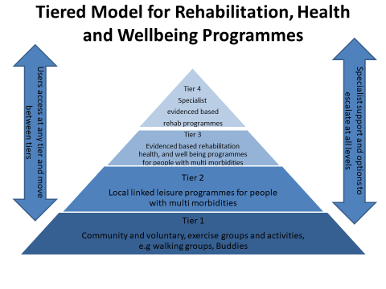
Method – what did you do?  (300 words) | Provide clear details of:  - What activity you undertook  - Who was involved and why  - Which outcomes did you measure, why you chose these and how they were collected?  - You can also include flowcharts, tables or images  The team background is cardiac rehabilitation. Although able to provide rehabilitation across a variety of cardiac diagnoses, the existing service had no capacity to accept referrals for those with angina or arrhythmias. Within this in mind, there was an application made to the Integrated Care Fund with the offer of an innovative new tier three multi-morbidity rehabilitation option to increase access to those with multiple long term conditions. The project was designed collaboratively, working with health partners as well as community partners. An approach based on PDSA principles was adopted. The tiers were designed with condition-specific specialists. As each new condition was brought on board to be assessed the knowledge and skills of the team members were enhanced by inclusive an inclusive training programme. We invited AHP’s, and our leisure partners to training events where we invited specialists locally and nationally to present and form partnerships with us. To keep up with challenges that arose during the project we started an issues log that anyone could submit, these were compiled, answered with a solution and shared again back to all staff. Evaluation looked at staff needs, team training, service and people outcomes, case studies. As evaluation occurred HARP evolved continuously, for example, looking at people who failed to attend showed that most were experiencing persistent pain. We then did further training for the team in this area and brought it in as an education topic. The project enhanced the relationship between people in all the tiers and people were able to move between tiers in a flexible way.
Outcomes – what difference did you make? (300 words) | - Can you show evidence of impact?  - Outcome measures - What has changed?  - Was there any service-user or staff feedback?  - Was this value for money / cost effective?  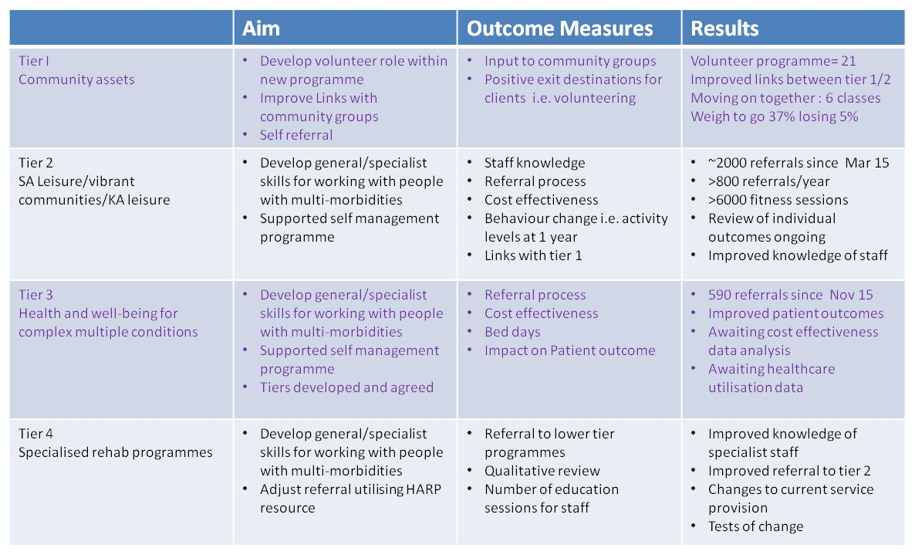  - Make sure you obtain permission to use direct quotes or photos/pictures if using these.  - The project successfully demonstrated it was financially viable using EQ5D-5L with a cost per QALY (quality-adjusted life year) under the £30,000 threshold.  - Visual Analogue Scales show an average 20-30% improvement across all quality of life measures  - Emergency admission data was examined in three groups of age- and sex-matched individuals who had been referred to HARP. Those who completed the 10-week programme demonstrated a 70% reduction in bed days over one year.  - Two volunteer roles have been created and a third role is under development and about to be piloted. Our volunteers have high levels of satisfaction and deliver peer support to many of our service users in classes and group settings. Two of our volunteers won Ayrshire Achieves.  - We have been recognised nationally in the work we are doing and have interest nationally including from Public Health England, the Chartered Society of Physiotherapy and British Association of Cardiac & Pulm Rehab.  - Participants in Kilbirnie (a small, rural town with high levels of deprivation) told us that they would not have travelled for these classes, but the effect on individuals had been transformative, emphasising the importance of local targeted interventions in areas of inequality.  - We have reported on the project across two publications - one paper examined service user perceptions of the programme (Cowie et al, 2018):  and the other examined the staff journey (Cowie et al, 2021):  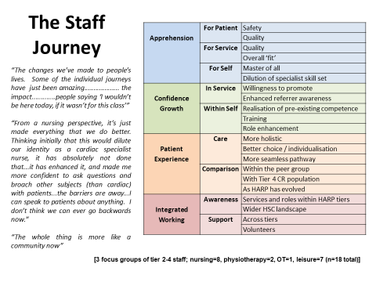
Key learning points  (300 words) | - What are the key learning points?  - What worked well and what didn’t?  - What things you might do differently in future  - What future plans do you have to embed this work?  - What lessons have you learnt?  - Any advice you'd give others looking to do a similar work  The project has established that a multi-modal multimorbidity rehabilitation model is safe and effective. Acknowledging the staff journey is key to the process of transformational change (Landaeta et al, 2008). In this project, staff were concerned that delivering HARP would be at the expense of the existing care and service (the ‘cannabalisation cost’ of the change), plus the perception that they lacked capability to deliver the change. Importantly, staff had the opportunity to help shape the change, which enabled them to challenge their own embedded work routines and pre-existing ideas about practice.  As HARP progressed, and referrers gained confidence in the service, the caseload became more complex. With the potential for a service ‘bottleneck’ within leisure (as more complex individuals may require more ongoing support) collaboration and continued development of leisure is imperative.  The future includes resumption of classes post-pandemic, working with people affected by long covid, and seeking opportunities to delivering rehabilitation through a locally delivered walking groups.  Our advice is to other services undergoing such transformational change is to have determination, co-productive working with all relevant partners and stakeholders. Ideally this should be backed up by funding to support a transition with staff knowledge and skill development being part of that journey.
References (max 6) | - Include relevant links and references  - Use an academic style for all references (eg Harvard, Vancouver, APA etc.)  Cowie A, McKay J, Keenan A. Combined generic-specialist multimorbidity rehabilitation post acute cardiac event. British Journal of Cardiac Nursing 2018; 13(7): 340-347  Cowie A, Good K, McKay J, Holt J. Tackling multimorbidity: staff perceptions of the transition from single-condition rehabilitation to a specialist-generalist model. International Journal of Therapy and Rehabilitation 2021; https://doi.org/10.12968/ijtr.2020.0062  Landaeta RE, Mun JH & Rabadi G. 2008. Identifying Sources of Resistance to Change in Healthcare. International Journal of Healthcare Technology and Management 2008; 9(1): 74-96

Please return your completed template to AHPs@phe.gov.uk for review.

We aim to respond to case study submissions within 8 weeks, but please note that it may take longer to hear back. Please provide two email addresses in the contact section above to ensure that we are able to contact you if you change workplace or email during this time.

Thank you for taking the time to submit this case study.

