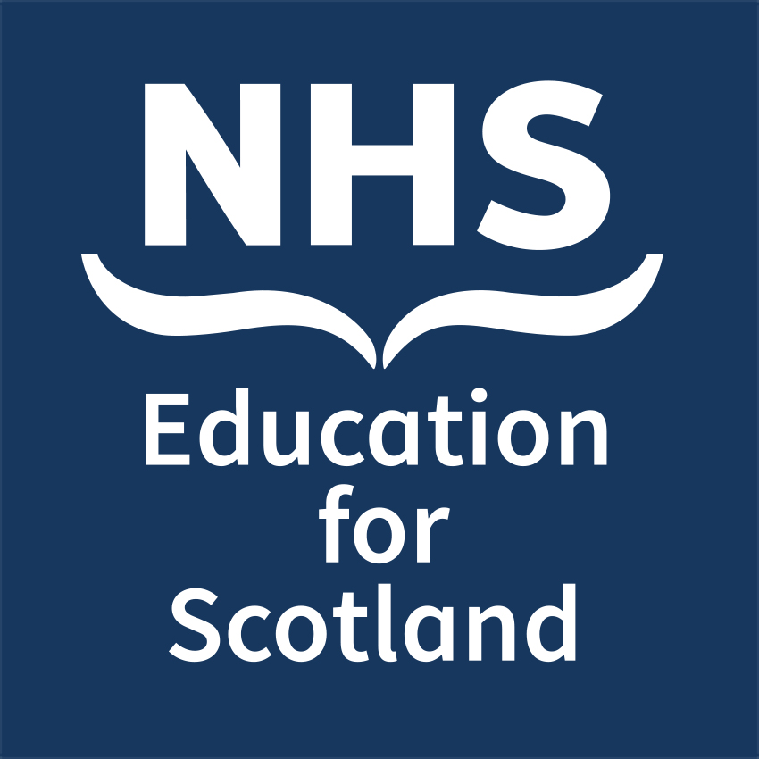

**NES Annual Conference 2026 - Collaborate. Innovate.**

**Transform: Delivering change towards improving health,**

**social care and other public services in Scotland  
 Thursday 23 and Friday 24 April 2026**

**Seminar Session Abstract Submission Form**

**Your Details:**  
Full Name:   
Job Title:   
NHS Board / Organisation:   
Email Address:   
Tel No:

Do you work for NHS Education for Scotland

Submissions are welcome from across the NHS, from social care and social work services, integration authorities, voluntary and partner organisations, and other public or private sector organisations.

For the conference in 2026 we are looking for a broad range of abstract submissions that would be of interest to a multi professional audience and also a targeted audience, **please select one from the below list.**

Dental Education

Healthcare Science

Medical Education

Multi Professional (*session should be of relevance to all the attendees)*

Nursing, Midwifery & Allied Health Professionals

Pharmacy Education

Psychology

Social Care

Social Work

**Session Details:  
  
1**) Title of your proposed seminar:

**2**) Seminar session description: (this will be published on the NES conference website to inform delegate selection – max 150 words)

**3**) Please list the objectives of the seminar and how they relate to the theme of the conference, indicating the knowledge and skills participants should expect to gain. For Dental Education related submissions, please also list the expected learning outcomes and GDC development outcome(s) <https://www.gdc-uk.org/education-cpd/cpd/enhanced-cpd-scheme-2018>

**4**) Who will be contributing to the delivery of this seminar? (please state name, job title, NHS Board / Organisation and email address – please note we may have to restrict the number of presenters in a session)

Please email your completed form to: [nes.conference@nhs.scot](mailto:nes.conference@nhs.scot)

**Deadline for submission:** **23:59, 14 December 2025**