
Allied Health Professions Projects Progressing Practice-based Learning: Workstream Report 2026
Ailidh Hunter

Allied Health Professions Projects Progressing Practice-based Learning (PrBL) 2026

Table of Contents

Authors 3
Date of Publication 3
Acknowledgements and contributions 4
Introduction and Background 5
Method 6
Results 7
Workstream Recommendations 20
Conclusion 24
References 25

Appendices 26
Appendix A: AHP Practice Education Development Framework 26
Appendix B: Being and Becoming an AHP Practice Educator 29
Appendix C: AHP PrBL in Local Authority and Social Care Occupational Therapy 30
Appendix D: Involving Service Users in AHP PrBL 32
Appendix E: National Whistleblowing Guidance for AHP PrBL 33
Appendix F: AHP Student Indexing 34
Appendix G: Using a Coaching Approach in AHP PrBL 36
Appendix H: Long Arm Supervision 38
Appendix I: Project-based Placements 41
Appendix J: Student-led Services (Infographic) 43
Appendix K: Student-led Services (Report) 45

Authors
- Ailidh Hunter, Allied Health Professions (AHP) Senior Educator, NHS Education for Scotland (NES)
- Alice Toepritz, AHP Practice Education Lead, NES
- Clare Carson, AHP Practice Education Lead, NES
- Claire McAleer, AHP Practice Education Lead, NES
- Laura Torrance, AHP Practice Education Lead, NES
- Rachel Tainsh, AHP Practice Education Lead, NES
- Rhonwyn Smith, AHP Practice, Education Lead, NES
- Sarah Nicol, AHP Practice Education Lead, NES

Date of publication
31st July 2026

Acknowledgements and contributions

- Gail Nash, Principal Educator, NHS Education for Scotland (NES); Helen McFarlane, Programme Director, NES; and Gillian Macleod, Associate Director, NES for the opportunity to undertake the projects, and for their guidance and encouragement throughout.
- Joanne Gibson, Karin Massie, Laura O’Halloran, Pete Glover, and Lorna Darrie, Senior Educators in the NES AHP Practice Education Team for their support, direction, and line management.
- The Board AHP Practice Education Leads, colleagues at the Higher Education Institutes (HEIs), the NES Design Team, and the NES Business Support Team for their collaboration, support, and advice.
- Carolyn McDonald, Chief Allied Health Professions Officer, Scottish Government and Anne Wallace, Allied Health Professions Education Advisor, Scottish Government, as funding sponsors of the workstream and for their ongoing support throughout the projects.
- Thank you to the many other stakeholders who have engaged in and contributed to this work from organisations across Scotland.

Introduction and Background

This report provides an overview of the Allied Health Professions (AHP) Projects Progressing Practice-based Learning (PrBL) Workstream 2025-26, funded by the Scottish Government. It builds on the key learning and outputs presented in the AHP Projects Progressing PrBL Workstream Report 2025 (NHS Education for Scotland, 2025) and sets out recommendations to support the continued development of modern, diverse, and sustainable AHP PrBL in Scotland.

The AHP Projects Progressing PrBL is aligned with the AHP PrBL Consensus Statements, AHP Principles of PrBL, and supports the recommendations set out in the AHP Education and Workforce Policy Review (Scottish Government, 2023), and the AHP PrBL Recovery workstream 2021-23 (NHS Education for Scotland, 2023). These projects form a key component of the NHS Education for Scotland (NES) AHP PrBL workstream and contribute to ongoing, collaborative efforts to strengthen AHP PrBL capability, expand capacity, and embed sustainable quality assurance and governance for AHP PrBL across Scotland.

Ensuring students receive a high-quality, positive learning experience is essential to developing a future AHP workforce that is fit to practise and prepared for employment across all sectors in Scotland. In collaboration with the national NES AHP PrBL workstream, the projects aimed to:
- Develop AHP PrBL capability by supporting those delivering PrBL and equipping the future AHP workforce with the knowledge, skills, and behaviours required to work effectively across health and social care settings
- Build AHP PrBL capacity sustainably through the use of a range of PrBL models
- Embed robust quality and governance to support high quality AHP PrBL across Scotland

Method

The AHP Projects Progressing PrBL 2025-26 were led by AHP PrBL Practice Education Leads (PELs) recruited by NES, and ran from 1st April 2025 to 31st March 2026. The workstream comprised ten distinct projects with an AHP-wide focus.

Implementation was facilitated through monthly progress meetings attended by the AHP PrBL PELs and the NES AHP Practice Education Team, supported by the use of project management tools, including project charters, project plans, communication strategies, and risk registers. The AHP PrBL PELs provided quarterly updates, and utilised a Red, Amber, Green (RAG) rating system to montior progress against project deliverables. In addition, the Goals, Roles, Process, Interpersonal (GRPI) Model of Team Effectiveness (Beckhard, 1972) short form was completed monthly and extended form was completed quarterly to review key factors influencing team functioning, identify areas for improvement, and monitor overall project progress and outputs.

Individual infographics for each project are provided in Appendices A–J. A more detailed report on student-led services, introduced as a new component of the 2025/26 workstream, is included in Appendix K

Results

By 31st March 2026 new resources, and PrBL opportunities were created to support and develop PrBL in a modern, diverse, and sustainable way. Examples of key achievements are in Tables 1 and 2 below, and within the individual project reports in Appendices A-K.

Table 1: Key Workstream Achievements / Outputs
Development | Achievements / Outputs
AHP PrBL resources developed | - Development of resources to support embedding of the AHP Practice Education Development Framework in practice including resources to support local framework implementation sessions, an interactive self-evaluation tool and a staff mapping tool  - Being and Becoming an AHP Practice Educator: proposal of updates to modules  - Sway learning resource: A Golden Thread: Involving People Receiving Care and Unpaid Carers in Practice Based Learning  - New Turas Learn page developed on Involving Service Users in AHP PrBL  - National Whistleblowing Guidance for AHP Students: National Whistleblowing Guidance for AHP Students 2026  - Development of coaching workshop resources and guidance document including prompt question sheet  - Development of a range of resources including Long Arm Supervision (LAS) Guidance for Practice Educators, LAS Guidance for Learners, LAS Turas page, and LAS resource infographic  - Development of a range of resources including updated case studies, Project-based PrBL guidance, a companion infographic for students to share key information ahead of a Project-Based Placement, project proposal and project summary documents  - Development of a student-led services definition, Set-up Checklist, Microsoft Sway including case studies, and Student-led Services Turas Learn page  - Further development of the AHP PrBL pages on Turas Learn  - and AHP Projects Progressing PrBL pages on Turas Learn  8 presentations from the AHP Projects Progressing PrBL Event 19.03.26 available at AHP Projects Progressing PrBL Event 19.03.26 | Turas | Learn
New AHP PrBL training opportunities | - To increase PrBL opportunities in local authority and social care Occupational Therapy (OT): three sessions with the national practice education network, two in-person PrBL events, and a deep dive event in collaboration with the Royal College of Occupational Therapists  - Four bitesize CPD sessions delivered on the AHP PrBL Virtual Community (The Golden Thread: Embedding Lived Experience in AHP PrBL, Project-based Placements, Long Arm Supervision, and Student-led Services) – 368 attendees  - Two coaching workshops with 28 attendees in total
Networks, and support for practice educators | - Development of short-life working groups to support PrBL opportunities in local authority and social care OT  - Creation of an AHP Student Indexing stakeholder group  - Development of the AHP PrBL Virtual Community enabling engagement and support across professions Scotland-wide: AHP PrBL Virtual Community Sway

A summary of impact can be found below, and for each individual project within Appendices A-K.

Engagement Impact
- The AHP PrBL Virtual Community has been promoted as part of the PrBL projects and wider AHP PrBL workstream. Over 250 new members have joined the AHP PrBL Virtual Community since 1st April 2025. The community promotes the sharing of practice and aims to reduce duplication.
- 66 colleagues attended the AHP Projects Progressing PrBL Celebration and Sharing Event in March 2026, and many more contributed to the projects.

Educational Impact
- Increased knowledge, awareness, and confidence documented within polls and within evaluation of training opportunities and resources.
- At the AHP Projects Progressing PrBL Celebration and Sharing event in March 2026, 100% of evaluation respondents reported they were likely to change or improve their practice because of learning from the event.
- Positive feedback received from stakeholders on the value of resources, and increased awareness of where to find resources has been reported.
- Statements of intent / pledges from stakeholders to utilise different models and methods of delivery.

Performance Impact
- New PrBL opportunities created through utilisation of different models and methods of delivery.
- Positive practice educator and student testimonials as shared in the individual project reports (Appendices A-K).

GRPI results indicate a progressive improvement in AHP PrBL project team effectiveness as perceived by team members over the course of the projects as seen in Figure 1 below.

Figure 1: Goals, Roles, Processes, Interprofessional (GRPI) Scores Over Time

Table 2: Summary of objectives, deliverables, key measures, and recommendations from the individual AHP Projects Progressing PrBL

Project | Objective | Deliverables | Key Measure(s) | Recommendations
AHP PrBL Capability: AHP Practice Education Development Framework | To support the growth of AHP PrBL capacity and capability through embedding the AHP Practice Education Development Framework in practice | - Support provided to AHP Practice Education Leads to embed the framework in health boards across Scotland  - Development of resources to support local implementation sessions, an interactive self-evaluation tool and a staff mapping tool to support practical use of the framework  - Review of evaluation feedback to inform spread and scale | Engagement statistics and evaluation of framework local implementation sessions:  -94% of 85 respondents reported the session attended was relevant to their practice  -Attendees reported an increase in confidence in describing their AHP PrBL role, accessing resources, and applying learning to practice | - Continue to embed the AHP Practice Education Development Framework through awareness raising, local and national implementation sessions  - Where possible, track data on access to resources to provide insight into which staff groups are being reached and to inform targeted support for those who may benefit from additional input

Project | Objective | Deliverables | Key Measure(s) | Recommendations
AHP PrBL Capability: Being and Becoming an AHP Practice Educator | To update the Being and Becoming an AHP Practice Educator online resource to provide a contemporary, engaging learning programme aligned with current AHP practice-based learning (PrBL) priorities | - Feedback on the existing resource has been gathered and analysed to inform the proposed updates  - Consultation is underway to refine content and format options, informed by the AHP Board Practice Education Leads (PELs), the AHP PrBL Operational Collaboration, and the AHP Practice Educator Development National Working Group | Positive feedback received on proposal allowing progression to the next stage of development | - Analysis of detailed feedback from stakeholder consultation  - Design and development of updated content which will be piloted before new eLearning modules are finalised and published

Project | Objective | Deliverables | Key Measure(s) | Recommendations
AHP PrBL Quality and Governance: AHP PrBL in Local Authority and Social Care | To increase practice education opportunities for  OT students across local authority and social care settings | - Strong momentum has been established, underpinned by effective collaboration, a positive culture, and enabling structures that support PrBL  - At least 30% of the current local authority and social care OT workforce has been reached through a combination of online and in-person events | Stakeholder feedback  -The sharing of lived experiences by students and practice educators is reported to have significantly contributed to challenging and dispelling common misconceptions  -Reported increase in local authority and social care OT PrBL placement offers made to the higher education institutes | - Connect the LA OT community through an online PrBL forum  - Collaborate across health, social care, and the third sector sharing PrBL learning and best practice  - Where possible, track data on local authority and social care OT PrBL placement offers made and utilised over time

Project | Objective | Deliverables | Key Measure(s) | Recommendations
AHP PrBL Quality and Governance: Involving Service Users in AHP PrBL | To explore how people who receive care and unpaid carers can be  active partners in supporting students and can meaningfully contribute to PrBL | - Explored the research and identified useful tools linked to key national initiatives e.g. Values Based Health and Care and Health Literacy  - Hosted an online CPD Session to raise awareness and provide practical guidance  - Developed a range of resources including A Golden Thread: Involving People Receiving Care and Unpaid Carers in Practice Based Learning Sway and Involving Service Users in AHP PrBL Turas page | Engagement statistics and evaluation of national involving service users CPD session:  -100% respondents reported an increase in knowledge on how they can involve service users and unpaid carers in PrBL  -100% of respondents reported feeling confident they could apply this learning in practice  -100% of respondents reported it was likely they would change or improve their practice as a result of this learning | - Practice educators are encouraged to engage with the Sway and new resources to role model active involvement  - Support students to seek feedback as part of everyday practice

Project | Objective | Deliverables | Key Measure(s) | Recommendations
AHP PrBL Quality and Governance: National Whistleblowing Guidance for AHPs | To update the student guidance to ensure it is accurate, user-friendly, and clearly focused on providing effective support for students | - Engaged with a range of stakeholders to develop revised guidance  - Guidance finalised following confirmation from the Independent National Whistleblowing Officer (INWO): National Whistleblowing Guidance for AHP Students 2026 | New guidance published at the end of the project. Engagement statistics and evaluation feedback will be gathered over time | - Review guidance format and transition from a Word document to a more engaging online platform  - Explore opportunities for shared cross-profession guidance with Nursing & Midwifery, with tailored add-ons for each group

Project | Objective | Deliverables | Key Measure(s) | Recommendations
AHP PrBL Quality and Governance: AHP Student Indexing | To understand the feasibility, challenges and facilitators of indexing Scotland’s AHP students | - Establishment of a stakeholder group to support AHP Indexing, fostering collaboration between the Scottish Government, NHS Education for Scotland, and Higher Education Institutions (HEIs)  - Pilot involved six HEIs, encompassing eleven programmes and six allied health professions. Valuable insights were generated into key processes, enablers, and challenges to inform future development | Learning from the AHP Student Indexing Feasibility Pilot has informed processes and generated recommendations that will allow progression to the next stage of development | - Partnership working and identified resource to allow indexing to be expanded to support AHP students’ journeys  - Make future connections to Occupational Classification Indexing to enhance workforce planning for all AHPs

Project | Objective | Deliverables | Key Measure(s) | Recommendations
AHP PrBL Capacity: Using A Coaching Approach in AHP PrBL | To introduce coaching conversations to support PrBL models and delivery | - Development of a structured coaching workshop, supporting resources, and guidance documentation  - Implementation of the Goals, Reality, Options, Way Forward (GROW) model, supported by tailored resources | Evaluation of a coaching approach across six allied health professions demonstrated its relevance to practice:  -Knowledge, skill, and confidence increased when the GROW model was adopted with supporting resources, and following attendance at the new coaching workshop -100% of respondents reported feeling confident they could apply learning from the coaching workshop in practice and that it was likely they would change or improve their practice as a result of this learning | - Continue to explore opportunities to embed a coaching approach within PrBL, including further evaluation and application of the GROW model as supported by the AHP Coaching Expression of Interest report 2026  - Deliver additional coaching workshops to support the effective use of coaching conversations within PrBL settings  - Ensure coaching resources are accessible to all allied health professionals to support PrBL, including integration within the Turas Learn platform

Project | Objective | Deliverables | Key Measure(s) | Recommendations
AHP PrBL Capacity: Long Arm Supervision (LAS) | To improve the clarity, accessibility, and usability of LAS by collating, developing, and promoting relevant resources | - Development of a range of resources including LAS Guidance for Practice Educators, LAS Guidance for Learners, LAS Turas page, and LAS resource infographic  - A range of stakeholders consulted for advice and input on development of these resources  - Hosted a national CPD session to launch the resources | Engagement statistics and evaluation of national CPD session:  -100% of respondents reported an increase in knowledge following attending the session  -Over 90% felt able to apply this learning right away  -67% of respondents expected that learning from the session would change their practice | - Encourage teams to offer LAS placements using updated  guidance  - Share the infographic, guidance document, and previously developed LAS podcast series widely to drive consistent adoption  - Gather more case studies and develop new tools as required  - Where possible, track data on AHP LAS PrBL placement offers made and utilised over time

Project | Objective | Deliverables | Key Measure(s) | Recommendations
AHP PrBL Capacity: Project-based Placements | To provide resources and support for AHPs across Scotland to plan for and carry out Project-Based Placements | - Development of a range of resources including updated case studies, Project-based PrBL guidance, a companion infographic for students to share key information ahead of a Project-Based Placement, project proposal and project summary documents  - A range of stakeholders including students consulted for advice and input on development of these resources  - Hosted a national CPD session to support AHPs to understand and plan Project-Based Placements | Engagement statistics and evaluation of national CPD session:  -100% of respondents reported an increase in knowledge following attending the session  -79% of respondents felt confident to apply this learning in practice and 88% of respondents advised they were likely to change their practice because of the session  -An increase in confidence was seen with 63% feeling confident to host a project-based placement following the session, and many others interested in accessing the highlighted resources to increase their confidence and knowledge | - Encourage teams to offer project placements using the updated guidance and a further national CPD session if required  - Share the infographic, guidance document, and other resources widely to drive consistent adoption  - Gather more case studies and develop further tools and support if required  - Where possible, track data on AHP project-based PrBL placement offers made and utilised over time

Project | Objective | Deliverables | Key Measure(s) | Recommendations
AHP PrBL Capacity: Student Led Services | To explore the potential of student-led services as a model of PrBL for AHP students across health and social care in Scotland. | - Literature search and national scoping undertaken to map existing models of AHP student-led services  - Definition, Set-up Checklist, Microsoft Sway including case studies, and Student-led Services Turas Learn page developed  - Hosted a national CPD session to share this work | Engagement statistics and evaluation of national CPD session:  -98% of respondents reported no or limited knowledge of student-led services at the start of the CPD session  -100% reported being well informed or somewhat informed on student-led services following the CPD session | - Those interested in exploring the implementation of student-led services may wish to review the new resources- the SWAY resource and set-up consideration check list- available on the AHP student-led services Turas page. They can also draw on the experience of people who have worked with this model in practice (identified contacts in Appendix K)  - Where possible, track data on AHP student-led services over time

Further impact data for the individual projects is available in Appendices A-K.

Workstream Recommendations

To help sustain and develop the significant work undertaken, the following recommendations are made. The allocated timeframes to each recommendation reflect time, financial and resource constraints. These are outlined below:
• Short – as soon as practicably possible and within 1 year
• Medium – 1 to 3 years
• Long – 3 years plus

Table 3: AHP Projects Progressing PrBL Recommendations
No. | Recommendation | Focus / Rationale | Lead Agency / Agencies | Indicative Timeframe
1 | Widely share the AHP Projects Progressing PrBL report and resources | - Focus: Promotion of new resources and learning  - Rationale: Widen access to reduce duplication, share, and develop learning across all Allied Health Professions and throughout Scotland | - The NES AHP Practice Education Team  - PEL networks  - The AHP PrBL Operational Collaboration (APOC) | Short
2 | Continue to develop the AHP PrBL Virtual Community | - Focus: Increase and broaden membership, expand the functions and resources available. All members encouraged to share and showcase resources and examples of good practice, offer support and networking opportunities  - Rationale: To create a one-stop shop to support all involved in AHP PrBL increasing collaboration | - NES AHP Practice Education Team  - AHP PrBL Virtual Community Core Development Group | Short
3 | Continue to embed the AHP Practice Education Development Framework, self-evaluation and staff mapper tools in practice tracking over time | - Focus: To support the growth of AHP PrBL capacity and capability by clarifying practice education roles and responsibilities for all AHP staff  - Rationale: To support practice educator development utilising clear guidance on the knowledge, skills, behaviours and recommended learning across 4 levels of practice education experience | - NES AHP Practice Education Team  - PEL Networks | Short/Medium
4 | Continue to design and develop the updated AHP Being and Becoming a Practice Educator resource | - Focus: To support the growth of AHP PrBL capacity and capability  - Rationale: To support practice educator development enabling them to provide high-quality PrBL opportunities | - NES AHP Practice Education Team  - AHP Practice Educator Development National Working Group | Short / Medium
5 | Widely share the National Whistleblowing Guidance for AHP Students 2026 and consider opportunities for further development | - Focus: Promotion of new resource and learning to support AHP students whilst considering future development  - Rationale: Exploring opportunities for shared cross-profession guidance with Nursing & Midwifery, with tailored add-ons for each group would promote consistent, safe experiences for students across professions | - NES Practice Education Team | Short / Medium

No. | Recommendation | Focus / Rationale | Lead Agency / Agencies | Indicative Timeframe
6 | Continue to support the utilisation of a range of PrBL models through the sharing of resources, and training | - Focus: To promote and support the use of a range of PrBL models/methods of delivery and emerging learning needs in a range of settings  - Rationale: To support practice educators and other key stakeholders to offer modern, diverse, and sustainable PrBL opportunities that will develop the future workforce | - NES AHP Practice Education Team  - HEIs  - AHP PrBL Models / Capacity National Working Group | Medium
7 | Continue to develop AHP PrBL opportunities within local authority and social care settings | - Focus: Collaborate across health and social care sharing PrBL learning and best practice  - Rationale: To broaden PrBL opportunities and  promote the valuable contribution these settings and AHP roles can offer | - NES AHP Practice Education Team  - Local Authority OT colleagues  - HEIs | Medium
8 | Continue to support practice educators to involve service users in student PrBL | - Focus: To build practice educator skill and confidence to involve service users in their day-to-day practice and PrBL  - Rationale: Involving service users strengthens person centred care, broadens perspectives, and can improve the quality and relevance of learning experiences | - NES AHP Practice Education Team | Medium

No. | Recommendation | Focus / Rationale | Lead Agency / Agencies | Indicative Timeframe
9 | Continue to develop data collection mechanisms to measure and demonstrate impact | - Focus: To agree and develop data sets in partnership, develop AHP student indexing, and a quality management system that meets AHP requirements  - Rationale: Robust data, reporting mechanisms that are fit-for-purpose, and undertaking regular evaluation processes to measure progress and utilise opportunities for continuous development | - NES AHP Practice Education Team  - NES Nursery Midwifery and AHP Directorate | Medium / Long
10 | Embed PrBL and PrBL resources in the national AHP PrBL infrastructure | - Focus: To increase access to and engagement with PrBL and PrBL resources across all Allied Health Professions and throughout Scotland.  - Rationale: To support PEs and other key stakeholders to offer modern, diverse, and sustainable PrBL opportunities that will develop the future workforce | - NES AHP Practice Education Team | Long

Conclusion

Opportunities to collaborate and share learning at both national and local levels are essential to support the continued development of modern, diverse, and sustainable AHP PrBL across Scotland. The AHP PrBL Virtual Community has played a key role in connecting stakeholders nationwide, providing a platform to network, share learning, problem-solve, and access resources and updates in a timely and coordinated manner. The importance of practice education development and effective team working at a local level is emphasised within the AHP Practice Education Development Framework. This framework promotes a whole-team approach to PrBL, recognising the value of all contributors and supporting the identification of appropriate resources and training opportunities to meet evolving learning needs.

To meet the future needs of the Scottish population and ensure that students are well prepared to enter the AHP workforce, it is clear that a flexible and innovative approach to PrBL is required. This includes supporting practice educators to meaningfully involve service users in student learning and expanding opportunities across a broad range of health and social care settings. In areas where AHP roles are not yet established, approaches such as long arm supervision offer valuable mechanisms to support high-quality placements in role-emergent contexts. Existing resources and training opportunities across settings should continue to be leveraged to optimise the use of diverse PrBL models, including peer-assisted learning, long arm supervision, project-based PrBL, student-led services, and coaching approaches.

There is a continued need to embed PrBL and associated resources within a national AHP PrBL infrastructure supported by AHP student indexing and a robust quality management system. This is essential to support ongoing innovation, strengthen system-wide capability, and ensure that practice-based learning evolves to meet the needs of both service users and the future AHP workforce in Scotland.

References

Beckhard, R. (1972). ‘Optimizing Team Building Effort’, Journal of Contemporary Business, 1(3), 23–32.

Chartered Society of Physiotherapy and Royal College of Occupational Therapists (2023) AHP Principles of Practice-based Learning: working together to develop our future workforce. London: Chartered Society of Physiotherapy. Available at: https://learn.nes.nhs.scot/72890 (Accessed 21 April 2026).

NHS Education for Scotland (2023) AHP PrBL Workstream Report. Edinburgh: NHS Education for Scotland. Available at https://www.nes.scot.nhs.uk/media/brib2bvz/ahp_prbl_recovery_workstream_report_2023.pdf (Accessed 21 April 2026).

NHS Education for Scotland (2025) AHP PrBL Workstream Report 2025. Edinburgh: NHS Education for Scotland. Available at ahp-projects-progressing-prbl-workstream-report-2025.docx (Accessed 21 April 2026).

The Scottish Government (2023) AHP Education and Workforce Policy Review. Available at Allied Health Professions Education and Workforce Policy Review Recommendations (Accessed 21 April 2026).

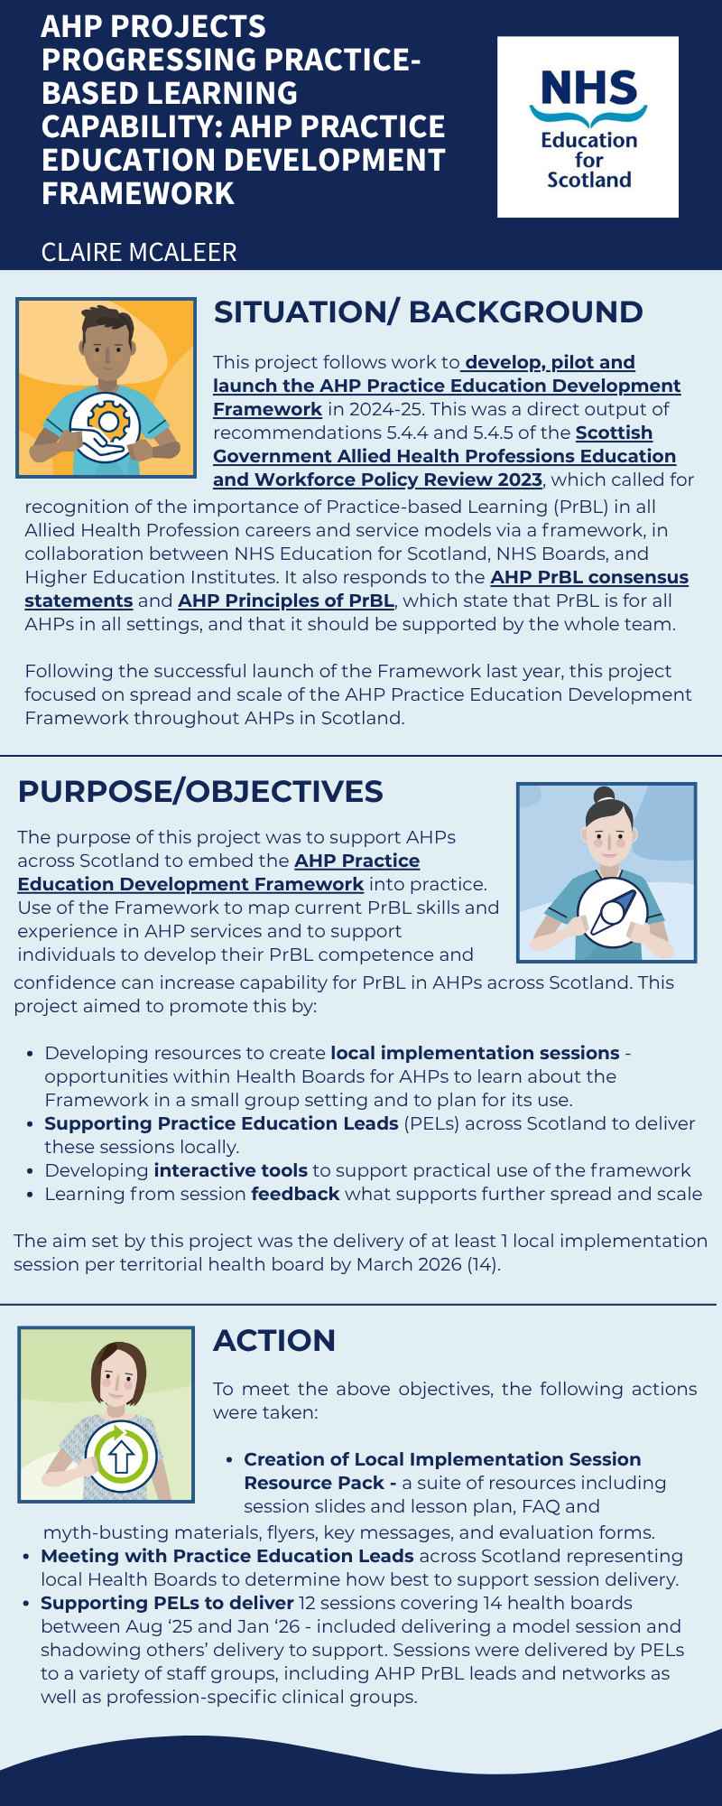
To access a larger version of this infographic with clickable links please click here
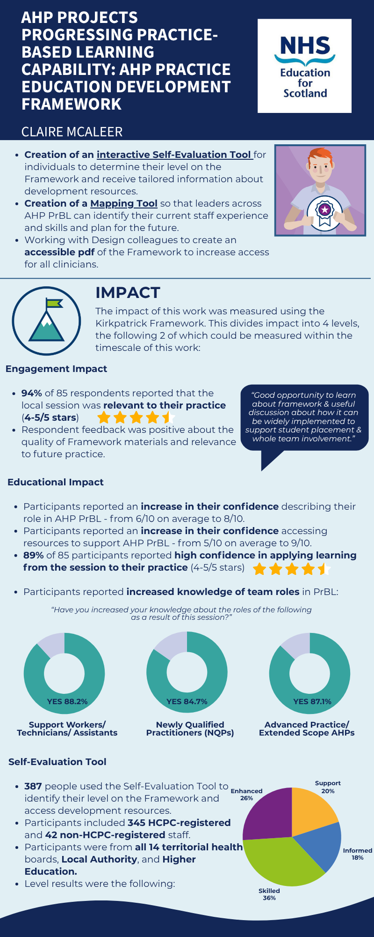
To access a larger version of this infographic with clickable links please click here
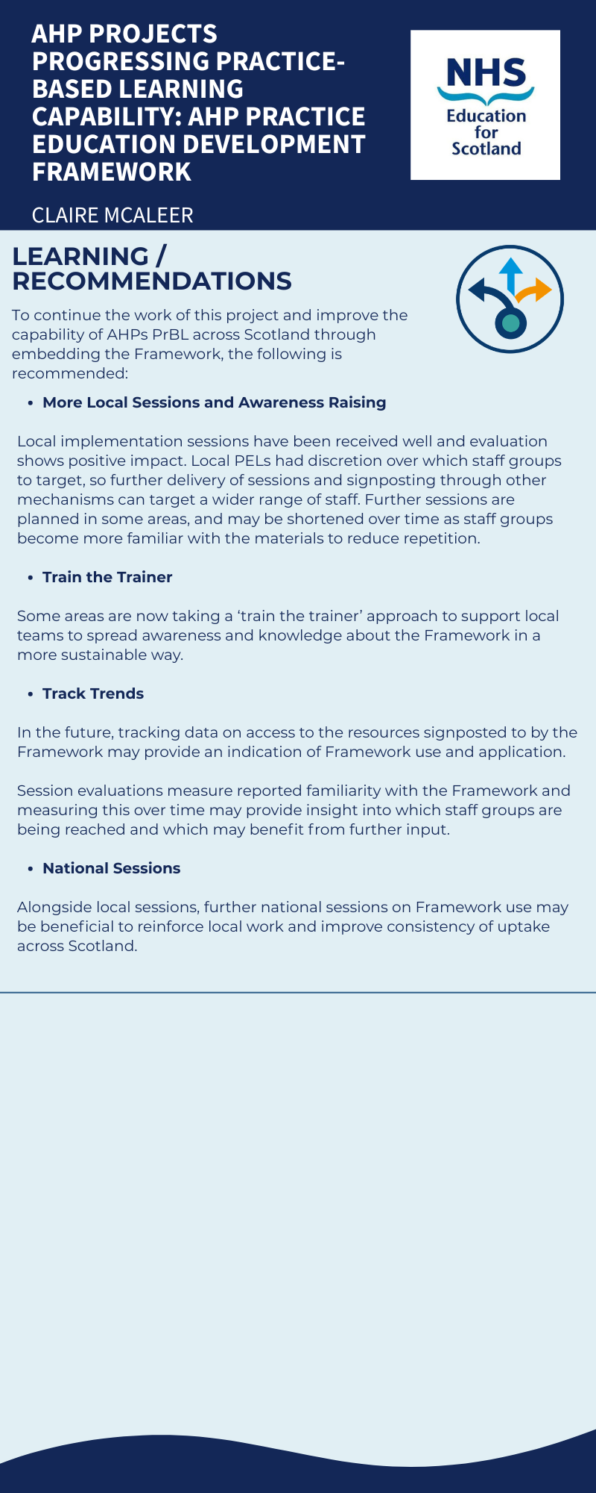
To access a larger version of this infographic please click here
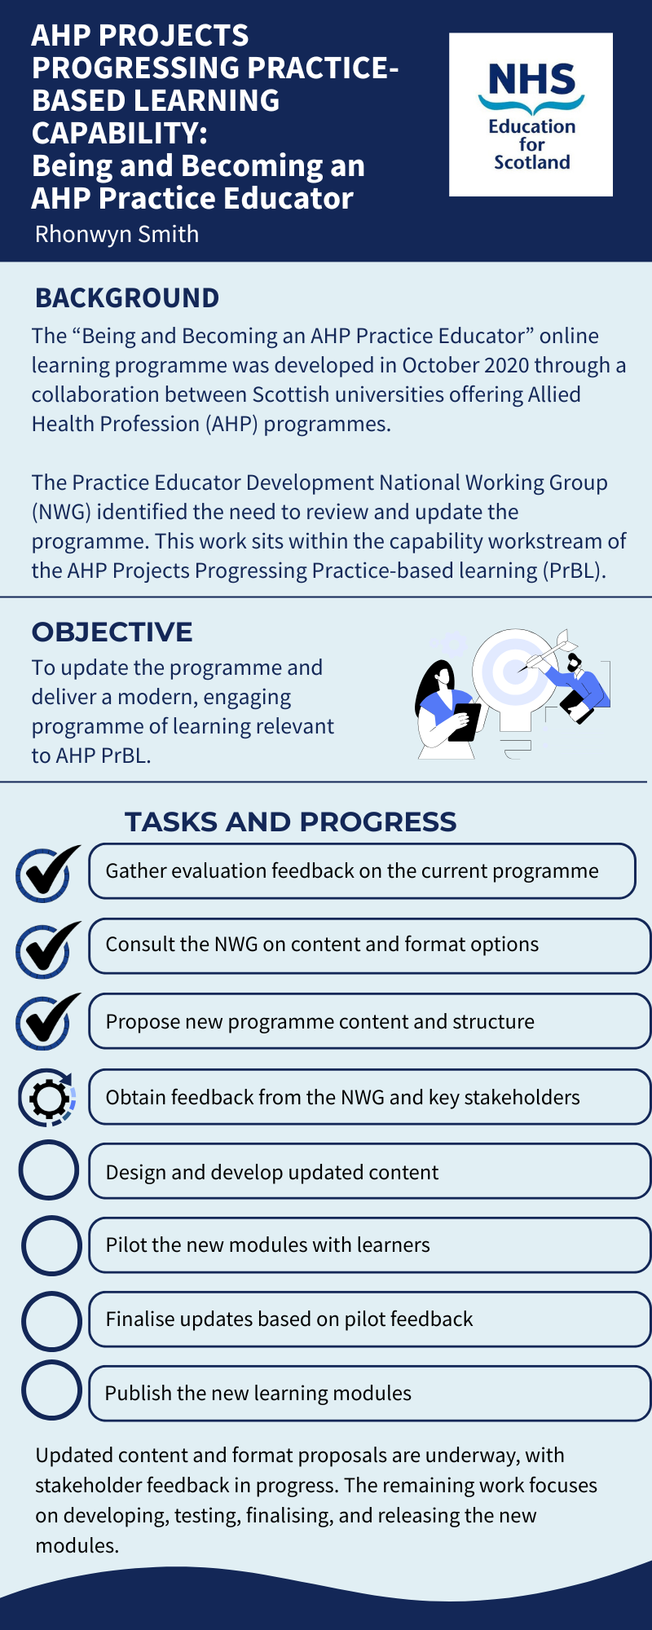
To access a larger version of this infographic please click here
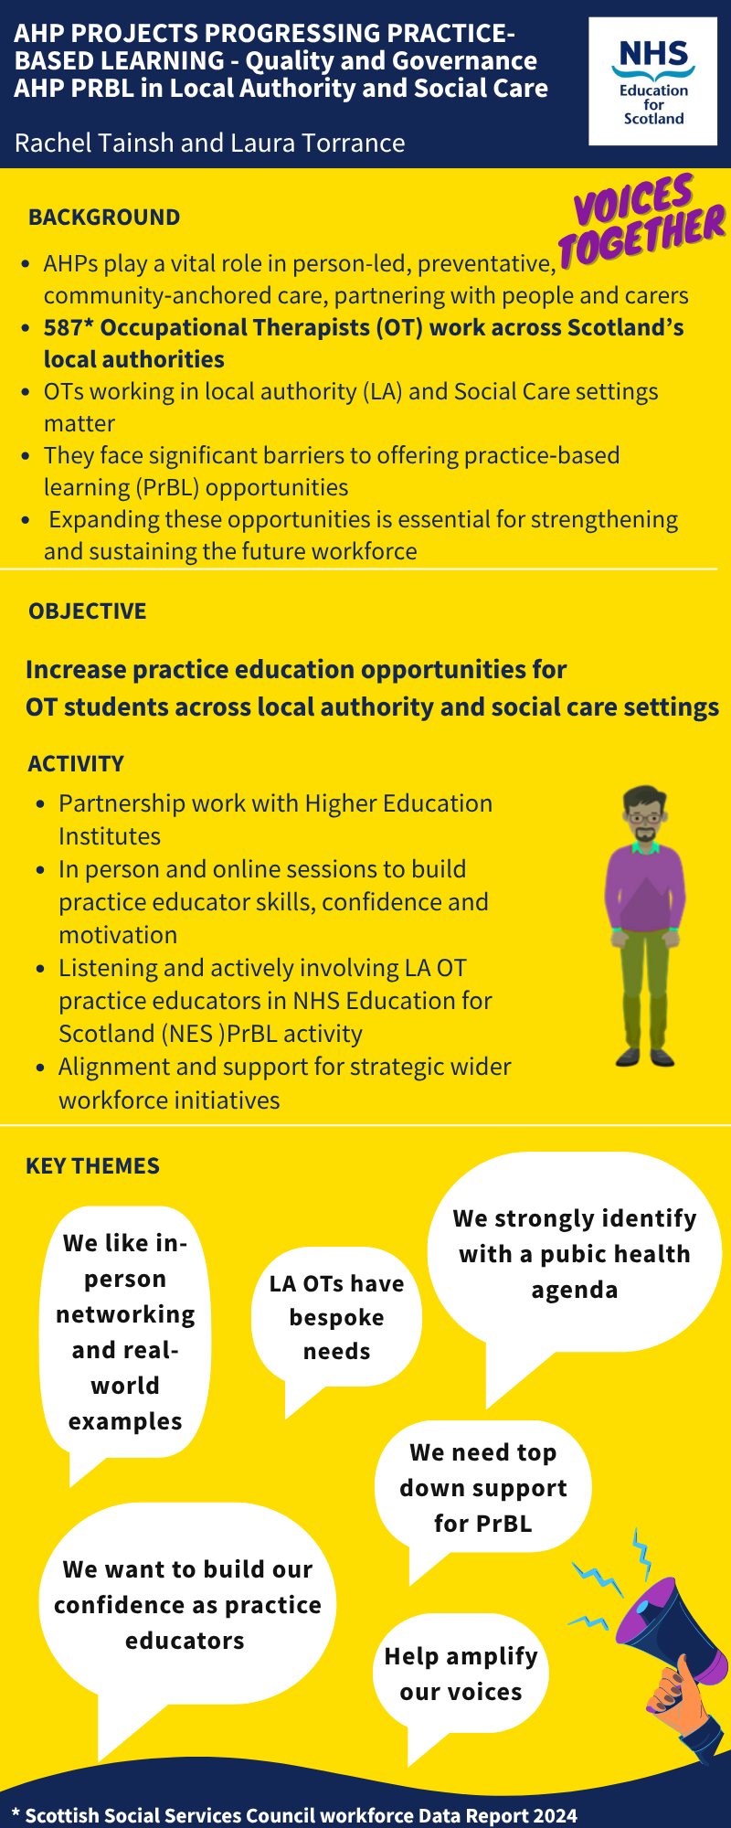
To access a larger version of this infographic please click here
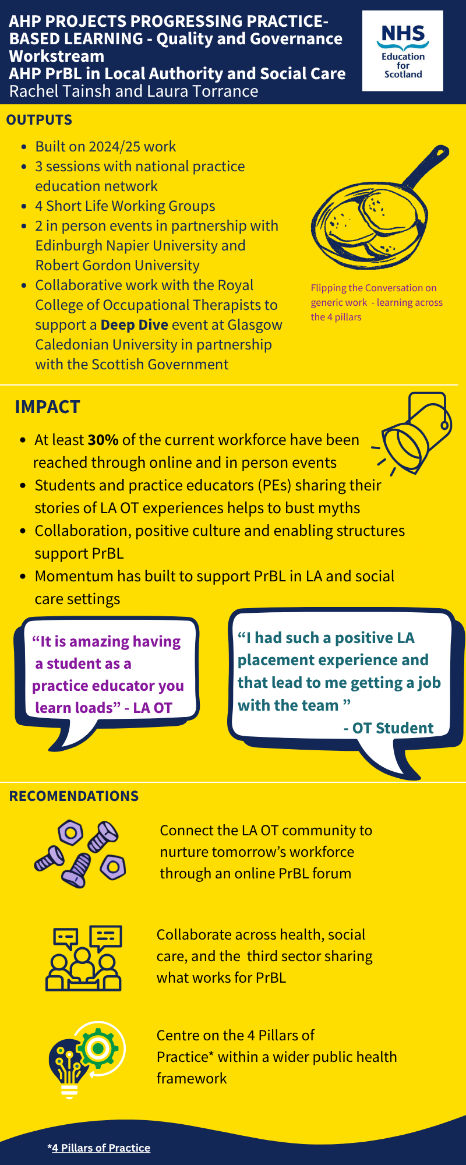
To access a larger version of this infographic please click here
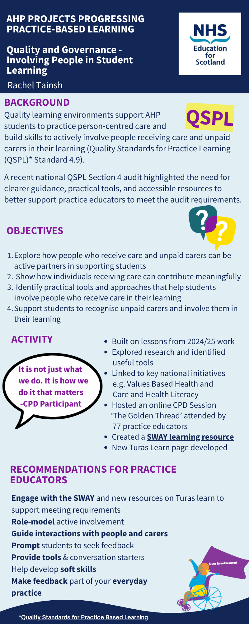
To access a larger version of this infographic with clickable links please click here
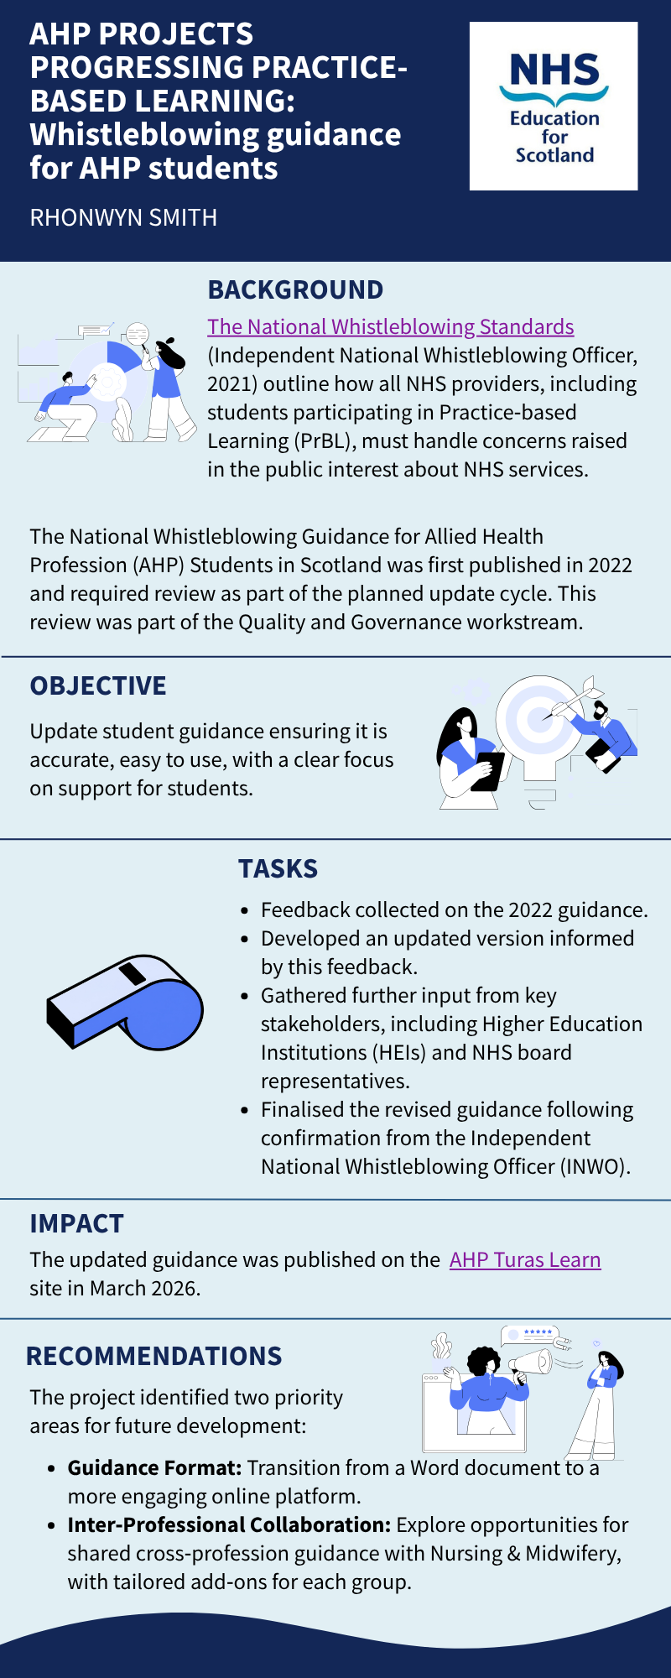
To access a larger version of this infographic with clickable links please click here
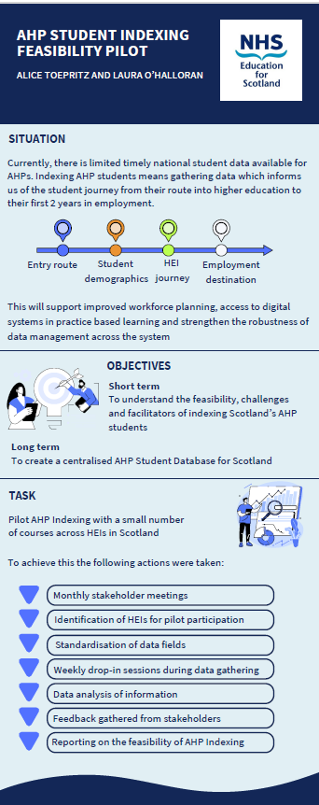
To access a larger version of this infographic please click here

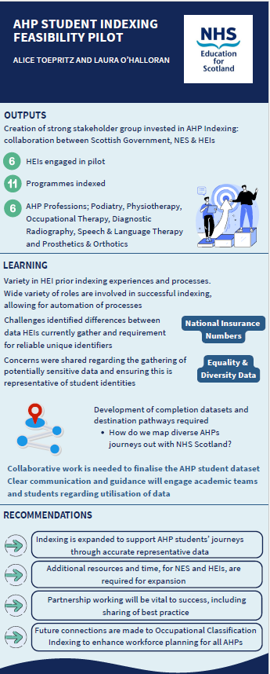
To access a larger version of this infographic please click here

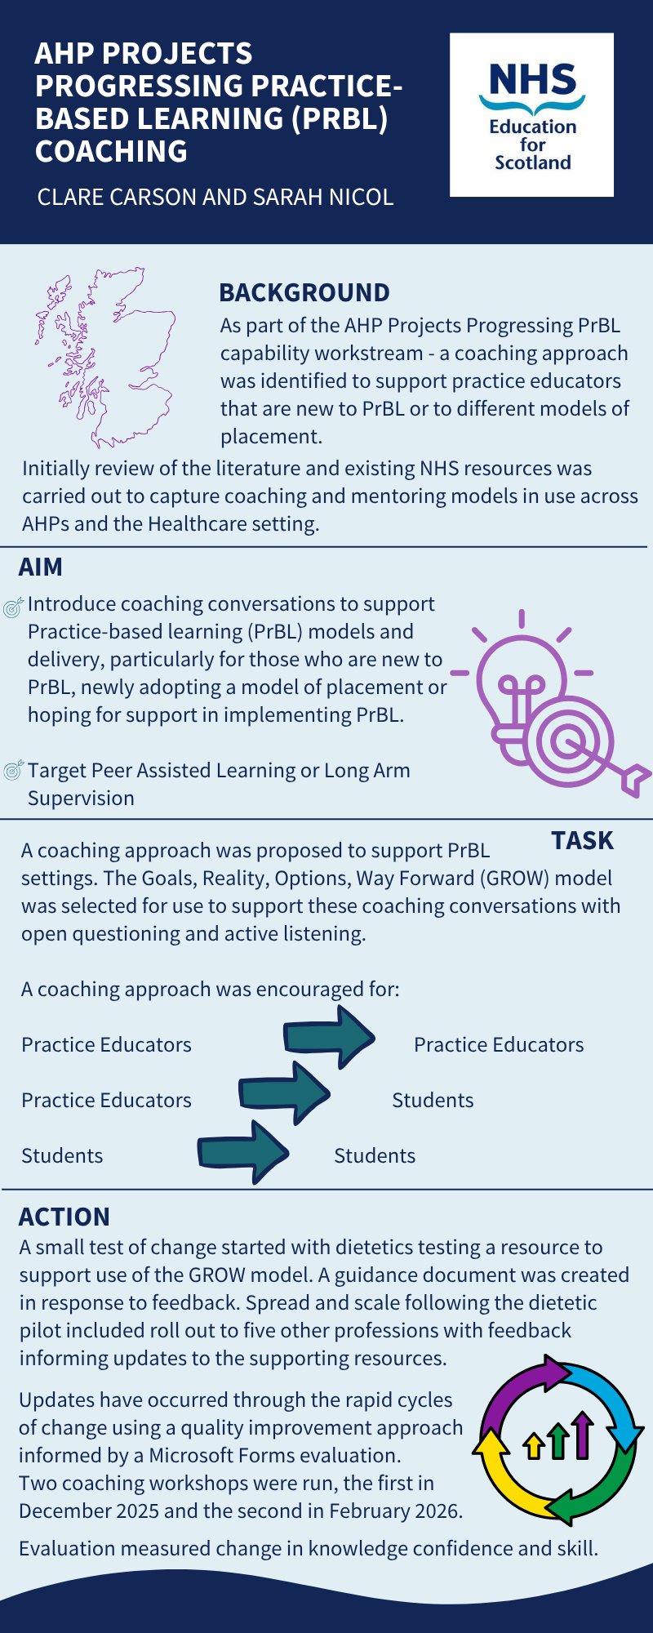
To access a larger version of this infographic please click here
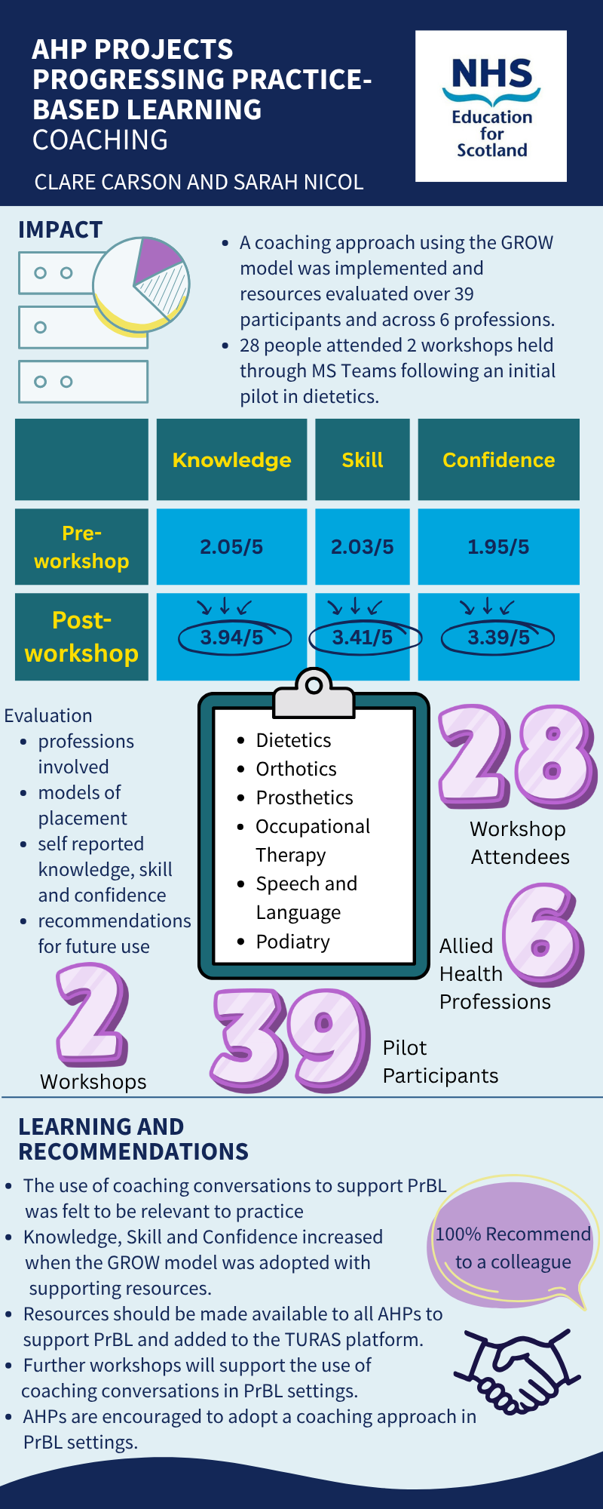
To access a larger version of this infographic please click here
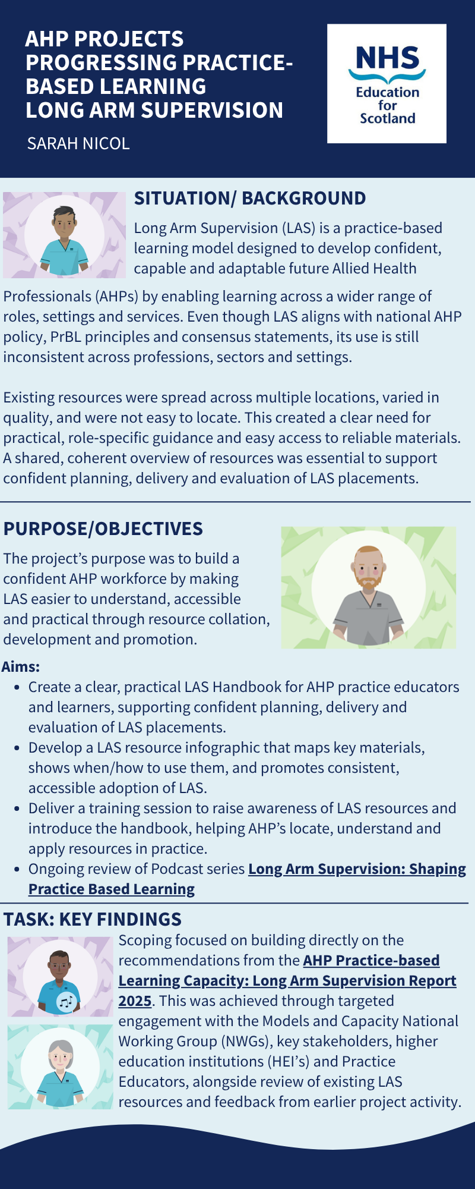
To access a larger version of this infographic with clickable links please click here
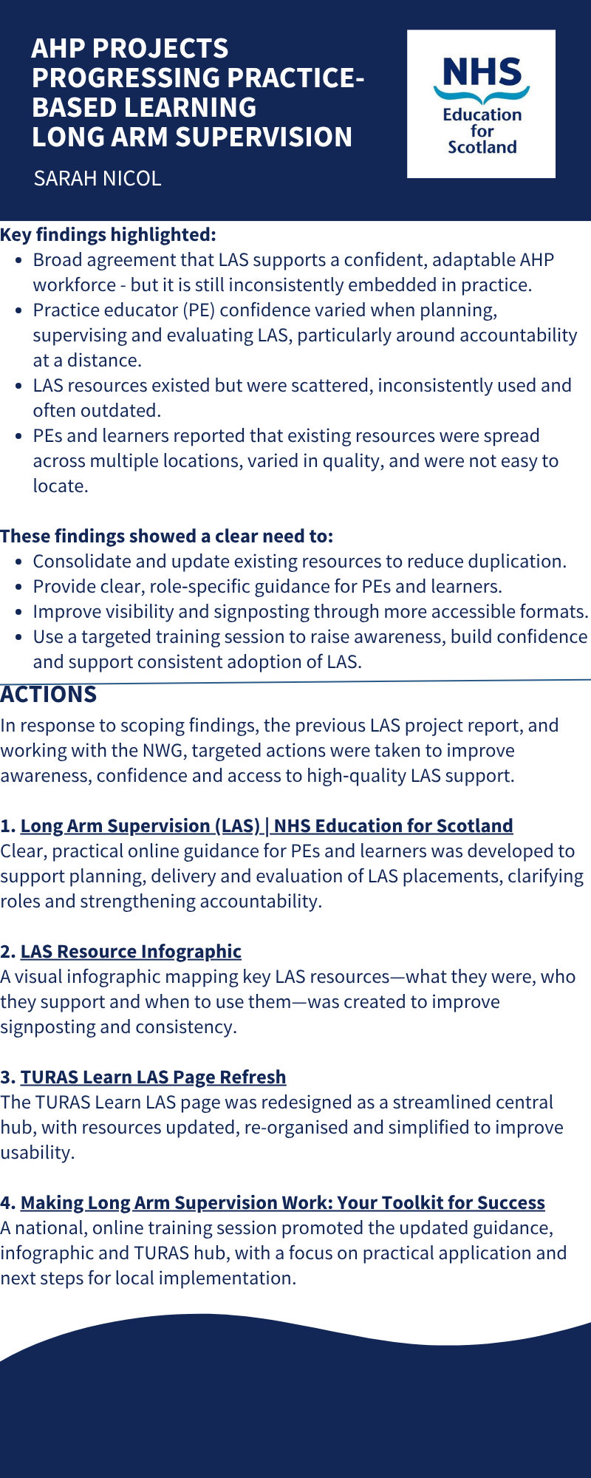
To access a larger version of this infographic with clickable links please click here
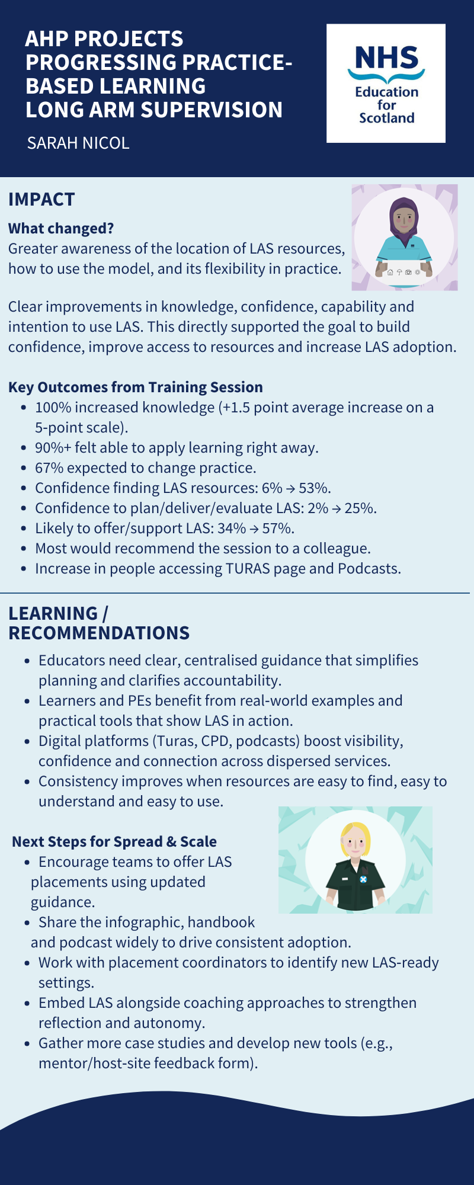
To access a larger version of this infographic with clickable links please click here
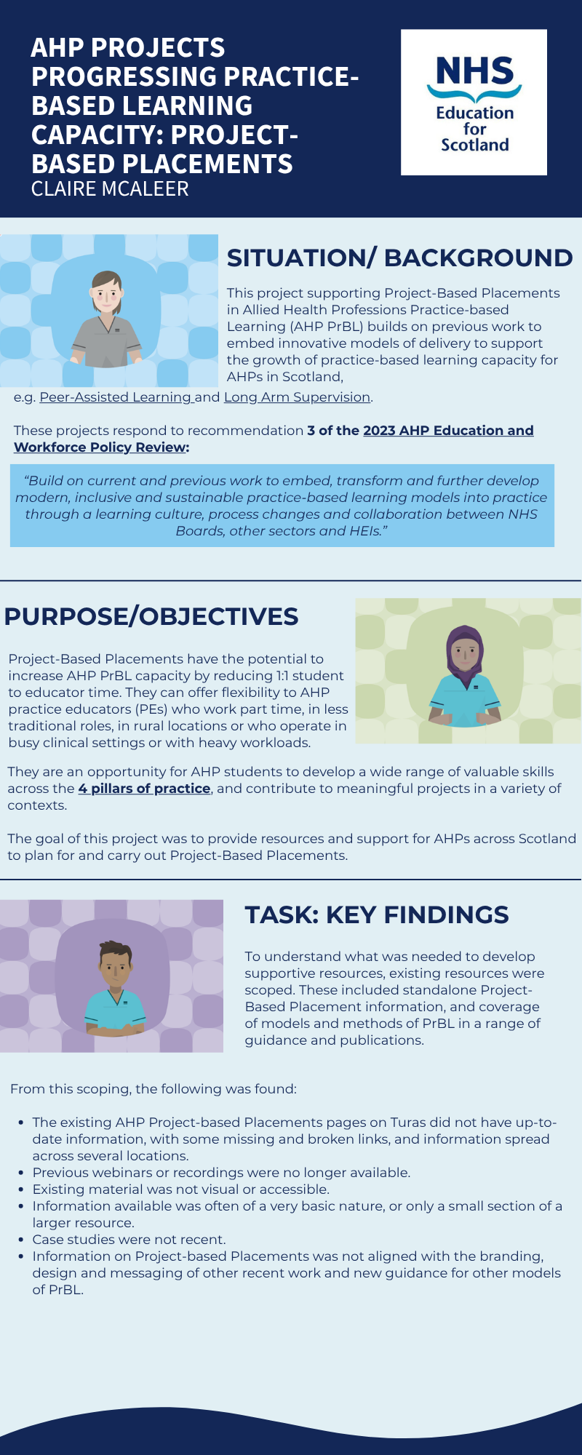
To access a larger version of this infographic with clickable links please click here
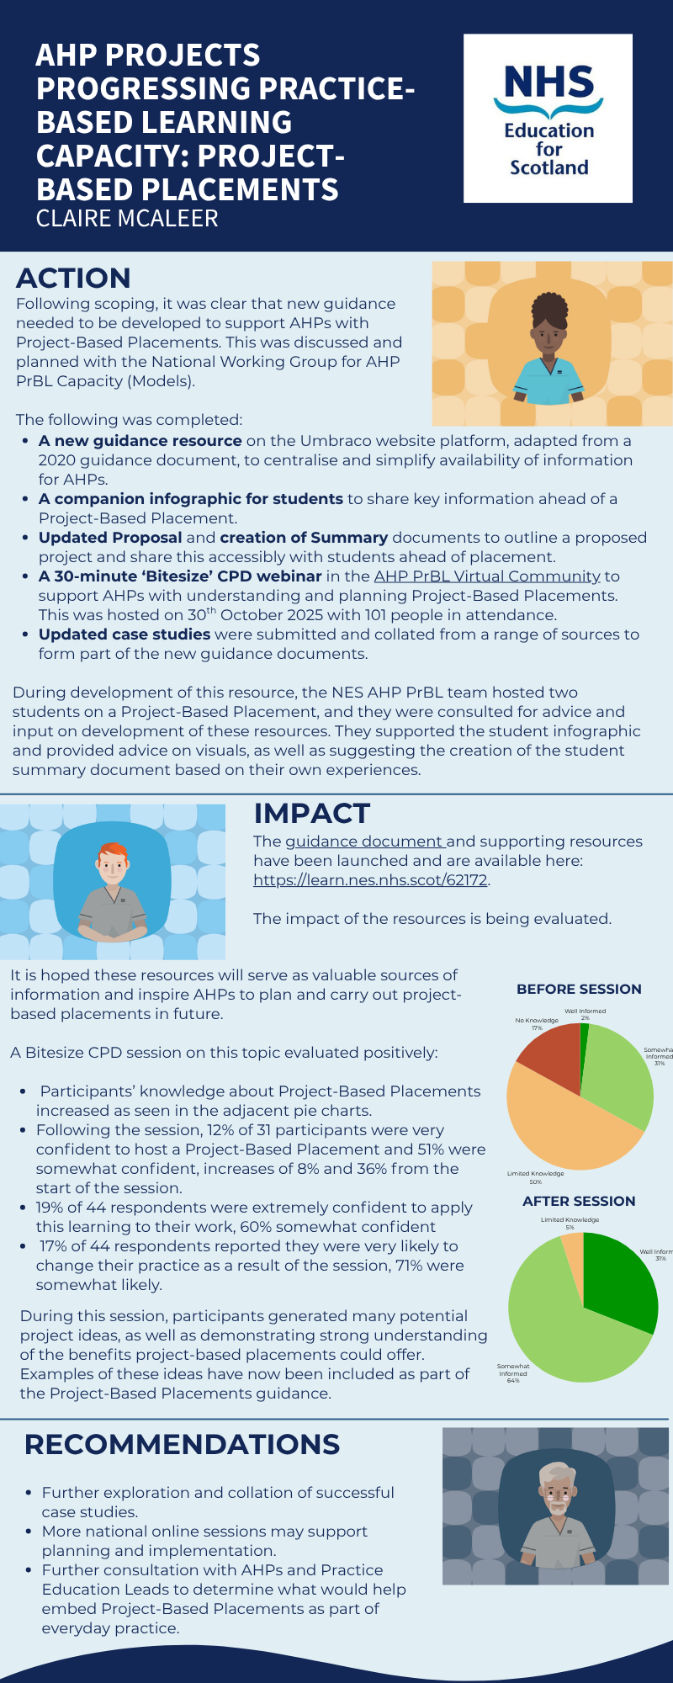
To access a larger version of this infographic with clickable links please click here
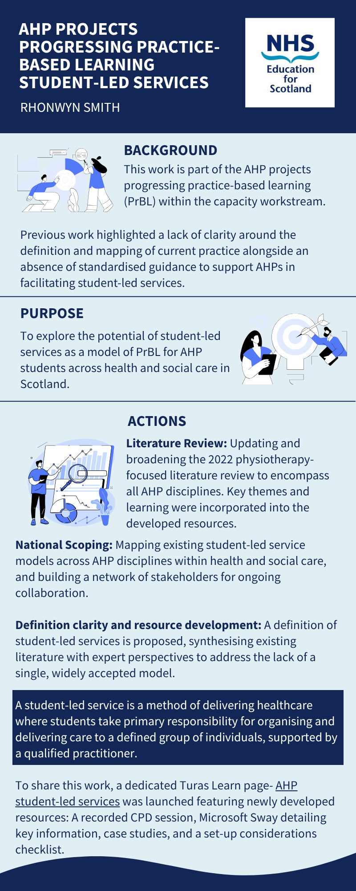
To access a larger version of this infographic with clickable links please click here
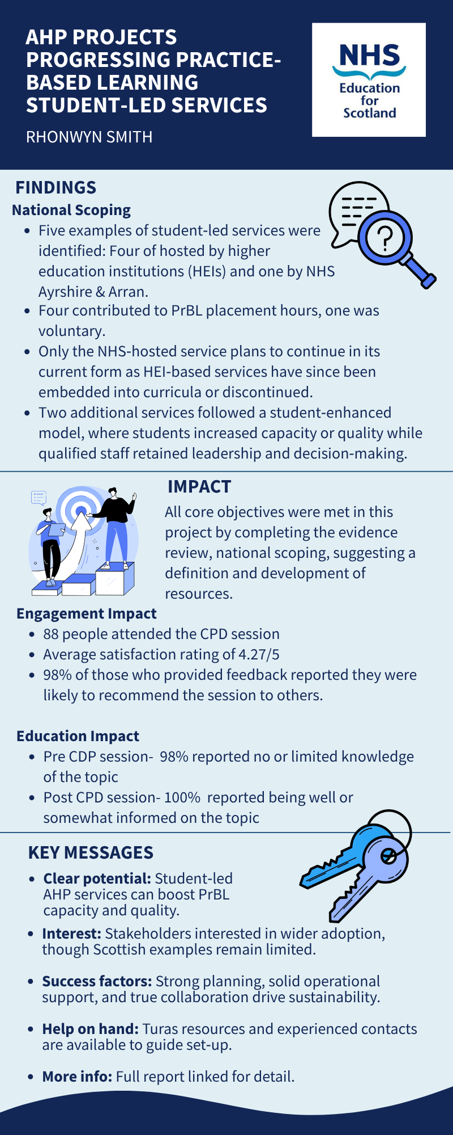
To access a larger version of this infographic with clickable links please click here

Background to project
Purpose
To explore the potential of student-led services as a model of practice-based learning (PrBL) for allied-health professional (AHP) students across health and social care in Scotland.

Context
This work is part of the AHP projects progressing practice-based learning within the capacity workstream and is a direct response to the Scottish Government Allied Health Professions Education and Workforce Policy Review (2023). Specifically, it aligns with Recommendation 5.4.3, which calls for the development of modern and sustainable PrBL models through cross-sector collaboration.

The project is further informed by national guidance and standards, including:
- AHP Principles of Practice-Based Learning (PrBL) 2023
- AHP PrBL Consensus Statements 2018
- Quality Standards for Practice Learning (QSPL) 2020
- HCPC Standards for Education and Training 2017
Previous work- Student Led Clinics in Practice Based Learning (PrBL) - Benefits and Challenges and Increasing Remote & Rural Placements for AHP Students highlighted a lack of clarity regarding the definition and mapping of current practice alongside an absence of standardised guidance to support AHPs in facilitating these models.

Task
Over a six month period, the primary task was to investigate the viability and current landscape of student-led services as a sustainable PrBL model for AHPs in Scotland, and to use this information to develop national resources. Sub-tasks included:
- Literature Review: Updating and broadening the 2022 physiotherapy-focused literature review to encompass all AHP disciplines via the NHS Knowledge Network.
- National Scoping: Mapping existing student-led service models across AHP disciplines across health and social care, and building a network of stakeholders for ongoing collaboration.

- Definition Clarity and Resource Development: Establishing a definition and producing practical resources to address the current gaps in support for implementing student-led services.

Actions
- Literature Review
In partnership with the NHS Knowledge Network, the literature search was updated and expanded in November 2025. Studies were included based on AHP relevance, comparable healthcare system, date and type of study. Findings were themed to identify AHP-specific characteristics, benefits, challenges, and potential enablers to inform the development of national guidance.

- National Scoping
Outreach was targeted towards key groups, including AHP Practice Education Leads (PELs) across NHS Boards, the AHP Practice-based learning stakeholder group and the National Working Group for Models of PrBL. A snowball approach helped identify further stakeholders and experts. All interactions, including specific PrBL models and expressions of interest, were documented to create a record of national expertise and case studies.

- Definition Clarity and Resource Development
A national definition of student-led services is proposed, synthesising existing literature with expert perspectives to address the lack of a single, widely accepted model.

A student-led service is a method of delivering healthcare where students take primary responsibility for organising and delivering care to a defined group of individuals, supported by a qualified practitioner.

To share this work, a dedicated Turas Learn - AHP student-led services page was launched featuring newly developed resources :
- Recording of the bite-sized CPD session delivered to the AHP PrBL virtual community.
- A Microsoft Sway detailing key information about the model and case study examples
- A set-up considerations checklist.

Findings

Literature Review
After removing duplicates from the various databases, 326 references were identified and then screened by title and abstract. Screening by title and abstract, and in some cases full-text found forty-six references that were relevant to the goals of the review.

Key characteristics of the included studies:

Figure 1: Literature review study design Figure 2: Literature review AHP professions

Figure 3: Literature review supervision models Figure 4: Literature review host providers
A wide range of service populations and service delivery methods were represented across the included studies, demonstrating the versatility of this model in meeting diverse needs. The review also highlighted important findings related to definitions, benefits, challenges, and proposed solutions, all of which informed the development of the proposed definition and accompanying resources.

National Scoping

Between October 2025 and February 2026, nineteen individual or small-group scoping meetings were conducted to gather insight into current practice and gauge interest in future development of student-led services. These meetings involved representatives from a wide range of AHP roles, including four profession-specific areas.

Student-Led Service Examples
Five examples of student-led services were identified:
- Glasgow Caledonian University Physiotherapy: Otago exercise group
- NHS Ayrshire and Arran Speech and Language Therapy: Parkinson’s voice groups
- Robert Gordon University Physiotherapy: PECAP- Peer exercise and community activity placement
- University of Strathclyde Speech and Language Therapy: Parkinson’s voice group and intensive comprehensive aphasia programme groups
Of the five examples:
- Four had been used to deliver Practice-based Learning (PrBL) placement hours.
- One was a voluntary opportunity aimed at enhancing students’ practice but did not contribute to formal placement hours.
- Only the NHS-hosted service has plans to continue operating in this format.
- HEI-based services have since been embedded into curricula or discontinued.

Placement capacity was a key driver for establishing these services, hence subsequent improvements in capacity led to the discontinuation or transformation of all of the HEI-hosted models.

Lessons learned from these case studies directly informed the development of the Sway resource. Key themes included challenges relating to safety, service continuity, student and service user expectations, administration, referral and recruitment, and the time commitment required for planning and delivery.

Student-Enhanced Models
In addition to the student-led examples, two services were identified that align more closely with what could be describes as a student-enhanced model. In these models, student involvement increased capacity or quality of care, while overall leadership and decision-making remain with qualified staff.
- NHS Greater Glasgow & Clyde Podiatry: Peer-assisted learning clinics where educator-to-student ratios of up to 1:4 can support increased clinic capacity at times.
- NHS Greater Glasgow & Clyde Speech & Language Therapy: Students support delivery of intensive comprehensive aphasia programmes. Here, pairs of students work alongside qualified staff and support workers to provide a service that would otherwise not be available.
These were identified as sustainable approaches to delivering PrBL and provide a potential scaffold for progressing toward true student-led models.

Impact
This project successfully met the core objectives by completing an evidence review, mapping current practice and identifying potential partners for future national development. A definition of student-led services has been proposed, addressing a longstanding gap in shared understanding across AHP professions.

Given the six-month timeline, the achievable outcomes of this project were intentionally focused on Levels 1 and 2 of the Kirkpatrick Framework, assessing engagement and learning.

Level 1: Engagement impact
Engagement with the bite-sized CPD session indicates a strong level of interest and relevance across the AHP practice-based learning community. Key measures include:

- A total of eighty-eight people attended the CPD session
- The average satisfaction rating was 4.27/5
- 98% of individuals who provided feedback on the CPD session reported they were either very likley or somewhat likely to recommend the session to others

In future, further engagement impact can be measured by analytics from the turas learn student-led services page.

Level 2: Educational Impact
The educational impact highlights the value of learning opportunties provided.
The CPD session produced positive evidence of learning, with self-reported increases in knowledge and confidence:

- Level of knowledge of the topic
Pre CPD session- 98% of the 27 respondents reported no or limited knowledge |   Post CPD session- 100% of the 27 respondents reported being well informed or somewhat informed

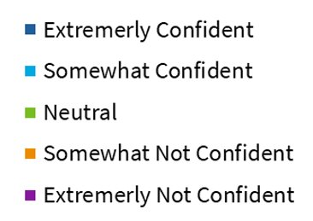
- In-session polls mapped to learning objectives, demonstrated measurable gains in confidence in defining a student-led service.
Figure 5: CPD confidence in defining SLS

Learning

Over this six month project, findings indicate that AHP student-led services have clear potential to enhance both the capacity and quality of PrBL opportunities in Scotland. Stakeholder engagement through national scoping and the CPD event showed enthusiasm for broader adoption of this model. However, current examples within Scotland remain limited. The work shows an appetite for innovation, despite the variability in service sustainability caused by changing pressures.

Compared to more established PrBL models, student-led services require greater upfront planning, governance assurance, and coordinated operational support. However, findings from the project demonstrates that when these elements are in place, co-created models can deliver meaningful educational and service benefits. Bringing together students, practitioners, service leaders, higher education institutions, and individuals receiving care in the planning was found to be particularly effective in developing sustainable models.

Those interested in exploring the implementation of student-led services may wish to review the new resources- the SWAY resource and set-up consideration check list- available on the AHP student-led services Turas page. They can also draw on the experience of people who have worked with this model in practice. Identified contacts with expertise include:
- Dr David Hegarty, Senior Lecturer in Physiotherapy, Glasgow Caledonian University. david.hegarty@gcu.ac.uk
- Dr Donna Wynne, Associate Dean for the School of Health, Robert Gordon University. d.wynne@rgu.ac.uk
- Julie Mathers, Principal Lecturer for Interprofessional Learning (IPL), AHP Practice-based Learning (PrBL), and Simulation at Robert Gordon University. j.mathers5@rgu.ac.uk

This resource may be made available, in full or summary form, in alternative formats and community languages. Please contact us on 0131 656 3200 or email altformats@nhs.scot to discuss how we can best meet your requirements.
© NHS Education for Scotland 2026. You can copy or reproduce the information in this resource for use within NHSScotland and for non-commercial educational purposes. Use of this document for commercial purposes is permitted only with the written permission of NES.



