
AHP Projects Progressing PrBL:
PrBL Capacity (Models) – Long Arm Supervision

Sarah Nicol, 2025

Situation /Background to project
The Long Arm Supervision (LAS) practice-based learning model has been in existence for some time, but its implementation remains inconsistent across the health and social care sectors. Despite its significant potential to support the first three of the 2019 Allied Health Professions (AHP) Practice-based Learning Consensus Statements , the model has not yet been fully integrated into routine practice. As a result, its full benefits have not been realised, and there remains a need for more comprehensive integration into service plans and infrastructure to ensure its effectiveness.
The AHP Practice-based Learning (PrBL) Recovery Workstream (2023) has underscored the necessity for continued work to raise awareness, build knowledge, and enhance confidence surrounding the LAS model. This project is guided by the principles set out in the 2023 AHP Principles of Practice-based Learning, the AHP PrBL Consensus Statements, and the AHP Education and Workforce Review . This initiative also aligns with the AHP Quality Standards for Practice Learning (QSPL), which were highlighted in the 2023 AHP Education and Workforce Review and subsequent PrBL recommendations.
By advancing opportunities for LAS, the project seeks to improve the quality and consistency of PrBL across the AHP sector, ultimately leading to more effective service delivery and enhanced professional development.
Purpose
This project aims to raise awareness of LAS in PrBL for AHPs across all professions, sectors, and settings. It seeks to align with policy frameworks and the consensus statements which highlight the need for diverse, sustainable, and modern approaches to practice education. By increasing awareness of LAS, this project aims to increase use of this model of placement in the future and thus build a highly skilled workforce capable of adapting to diverse clinical environments and working autonomously.

The broader adoption of LAS will also help make placement opportunities more sustainable for busy clinicians. It supports roles that face challenges with traditional placement models, including nonclinical roles, part-time staff, middle management, remote workers, and those in geographically isolated areas. Furthermore, considering LAS placements in future-focused areas for AHPs, where there is a strong link between positive placement experiences and career choices, can further strengthen the workforce.

Objectives
- An increase in practice educators (PEs) from a range of AHP professions and settings expressing interest in learning more about or offering a LAS placement.
- PEs (from diverse AHP professions, settings, and geographical areas) will demonstrate increased awareness, knowledge, and confidence regarding LAS placements, including benefits, preparation, delivery, and evaluation.
- PEs will show engagement with resources supporting LAS placement planning, delivery, and evaluation.

Scope of project and identification of stakeholders
The project aimed to consolidate existing resources and focused on engaging learners, PEs, Higher Education Institutions (HEIs), and National Working Groups (NWGs), raising awareness, and dispelling myths. The initiative prioritsed early adopters and groups interested in exploring this model, while collaborating with AHPs across all professions, sectors, and settings.

Task
The scoping phase focused on reviewing existing resources, including those on the AHP Turas Learn site, engaging with HEIs, PEs, and collaborating with NWGs to assess LAS in practice-based learning.

This revealed limited LAS use, with PEs lacking confidence and understanding of what this model was, how to implement it and where to source resources. AHP students had insufficient access to LAS, and PEs struggled with setting up and evaluating LAS placements. LAS placements were often individual efforts, with inconsistent recognition of its value.

Given LAS’s different position compared to Peer Assisted Learning (PAL), the focus was on raising awareness and building a foundation for future engagement through resources like the Turas Learn page and case study podcasts. The project identified key challenges and laid the groundwork for broader LAS adoption through centralised resources and targeted educational initiatives.

Actions
- Collaboration with NWGs:
Worked with the Models and Capacity National Working Group and LAS experts to address barriers and promote LAS adoption.
- Turas Learn Page Creation:
A dedicated AHP Long Arm Supervision Turas Learn Page was created to consolidate resources and support practice educators.
- Bite-Sized CPD Sessions:
A CPD Event on Long Arm Supervision session was developed to raise awareness of LAS benefits and resources including the podcast series and hosted on the Scottish AHP Practice-based Learning Virtual Community. A recording of this CPD event is available for community members and information about how to become a member is available at AHP PrBL Virtual Community Sway
- Podcast Series Development:
A podcast series called Long Arm Supervision: Shaping Practice-Based Learning was created with interviews from HEIs, NHS Education for Scotland (NES), practice educators, and learners. An interview-based podcast was selected for its ability to provide real-life perspectives from diverse stakeholders. This format fosters engagement through authentic, conversational content, making it accessible for listeners on-the-go. The series was published on both Podbean and Spotify. Interviews help address misconceptions, showcase the flexibility and benefits of LAS, and offer diverse insights on its implementation across different settings. The format supports both in-depth learning and casual exploration, ensuring the content resonates with a wide range of listeners. The podcast aimed to dispel myths, build confidence, and signpost resources. Feedback survey and links to the Turas Learn page were embedded in the podcast description.

Impact
The project has increased awareness, understanding, and engagement with the Long Arm Supervision (LAS) model.
- Cultural Shift in LAS Perception (see Appendices 1 & 2):
The project is shifting LAS perceptions, laying the foundation for broader adoption, with ongoing data collection to inform future efforts. This has been evidenced through ‘free text’ responses from both CPD Bitesize questionnaire and Podcast Survey.
- Bite-Sized CPD Sessions: (see Appendix 1)
Polls showed familiarity with LAS increased from 33% to 88% of respondents, and awareness of resources rose from 25% to 90% of respondents. 96% of respondents expressed interest in learning more, with 96% of respondents reporting that they were satisfied with the session and 80% of attendees reporting increased knowledge because of the session.
- Podcast Engagement:
As of 21st March 2025 there have been 343 podcast downloads between Podbean and Spotify. This demonstrates strong engagement, and feedback indicates that the podcasts are meeting expectations and supporting practice changes. There is equal split of the podcast being accessed via a computer verses a mobile device and mainly listened to during working hours. There is a clear correlation with increased promotion with listening numbers, but people are tending to start with the first episode irrespective of which one has been promoted.
- Educational and Behavioural Impact (see Appendices 1 & 2):
The project increased interest in LAS placements, with polls showing greater awareness. Pre- and post-learning questions showed improved confidence and understanding among educators.
- Resource Accessibility:
Clear guidance on accessing resources led to increased views and engagement, with educators reporting the materials as more relevant. Since the creation of the page in January 2025, 65 users accessed the Turas AHP Long Arm Supervision Page with 153 views.

Summary of Impact:
The project has boosted LAS awareness and engagement, increased educator confidence, and supports greater adoption of LAS placements in the future, setting the stage for continued success.

Learning / Recommendations
This project is beginning to shift the perception of LAS, laying the foundation for future change and greater adoption. Key priorities moving forward include raising awareness, dispelling myths, and providing accurate LAS information. Data collection and impact measurement of the podcast series are ongoing, with insights informing future iterations. Supporting practice educators in adapting LAS to their settings remains central, and streamlining access to resources will empower and support effective implementation. Future recommendations are found below.

Update LAS Guidance and Resources and Embed in Practice:
- Collate and develop LAS resources including a LAS handbook, resources infographic, and continued development of the LAS page on the AHP Turas Learn site.
- Finalise, test and implement an AHP LAS Practice-based Framework to support and embed the LAS supervision model.

Ongoing Collaboration with AHPs to Raise Awareness and Embed LAS as a PrBL Model:
Continue collaborating with AHPs to raise awareness of LAS as an effective PrBL model, integrating it across various practice settings. This can be achieved through:
- Gathering and sharing examples of LAS in practice to inspire adoption in different sectors.
- Promoting the podcast series to further disseminate LAS benefits Long arm supervision: Shaping practice-based learning podcast | NHS Education for Scotland
- Exploring and testing mentorship and coaching opportunities to increase LAS adoption in PrBL placements.
- Building support networks to mentor and share "lived experiences" of practice
educators, fostering ongoing learning and adaptation.
- Further education sessions for PEs highlighting how LAS can be used flexibly and in combination with other PrBL models such as peer assisted learning and project-based PrBL.

By focusing on these actions, LAS will continue to expand as a successful model of PrBL, benefiting practice educators and learners across sectors.

Appendix 1: Bitesize CPD Session Analytics

Over 81% of responses reported an increase in knowledge following the session. This rises to over 95% if those that rated their knowledge as ‘well informed’ at both the start and the end of the session are removed.

Appendix 2 – Podcast Survey Feedback
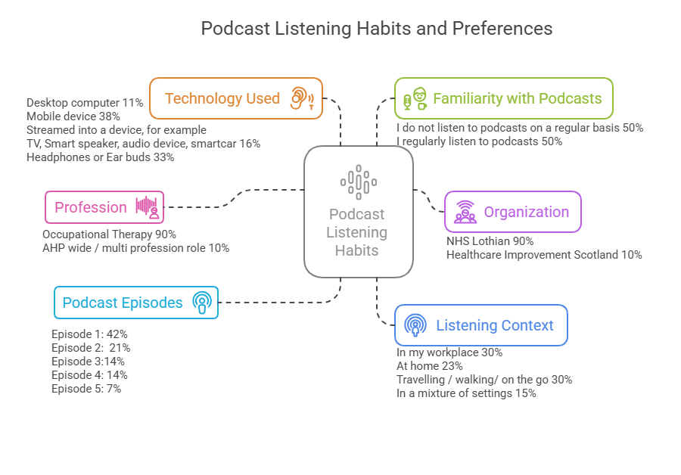

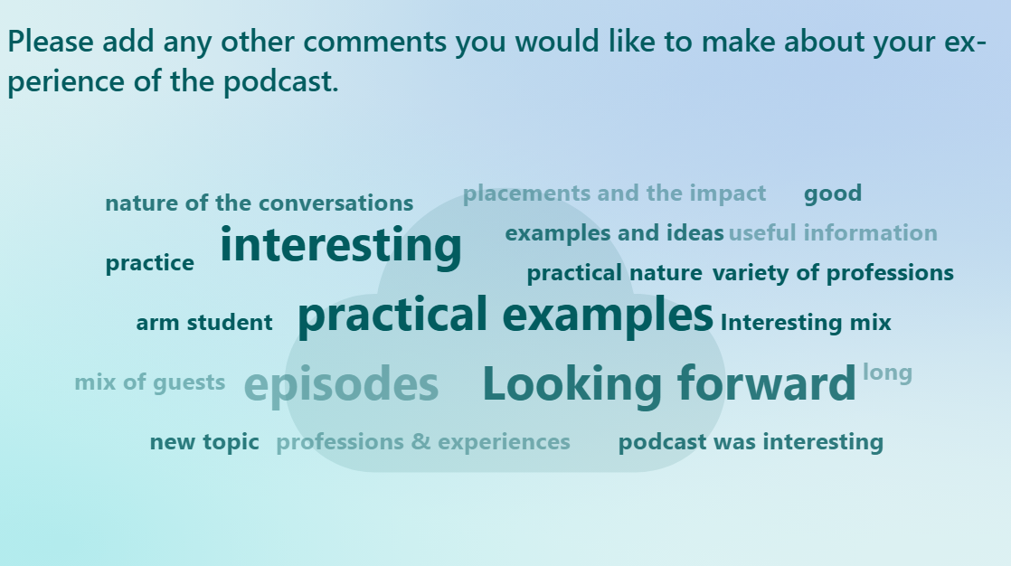

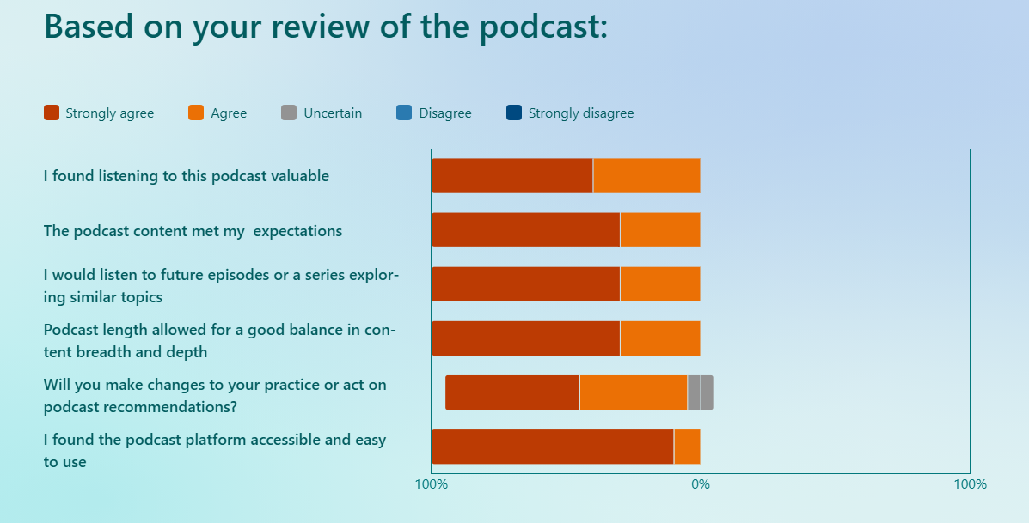

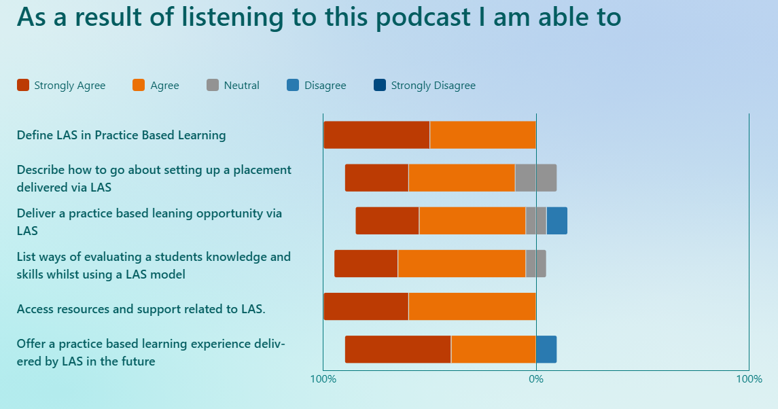

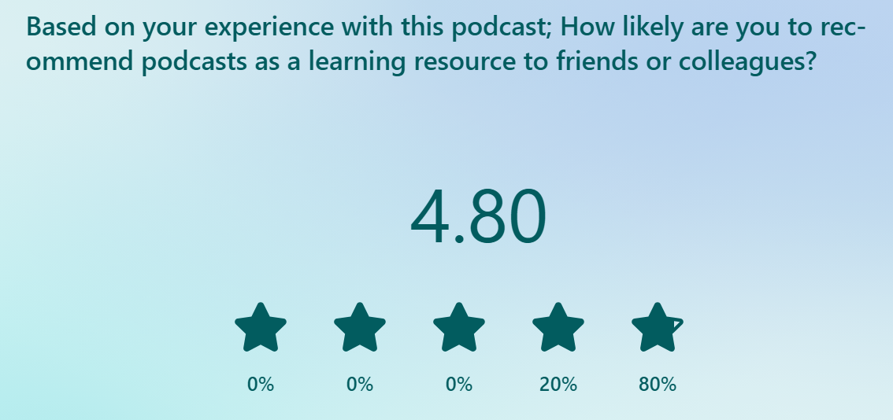


NHS Education for Scotland
Westport 102
West Port
Edinburgh EH3 9DN
tel: 0131 656 3200
www.nes.scot.nhs.uk
© NHS Education for Scotland 2024. You can copy or reproduce the information in this resource for use within NHSScotland and for non-commercial educational purposes. Use of this document for commercial purposes is permitted only with the written permission of NES.

This resource may be made available, in full or summary form, in alternative formats and community languages. Please contact us on 0131 656 3200 or email altformats@nhs.scot to discuss how we can best meet your requirements.

