
Allied Health Professions Projects Progressing Practice-based Learning: Workstream Report 2025

Executive Summary

Aim and Background
Modern, diverse, and sustainable Allied Health Professions (AHP) practice-based learning (PrBL) opportunities are required to meet the needs of the Scottish population now and in the future. The AHP Projects Progressing PrBL are an important part of the NHS Education for Scotland (NES) AHP PrBL workstream. The projects are aligned to the AHP PrBL Consensus Statements, AHP Principles of PrBL, and support the recommendations of the AHP Education and Workforce Policy Review (Scottish Government, 2023), and the AHP PrBL Recovery workstream 2021-23 (NES, 2023).

Scottish Government funding allowed NES to employ 3.6 whole time equivalent AHP Practice Education Leads (PELs) for 12 months to lead eight projects progressing PrBL. Four of these projects had an AHP-wide focus and four projects focused on specific professions (Arts Psychotherapies, Dietetics, Orthoptics, Prosthetics and Orthotics).

This work aims to continue to develop AHP PrBL capability, build AHP PrBL capacity, and embed AHP PrBL quality and governance in Scotland. This is essential to ensure that students, practice educators and service users have high quality and positive learning experiences. Through the development of modern, diverse, and sustainable PrBL opportunities we will continue to support a new generation of AHPs enter the workforce and gaining employment across all sectors in Scotland.

Results
Project scoping identified that protected time, resources and training opportunities, and support from managers and peers, remained key enablers to allow practice educators to develop their knowledge, skills, and confidence in supporting AHP PrBL. A framework/ guidance to support practice education skill progression was also identified as important to aid facilitation of PrBL.

The projects developed a range of PrBL resources, training opportunities, and PrBL networks. Key achievements from the projects are within Table 1 below.

Executive Summary Table 1: Key Workstream Achievements and Impact
Development | Achievements / Outputs | Impact
AHP PrBL resources developed | - AHP Practice Education Development Framework  - AHP PrBL Cancellation Guidance  - Long Arm Supervision Podcast Series  - Peer Assisted Learning Guidance for Practice Educators  - Peer Assisted Learning Guidance for Students  - Involving Service Users in Student Learning Video  - Paediatric Dietetics Learning Programme (Turas sign in required)  - Peer Assisted Learning Case Studies  - Development of local authority Occupational Therapy bespoke branding and blog  - Further development of the AHP PrBL pages on Turas Learn  - Further development of AHP Projects Progressing PrBL pages on Turas Learn  - 8 presentations from the AHP Projects Progressing PrBL Event 13.03.25 available at https://learn.nes.nhs.scot/75218 | Resources developed to share guidance and top tips.  Positive feedback received from stakeholders on the value of resources, and increased awareness of where to find resources has been reported.
AHP PrBL training opportunities | - AHP Practice Education Development Framework Launch event – 472 attendees  - 3 Bitesize CPD Sessions delivered on the AHP PrBL Virtual Community (AHP Practice Education Development Framework, Involving Service Users in PrBL, Long Arm Supervision) – 437 attendees  - Peer Assisted Learning workshops – 62 attendees  - Local Authority Occupational Therapy Engagement events - 24 attendees at in-person event; 43 attendees at online event  - Arts Psychotherapies CPD event – 11 attendees  - 5 Prosthetics and Orthotics Practice Educator sessions – 32 attendees  - Development and testing of a 6-session programme of Orthoptic simulation-based learning – attended by 7 fourth-year students  - Design of a 4-week Peer Enhanced e-Placement (PEEP) programme, blending with the Orthoptic simulation programme for future use | Increased knowledge and confidence reported by attendees.  Provision of an additional 126 hours of clinical practice education, and the opportunity to build on this in the future.
Networks, and support for practice educators | - Further development of the AHP PrBL Virtual Community enabling engagement and support across professions Scotland-wide: AHP PrBL Virtual Community Sway  - Prosthetics and Orthotics PrBL Teams channel developed within the AHP PrBL Virtual Community – 79 members | Members sharing practice and reducing risk of duplication.

A detailed summary of the key focus, impact, and recommendations from each individual AHP project progressing PrBL can be found within Table 2 in the main report and appendices C-J.

Recommendations
To help sustain and develop the significant work that has been done the following recommendations are made:

- Widely share the AHP Projects Progressing PrBL report and resources
- Continue to develop the AHP PrBL Virtual Community
- Disseminate the AHP Practice Education Development Framework, deliver locally tailored learning and support sessions, and develop self-evaluation and staff mapper tools
- Continue to support the utilisation of a range of PrBL models through the sharing of resources, training, and mentoring opportunities
- Continue to develop AHP PrBL opportunities within local authority settings
- Support practice educators to continue to involve service users in student PrBL
- Continue to develop data collection mechanisms to measure and demonstrate impact
- Embed PrBL and PrBL resources in the national AHP PrBL infrastructure

Further detail on these recommendations can be found within the recommendations section of the main report.

Conclusion
We must continue to work flexibly and support PrBL opportunities across all sectors of health and social care to meet the future needs of the Scottish population and ensure our students are well equipped to join the AHP workforce.

Allied Health Professions Projects Progressing Practice-based Learning 2025

Table of Contents

Executive Summary 2
Authors 7
Date of Publication 7
Acknowledgements and contributions 8
Introduction 9
Background 10
Purpose and aims 11
Method 13
Results 15
Workstream Recommendations 22
Conclusion 25
References 26

Appendices 27
Appendix A: AHP Survey Infographic 27
Appendix B: AHP HEI Survey Infographic 29
Appendix C: AHP PrBL Capability Report 31
Appendix D: AHP PrBL Quality and Governance Report 37
Appendix E: AHP PrBL Capacity (Long Arm Supervision) Report 43
Appendix F: AHP PrBL Capacity (Peer Assisted Learning) Report 49
Appendix G: Orthoptics Report 55
Appendix H: Arts Psychotherapies Report 61
Appendix I: Dietetics Report 68
Appendix J: Prosthetics and Orthotics Report 74

Authors
- Ailidh Hunter, Allied Health Professions (AHP) Senior Educator, NHS Education for Scotland (NES)
- Clare Carson, AHP Practice Education Lead, NES
- Claire McAleer, AHP Practice Education Lead, NES
- Jennifer Dick, AHP Practice Education Lead, NHS Greater Glasgow and Clyde
- Jillian Rennie, AHP Practice Education Facilitator, NHS Greater Glasgow and Clyde
- Jo Teece, AHP Practice Education Lead, NES
- Kassandra e’Silva, AHP Practice Education Lead, NES
- Megan Hatcher, AHP Practice Education Lead, NES
- Rachel Tainsh, AHP Practice Education Lead, NES
- Sarah Brown, AHP Practice Education Lead, NES
- Sarah Nicol, AHP Practice Education Lead, NES

Date of publication
January 2026

Acknowledgements and contributions

- Gail Nash, Principal Educator, NES; Helen McFarlane, Programme Director, NES; Gareth Hill and Gillian Macleod, Associate Directors, NES for the opportunity to undertake the projects, and for their guidance and encouragement throughout.
- Joanne Gibson, Karin Massie, Lorna Darrie, Pete Glover, and Laura O’Halloran, Senior Educators in the NES AHP Practice Education Team for their support, direction, and line management.
- The Board AHP Practice Education Leads, colleagues at the Higher Education Institutes (HEIs), the NES Design Team, and the NES Business Support Team for their collaboration, support, and advice.
- Carolyn McDonald, Chief Allied Health Professions Officer, Scottish Government and Anne Wallace, Allied Health Professions Education Advisor, Scottish Government, as funding sponsors of the workstream and for their ongoing support throughout the projects.
- Thank you to the many other stakeholders who have engaged in and contributed to this work from organisations across Scotland.

Introduction

This report provides an overview of the Allied Health Professions (AHP) Projects Progressing Practice-based Learning (PrBL) Workstream 2023-25. The report considers the key learning, outputs, and impact of the workstream initiatives, and sets out recommendations to support the continued development of modern, diverse, and sustainable AHP PrBL in Scotland.

The AHP Projects Progressing PrBL projects are aligned to the AHP PrBL Consensus Statements, AHP Principles of PrBL, and support the recommendations of the AHP Education and Workforce Policy Review (Scottish Government, 2023), and the AHP PrBL Recovery workstream 2021-23 (NES, 2023). The projects are an important component of the NES AHP PrBL workstream, and of the ongoing collaborative work to develop AHP PrBL capability, build PrBL capacity, and embed sustainable AHP PrBL Quality and Governance in Scotland.

The AHP Projects Progressing PrBL Workstream 2023-25 is comprised of eight distinct projects. An individual report for each project can be found within Appendices C-J.

Background

The Health and Care Professions Council (HCPC) highlight that practice-based learning should be integral to higher education institute (HEI) programmes, and used effectively to prepare learners for future practice through “access to an appropriate range of practice-based learning experiences which reflect the nature of modern practice and the range of practice settings of the profession they are preparing to enter” (HCPC, 2017, p.38).

The four AHP PrBL consensus statements agreed by AHP PrBL stakeholders at the 2018 national Growing Capacity event continue to provide direction to meet HCPC standards. The consensus statements can be seen in Figure 1 below and are a focus for ongoing work across Scotland to provide quality, modern, diverse, and sustainable PrBL opportunities for all students in all AHP professions across all sectors of health and social care.
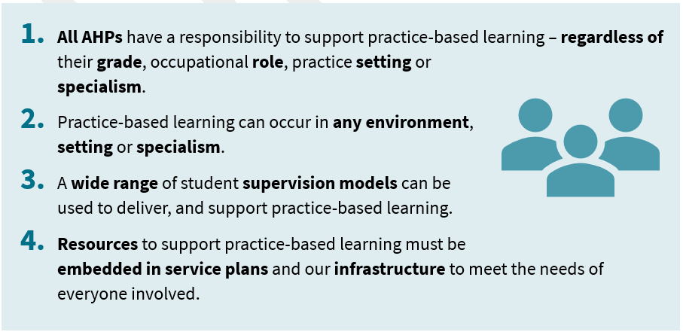
Figure 1: AHP PrBL Consensus Statements (2018)

The AHP Education and Workforce Policy Review (Scottish Government, 2023) analysed the current and future requirements of AHP education in Scotland. The review identified key recommendations (Practice based learning 3, 4 and 5) to enable an AHP workforce that is equipped with the right skills to deliver services that meet the current and future needs of Scotland’s population. The Scottish Government, NHS Education for Scotland (NES), and the Scottish HEIs are working collaboratively with key stakeholders to ensure sustainable national practice education infrastructure to deliver this. This infrastructure supports high quality, diverse AHP PrBL opportunities across Scotland with the best possible experience for students, staff, and service users.

Purpose and Aims

The National Workforce Strategy for Health and Social Care in Scotland (Scottish Government, 2022) supports and enables critical work through the tripartite ambition of recovery, growth and transformation of the health and social care workforce:
- Recover from the COVID-19 pandemic
- Grow the health and social care workforce sustainably in line with Scotland’s population demographics and the demands on our health and social care services
- Transform the ways in which our workforce is trained, equipped and organised to deliver services
The COVID-19 pandemic and the requirement to work differently has served as a springboard for innovation and change in skillset and culture. The AHP PrBL Recovery workstream 2021-23 supported recovery, and AHP PrBL work in Scotland is now focused on growth and transformation.

In order to grow and transform AHP PrBL in Scotland, supporting the delivery of the National Workforce Strategy for Health and Social Care in Scotland (Scottish Government, 2022), and the recommendations of the AHP Education and Workforce Policy Review (Scottish Government, 2023), the Scottish Government funded the 8 AHP Projects Progressing PrBL.

In collaboration with the national NES AHP PrBL workstream the projects aim to:
- Develop AHP PrBL capability and a future AHP workforce in Scotland with the knowledge, skills and behaviours to work across health and social care settings
- Build AHP PrBL capacity sustainably through the utilisation of a range of PrBL models including peer assisted learning and long arm supervision
- Embed AHP PrBL Quality and Governance ensuring that AHP PrBL in Scotland is supported by robust governance arrangements

This work is essential to ensure that students have a high quality and positive learning experience, and that we continue to have a new generation of AHP graduates fit to practice and to gain employment across all sectors in Scotland.

The AHP Projects Progressing PrBL were undertaken over 12 months from April 2024 to March 2025 inclusive, and were led by 3.6 whole time equivalent (WTE) practice education leads (PELs) within NES. A 0.4 WTE senior educator ensured coordination of the posts and workstream, and support and supervision of the PELs was shared by the NES AHP Practice Education team. Four of the projects were AHP-wide, and four projects had a focus on specific professions (Arts Psychotherapies, Dietetics, Orthoptics, and Prosthetics and Orthotics). Individual project reports can be found in Appendices C-J.

Method

PEL Induction, Development, and Reporting
The NES AHP PELs undertook a period of induction to orientate them to their roles and the AHP PrBL landscape. In addition to local NES induction and mandatory training, this included reviewing information from the AHP PrBL Recovery workstream 2021-23 (NES, 2023), different models and methods of PrBL delivery, and AHP PrBL governance documents including the Quality Standards for Practice Learning (NES, 2021).

As part of the induction process, each PEL undertook a personal learning needs analysis to identify opportunities for development and further training which was discussed at support and supervision sessions and captured within the Turas Appraisal process. The NES AHP PELs undertook training in project management, and impact assessment and measurement. Monthly progress meetings and the use of project management tools including a project charter, project plan, communication strategy, and risk register, supported implementation.

The AHP PELs completed quarterly project updates, and utilised a ‘red, amber, green’ scale to measure progress on project deliverables. The Goals, Roles, Process, Interpersonal (GRPI) Model of Team Effectiveness (Beckhard 1972) was completed monthly to review key factors, how the team worked together, identify areas for improvement and monitored the project progress and outputs.

Identification of Stakeholders and Communication Strategy
Additional scoping was undertaken, which built on the previous work identified by key stakeholders and supported the projects. Key stakeholders included, but was not limited to Practice Education Coordinators, Practice Educators and the AHP workforce across a range of sectors and settings; Board AHP PELs, the AHP Professional Bodies, AHP Directors, students, and colleagues from the HEIs, national and Board PrBL groups, and the Scottish Government.
The workstream communication strategy developed encompassed monthly updates shared on the AHP Projects Progressing PrBL Updates page on the Turas Learn site, and via the Scottish AHP PrBL Virtual Community. A range of media including infographics, and video were utilised. A quarterly workstream brief highlighting key messages was widely disseminated through the virtual community, Turas page, by email, and within AHP Practice Education quarterly newsletters. Each of the individual projects also had their own communication strategy.

Data Collection
An AHP Survey on Student Practice Education 2024 was circulated to practitioners, service leads, and managers in June 2024 and received 824 responses. Protected time, support from managers and colleagues, and access to resources and training were identified as key enablers for AHP PrBL, in keeping with results from the AHP Survey on Student Practice Education 2022 developed and shared as part of the AHP PrBL Recovery workstream 2021-23 (NES, 2023). It was reported in the 2024 survey that a framework/ guidance to support practice education skill progresssion would also aid facilitation of PrBL. The 2024 survey explored the use of PrBL models in more detail and identified that utilisation of PrBL models varied amongst respondents. Further training, guidance documents, and case studies were identified as key resources that would support the use of PrBL models in the future.

There were 19 responses from AHP HEI colleagues received in response to the separate HEI survey shared in June 2024. Enablers to facilitating PrBL were in keeping with responses from the AHP Survey on Student Practice Education, 2024. Increased knowledge and understanding of different models of placement delivery, and profession-specific practice educator training from the HEIs were also identified as key PrBL enablers alongside interprofessional learning. HEI colleagues reported utilising a range of PrBL models. Additional time and funding, raising awareness and understanding of models, and case study examples were identified as key resources / actions that would support the use of PrBL models in the future.

A summary of findings from the surveys is displayed in Appendices A and B.

A range of other scoping mechanisms were utilised by the AHP PELs including but not limited to individual discussions, focus groups, and stakeholder events. Findings from the surveys and other scoping mechanisms guided development of action plans and recommendations moving forwards.

Results

By 31st March 2025 new resources, and PrBL opportunities were created to support and develop PrBL in a modern, diverse, and sustainable way. Examples of key achievements are in Tables 1 and 2 below, and within the individual project reports in Appendices C-J.

Table 1: Key Workstream Achievements / Outputs
Development | Achievements / Outputs
AHP PrBL resources developed | - AHP Practice Education Development Framework  - AHP PrBL Cancellation Guidance  - Long Arm Supervision Podcast Series  - Peer Assisted Learning Guidance for Practice Educators  - Peer Assisted Learning Guidance for Students  - Involving Service Users in Student Learning Video  - Paediatric Dietetics Learning Programme (Turas sign in required)  - Peer Assisted Learning Case Studies  - Development of local authority OT bespoke branding + blog  - Further development of the AHP PrBL pages on Turas Learn  - Further development of AHP Projects Progressing PrBL pages on Turas Learn  - 8 presentations from the AHP Projects Progressing PrBL Event 13.03.25 available at https://learn.nes.nhs.scot/75218
New AHP PrBL training opportunities | - AHP Practice Education Development Framework Launch event – 472 attendees  - 3 Bitesize CPD Sessions delivered on the AHP PrBL Virtual Community (AHP Practice Education Development Framework, Involving Service Users in PrBL, Long Arm Supervision) – 437 attendees  - Peer Assisted Learning workshops – 62 attendees  - Local Authority Occupational Therapy Engagement events – 24 attendees at in person event, and 43 attendees at online event  - Arts Psychotherapies CPD event – 11 attendees  - 5 Prosthetics and Orthotics Practice Educator Sessions – 32 attendees  - Development and testing of a 6-session programme of Orthoptic simulation-based learning – attended by 7 fourth-year students  - Design of a 4-week Peer Enhanced e-Placement (PEEP) programme, blending with the orthoptic simulation programme for future use
Networks, and support for practice educators | - Development of the AHP PrBL Virtual Community enabling engagement and support across professions Scotland-wide: AHP PrBL Virtual Community Sway  - Prosthetics and Orthotics PrBL Teams channel developed within the AHP PrBL Virtual Community – 79 members

A summary of impact can be found below, and for each individual project in Appendices C-J.

Engagement Impact

- The AHP PrBL Virtual Community has been promoted as part of the PrBL projects and wider AHP PrBL workstream. Over 850 new members have joined the AHP PrBL Virtual Community since 1st April 2024 (the community now has 1313 members in total). The community promotes the sharing of practice and aims to reduce duplication.
- 472 attended the launch event of the AHP Practice Education Development Framework in November 2024, and 132 attended the AHP Projects Progressing PrBL Celebration and Sharing Event in March 2025.

Educational Impact
- Increased knowledge, awareness, and confidence documented within polls and within evaluation of training opportunities and resources.
- Following the AHP Practice Education Development Framework launch event in November 2024, 95% of respondents reported they felt confident or extremely confident describing their role in AHP Practice Education.
- At the AHP Projects Progressing PrBL event in March 2025, 100% of evaluation respondents reported an increase in knowledge as a result of attending the event and 84% reported they felt well informed.
- Positive feedback received from stakeholders on the value of resources, and increased awareness of where to find resources has been reported.
- Statements of intent / pledges from stakeholders to utilise different models and methods of delivery.

Performance Impact
- New PrBL opportunities created through utilisation of different models and methods of delivery.
- Provision of an additional 126 hours of clinical practice education through the orthoptic simulation programme, and the opportunity to build on this in the future.
- Positive practice educator and student testimonials as shared in the individual project reports (Appendices C-J).

Table 2: Summary of key focus, impact, and recommendations from the individual AHP Projects Progressing PrBL
Project | Key Focus | Key Impact / Successes | Recommendations
AHP PrBL Capability | Support the growth of AHP PrBL capacity and capability by clarifying practice education roles and responsibilities for all AHP staff and challenging perceived barriers | Development and launch of the AHP Practice Education Development Framework describing the knowledge, skills, behaviours and recommended learning across 4 levels of practice education experience | - Ongoing promotion and dissemination of the framework  - Locally-tailored learning and support sessions to implement framework, with the aim of the majority of NHS Health Boards to be reached by March 2026  - Development of self-evaluation and staff mapper tools along with evaluation surveys
AHP PrBL Quality and Governance | Enhance the learning environment through strong governance and processes that support sustainability and growth | - Local authority OT PrBL engagement and collaboration  - Development of local authority OT bespoke branding and blog  - Delivery of Bitesize CPD session on involving service users in PrBL and development of video  - Refreshed national guidance for Managing AHP Student Cancellations | - Local authority OT involvement in strategic groups, creation of reference group, and spotlight training  - The theme of involving service users will be included on the Turas AHP pages with links to tools and useful resources  - Ongoing work should explore what else could build practice educator skills and confidence to involve service users in their day-to-day practice and PrBL  - Promotion and use of national guidance for Managing AHP Student Cancellations

Project | Key Focus | Key Impact / Successes | Recommendations
AHP PrBL Capacity: Long Arm Supervision (LAS) | - Increase practice educator awareness of and interest in offering LAS  - Increase practice educator knowledge and confidence regarding LAS placements including benefits, preparation, delivery, and evaluation | - Delivery of LAS Bitesize CPD session  - Development of AHP Long Arm Supervision Turas Learn Page  - Development of Long Arm Supervision Podcast Series | - Ongoing collaboration with AHPs to raise awareness of and embed LAS  - Explore mentorship opportunities  - Develop LAS handbook, infographic, and further develop LAS Turas page  - Review and consider existing resources, including AHP LAS Practice-based Framework, to support and embed the LAS model. Update or remove resources as required
AHP PrBL Capacity: Peer Assisted Learning (PAL) | - Support implementation of PAL through the update and delivery of the PAL digital education package  - Promote and increase accessibility of PAL guidance documents and resources | - Three national PAL interactive workshops delivered  - Development and launch of new PAL Guidance for AHP Practice Educators and new PAL Guidance for AHP Students  - Seven new PAL case studies developed | - Continue national PAL training and introduce six-month follow-up  - Promote, review, and evaluate new PAL guidance and supporting resources  - Embed case studies in PAL resources, and continue to gather and share examples and learning

Project | Key Focus | Key Impact / Successes | Recommendations
Orthoptics | - Increase orthoptic PrBL capacity in Scotland through the implementation and spread of different models of placement delivery  - Demonstrate the impact of different models of PrBL on orthoptic students PrBL | - Development and delivery of a 6-session programme of simulation-based learning, providing an additional 126 hours of clinical education  - Design of a 4-week Peer Enhanced e-Placement (PEEP) programme which can incorporate simulation-based learning events as required | - Embed simulation-based learning into orthoptic undergraduate education in Scotland as a bridge between academic and PrBL  - To be responsive to placement capacity challenges in the future, Glasgow Caledonian University (GCU) to develop their simulation-based orthoptic educator resource and NHS Boards to work collaboratively with GCU
Arts Psychotherapies | - Increase placement opportunities for arts psychotherapies learners  - Develop a growing network of practice educators in NHS boards who are ready to take on learners by September 2025  - Complete the Quality Standards for Practice Learning (QSPL) Section 3 audit | - Growth of the Arts Psychotherapies PrBL network within NHS boards  - Links made with new placement providers – 3 new placements delivered in 2024/25 and 2 pledges for 2025/26  - QSPL Section 3 audit completed, and action plan agreed  - Delivery of CPD event for arts psychotherapists | - Maintain and develop networks of arts psychotherapists in NHS Boards  - Progress QSPL Section 3 action plan  - Continue to explore opportunities for new arts psychotherapies PrBL opportunities utilising different PrBL models
Project | Key Focus | Key Impact / Successes |  | Recommendations
Dietetics | - Increase capacity through implementation of PAL and delivery of cross / third sector placements  - Develop digital paediatric resource | - Dietetic membership of the AHP PrBL Virtual Community increased by 318% between April 2024 and March 2025  - A dietetic cross-sector PrBL experience featured in the long arm supervision podcast series  - Dietetics Today PrBL Article published  - The digital module Paediatric Dietetics was co-produced, tested and launched in February 2025 |  | - Promote the AHP Virtual PrBl community, and engage Scottish members in British Dietetic Association UK-wide resources  - Embed the Paediatric Dietetics digital module within common assessment tools and expand to further areas of Dietetic PrBL  - Innovate and diversify placements in Dietetic PrBL including the use of PAL
Prosthetics and Orthotics | - Increase PrBL opportunities in Scotland  - Increase variety of models of PrBL delivery and support use of PrBL models  - Provide opportunities for development and collaboration of practice educators | - 72 new placement weeks created implementing PAL placements for the first time  - Two new Orthotic offers of PrBL made for future academic cycles (total of 36 placement weeks)  - New Orthotic practice educator and student videos were created demonstrating use of PAL  - New P+O channel on the AHP PrBL virtual community created  - Five PrBL CPD sessions delivered to P+O staff |  | - Continue to encourage engagement with the AHP PrBL Virtual Community and P&O channel  - Promotion of a diverse and modern range of PrBL models. PAL should be prioritised to sustain the momentum of the uptake  - New and existing PrBL offers to be followed through and sustained to optimise Scottish PrBL

Workstream Recommendations

To help sustain and develop the significant work that has been done the following recommendations are made. The allocated timeframes to each recommendation reflect time, financial and resource constraints. These are outlined below:
• Short – as soon as practicably possible and within 1 year
• Medium – 1 to 3 years
• Long – 3 years plus

Table 3: AHP Projects Progressing PrBL Recommendations
No. | Recommendation | Focus / Rationale | Lead Agency / Agencies | Indicative Timeframe
1 | Widely share the AHP Projects Progressing PrBL report and resources | - Focus: Promotion of these materials and the delivery of bitesize interactive session(s)  - Rationale: Widen access to reduce duplication, share, and develop learning across all Allied Health Professions and throughout Scotland | - The NES AHP Practice Education Team  - PEL networks  - The AHP PrBL Operational Collaboration (APOC) | Short
2 | Continue to develop the AHP PrBL Virtual Community | - Focus: Increase and broaden membership, expand the functions and resources available. All members encouraged to share and showcase resources and examples of good practice, offer support and networking opportunities  - Rationale: To create a one-stop shop to support all involved in AHP PrBL increasing collaboration | - NES AHP Practice Education Team  - AHP PrBL Virtual Community Core Development Group | Short
3 | Disseminate the AHP Practice Education Development Framework, deliver locally tailored learning and support sessions, and develop self-evaluation and staff mapper tools | - Focus: To support the growth of AHP PrBL capacity and capability by clarifying practice education roles and responsibilities for all AHP staff  - Rationale: To support practice educator development utilising clear guidance on the knowledge, skills, behaviours and recommended learning across 4 levels of practice education experience | - NES AHP Practice Education Team  - PEL Networks | Short/Medium
4 | Continue to support the utilisation of a range of PrBL models through the sharing of resources, training, and mentoring opportunities | - Focus: To promote and support the use of a range of PrBL models/methods of delivery and emerging learning needs in a range of settings  - Rationale: To support practice educators and other key stakeholders to offer modern, diverse, and sustainable PrBL opportunities that will develop the future workforce | - NES AHP Practice Education Team  - HEIs  - AHP PrBL Models / Capacity National Working Group | Medium
5 | Continue to develop AHP PrBL opportunities within local authority settings | - Focus: To develop mechanisms for collaboration including local authority OT involvement in strategic groups, creation of a reference group, and spotlight training  - Rationale: To broaden PrBL opportunities and  promote the valuable contribution these settings and AHP roles can offer | - NES AHP Practice Education Team  - Local Authority OT colleagues  - HEIs | Medium
6 | Support practice educators to involve service users in student PrBL | - Focus: To build practice educator skill and confidence to involve service users in their day-to-day practice and PrBL | - NES AHP Practice Education Team | Medium
7 | Continue to develop data collection mechanisms to measure and demonstrate impact | - Focus: To agree and develop data sets and a quality management system that meets AHP requirements  - Rationale: Robust data, reporting mechanisms that are fit-for-purpose, and undertaking regular evaluation processes to measure progress and utilise opportunities for continuous development | - NES AHP Practice Education Team  - NES Nursery Midwifery and AHP Directorate | Medium / Long
8 | Embed PrBL and PrBL resources in the national AHP PrBL infrastructure | - Focus: To increase access to and engagement with PrBL and PrBL resources across all Allied Health Professions and throughout Scotland.  - Rationale: To support PEs and other key stakeholders to offer modern, diverse, and sustainable PrBL opportunities that will develop the future workforce | - NES AHP Practice Education Team | Long

Conclusion

Opportunities to collaborate and share learning both nationally and locally are crucial in order to continue development of modern, diverse, and sustainable AHP PrBL in Scotland. The AHP PrBL Virtual Community has connected people across Scotland and allows opportunity to network, problem solve, and access PrBL resources and updates in a timely manner.

The importance of practice education development and team working locally is also highlighted within the AHP Practice Education Development Framework. The framework emphasises the importance of a team approach to PrBL, where everyone can add value, and resources and training opportunities are identified to meet learning needs.

In order to meet the future needs of the Scottish population and ensure our students are well equipped to join the AHP workforce it is clear we must work flexibly, support practice educators to involve service users in student PrBL and consider PrBL opportunities across all sectors of health and social care. As AHPs are not already employed in all of these settings, long arm supervision is required and there is also a benefit of peer assisted learning in these role emergent areas of practice. In a range of settings available resources and training opportunities support the utilisation of a number of PrBL models including peer assisted learning, long arm supervision, and simulation which we will continue to build on.

There is a need to embed PrBL and PrBL resources in the national AHP PrBL infrastructure to support AHPs across Scotland to continue to innovate, meet service user needs, and develop PrBL now and in the future.

References

Beckhard, R. (1972). ‘Optimizing Team Building Effort’, Journal of Contemporary Business, 1(3), 23–32.

Chartered Society of Physiotherapy and Royal College of Occupational Therapists (2023) AHP Principles of Practice-based Learning: working together to develop our future workforce. London: Chartered Society of Physiotherapy. Available at: https://learn.nes.nhs.scot/72890 (Accessed 31 March 2025).

Health and Care Professions Council (2017) Standards of Education and Training Guidance (Amended 2025). London: Health and Care Professions Council. Available at Standards of education and training | (hcpc-uk.org) (Accessed 31 March 2025).

NHS Education for Scotland (2021) Quality Standards for Practice Learning.Edinburgh: NHS Education for Scotland. Available at https://www.nes.scot.nhs.uk/media/s1mflta2/quality_standards_for_practice_learning_qspl.pdf (Accessed 1 April 2025).

NHS Education for Scotland (2023) AHP PrBL Workstream Report. Edinburgh: NHS Education for Scotland. Available at https://www.nes.scot.nhs.uk/media/brib2bvz/ahp_prbl_recovery_workstream_report_2023.pdf (Accessed 24 March 2025).

The Scottish Government (2022) The National Workforce Strategy for Health and Social Care in Scotland. Available at https://www.gov.scot/publications/national-workforce-strategy-health-social-care/ (Accessed 18 February 2025).

The Scottish Government (2023) AHP Education and Workforce Policy Review. Available at Allied Health Professions Education and Workforce Policy Review Recommendations (Accessed 18 February 2025).

Appendix A: AHP Survey Infographic
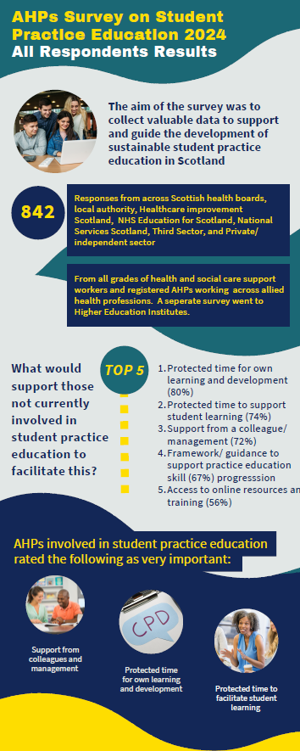
Appendix A Figure 1
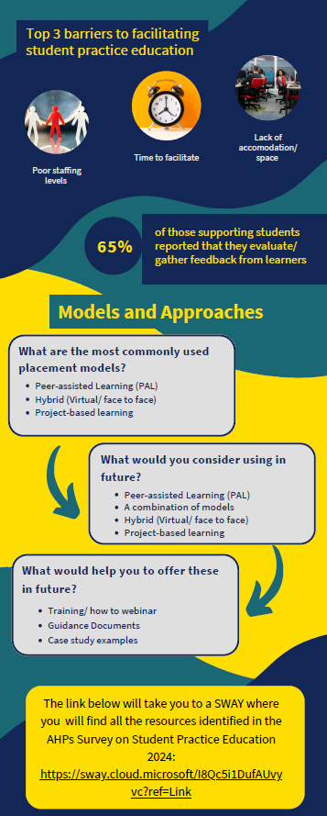
Appendix A Figure 2
Appendix B: AHP HEI Survey Infographic
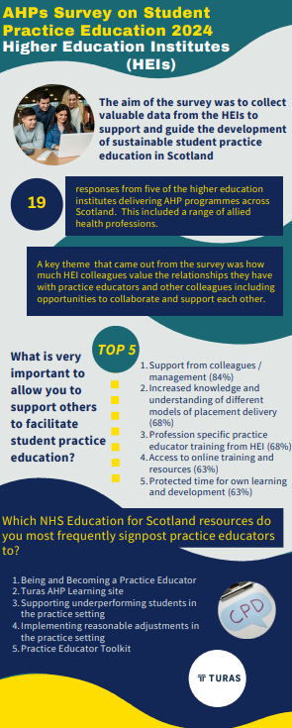
Appendix B Figure 1

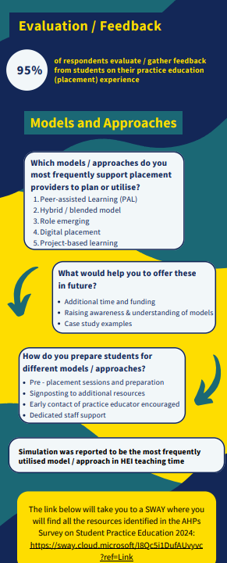
Appendix B Figure 2

Appendix C: AHP PrBL Capability Report

Background to project
This project is a direct output of recommendations 5.4.4 and 5.4.5 of the Scottish Government Allied Health Professions Education and Workforce Policy Review 2023 , which call for recognitition of the importance of Practice-based Learning (PrBL) in all Allied Health Profession (AHP) careers and service models via a framework, in collaboration between NHS Education for Scotland (NES), NHS Boards, and Higher Education Instiutes (HEIs). It also responds to the AHP PrBL consensus statements and AHP Principles of PrBL, which state that PrBL is for all AHPs in all settings, and that it should be supported by the whole team.

The project’s purpose was the development, pilot, national launch and initial evaluation of the AHP Practice Education Development Framework describing the knowledge, skills, behaviours and recommended learning across 4 levels of practice education experience. It supports growth in capability and capacity of PrBL for AHPs in Scotland.

Objective
By March 2025, a Framework will be launched nationally to support 4 audience groups of AHPs with the delivery of Practice-based Learning through improved capability and growth of capacity. The 4 audience groups are:
- Registered and non-registered AHPs
- Further and higher education institutes (HEIs)
- Team leads and operational managers
- Strategic leaders and Practice Education Leads

Scope of Project
This is a national project with stakeholders of all AHPs working in Health and Social Care in Scotland. A national working group was previously established with stakeholders from the aforementioned four audience groups and has been regularly consulted throughout this project. Professional bodies have also been consulted, including the British Dietetic Association, Royal College of Speech and Language Therapists, Royal College of Occupational Therapists, Chartered Society of Physiotherapy, and College of Paramedics.

Task
This project follows the 2023 AHP PrBL Recovery Infrastructure Project, which surveyed practice educators and Practice Education Leads on the value and purpose of a practice education development framework. This scoping recommended further development of an existing initial framework draft, and promotion of this work to increase PrBL capacity across Scotland. It also recommended inclusion of Healthcare Support Workers and the whole AHP team from Band 2 to Band 8a. Further scoping was carried out in the NES Survey of AHP Student Practice Education 2024, which found that of the 824 respondents:
- 87% reported that a framework or guidance would be very or moderately important to support AHP PrBL in Scotland.
- 83% reported that better access to online resources and training were very or moderately important to support AHP PrBL in Scotland.
The existing framework draft required clarification and streamlining, with a focus on creating a practical, operational tool to support AHP capability in practice-based learning. It was designed to be used by the four key audience groups outlined above to support and embed PrBL in all AHP jobs and settings. The project achieved its objective of developing, piloting and launching the AHP Practice Education Development Framework in consultation with stakeholders, and sharing this widely with AHPs across Scotland.

Actions
- Early draft of Framework required redevelopment - content and levels streamlined and clarified.
- 4 levels of Practice Education experience identified - Support, Informed, Skilled and Enhanced.
- Levels not attached to Agenda for Change bandings and include Support Workers.
- Framework design and language made accessible and user-friendly including colours, symbols and straightforward, operational language.
- Relevant learning resources identified for each level - divided into Highly Recommended and Recommended resources.
- Prototypes of interactive Self-Evaluation and Staff Mapper tools created.

Development

- Pilots of Framework and tools carried out June-September 2024 by stakeholders in PrBL networks in Scotland, including National Working Group.
- Pilots provided feedback on content and use, case studies, and information to support Framework launch.
- Responses from stakeholders via survey (29 responses), pilots/case studies (5) and additional individual feedback meetings (10) provided key feedback:
  - Framework design is effective and will support increasing capability in PrBL, including Support Workers.
  - Further streamlining suggested and additional learning resources recommended.
- Final version of Framework produced and with support of Design team hosted on Umbraco website platform with custom graphics in modern and accessible resource.

Pilot

- Launch event held online on 12th November 2024. 472 attended live and 784 total registered to access recording.
- Launch event attendance included: all territorial NHS Boards in Scotland; 11/14 AHP professions; 41 Local Authority staff; 21 Support Workers; 25% of attendees in leadership positions; representatives from 2 professional bodies.
- Bitesize 30-minute CPD session held within AHP PrBL Virtual Community of over 1000 AHPs in Scotland on 21st November 2024. Attended by 160 people.
- Launch, bitesize session and resources shared with PrBL networks across Scotland. Framework Turas page received 1,690 page views by March 2025.
- Myth-busting during launch events – consistent messaging:
  - Newly Qualified Practitioners don’t need to wait 2 years post-qualification to host students
  - Support Workers play an important role in PrBL
  - Advanced Practitioner/specialist roles can host students regardless of setting.
- Met with professional body and NHS England colleagues to discuss embedding resources in existing infrastructure and shared goals.
- Robert Gordon University session for ∼100 final year AHP students January 2025 to promote framework relevance to final placements and post-graduation careers.
- Presented at National Association of Educators in Practice conference in Birmingham in March 2025 to share learning with UK-wide educators.

Launch

Impact
This project met its goal of the development, pilot, launch and initial evaluation of a Practice Education development framework for AHPs in Scotland. The framework aims to increase AHP PrBL capability – to increase the number of registered and non-registered AHPs contributing to PrBL in Scotland. As this project focused primarily on development and launch, impact was evaluated using levels 1 and 2 of the Kirkpatrick Framework:

1. Engagement Impact
- 90% of 119 respondents rated launch session presentations useful or very useful.
- 92% of 119 respondents reported high confidence applying launch session learning to practice.
- 95% of 76 respondents were very satisfied with the CPD event.
- 93% of 15 respondents found the student session very useful.
Framework events and resources received positive feedback from stakeholders:
“Visually appealing, useful graphics. Use of bold colouring felt that sections were well organised and structured.”

“A really useful and informative session. I’ve shared details of the framework with our team to help spread the word.”
“The framework itself is fantastic - the visuals are great but it's also concise and easy to follow. I look forward to supporting our local teams to implement into practice.”

“Really informative, clear information on the framework and I think knowing what level staff are at and what resources are available will be beneficial in developing as practice educators.”

“Great and very interactive. I really liked the different levels described and these were very in depth and easy to determine what level people sit at.”

2. Educational Impact
Participants in the launch event were surveyed before and after the launch to evaluate the impact on their learning. The following questions were asked as part of the event:


- How confident are you in describing your role in AHP Practice Education?
Post-launch – 95% of 291 respondents were somewhat or extremely confident
Pre-launch – 69% of 341 respondents were somewhat or extremely confident

- How confident are you in accessing learning that supports your contribution to AHP Practice Education?
Post-launch – 94 % of 291 respondents were somewhat or extremely confident
Pre-launch – 48% of 357 respondents were somewhat or extremely confident

- Can Support Workers host students?
Pre-launch – 31% of 355 respondents
reported no
Post-launch – 0% of 329 respondents reported no
“I found it helpful that you provided suggestions for further training and how to access these. I plan to start with the 'Being and Becoming an AHP Practice Educator' TURAS training.”

“I look forward to sharing with my team and exploring how we can further develop our PrBL offering, especially around development of the healthcare support worker role and newly qualified practitioners”

“New information I will take back to the team is that non-HCPC registered staff can take students (although not as the named practice educator) and that newly qualified staff can also take a student. We are a very small team, and this has opened up opportunities for all members of the team to be more actively involved in student placements.”

Learning
- Mythbusting – data from the launch evidenced that the common myths outlined above in the ‘Actions’ section including regarding support worker roles, newly qualified practitioner timeframes and advanced practitioners in PrBL, are able to be challenged and that perceptions are changing.
- Support Workers - Feedback from all stakeholders throughout the project was very positive towards clarification and promotion of support workers’ contribution to Practice-based Learning. Any further work should continue to highlight and support the role of non-registered AHP staff in PrBL.
- Local Authority - This project consulted with Local Authority (LA) colleagues and Local Authority staff attended the framework launch. LA staff have fed back positively on the framework and reported that it may be a useful tool to explore expanding PrBL opportunities within Local Authority in the future.
- Models of PrBL – As knowledge and skills to support innovative models of PrBL are woven throughout the framework, colleagues across Health and Social Care have expressed interest in finding out more about models of placement delivery.There is continued demand for ongoing work to support capacity and capability in a range of models of PrBL delivery in Scotland.

Recommendations
Future recommendations for the spread and scale of this project are in progress.These include:
- Local Implementation Sessions hosted by Practice Education Leads in NHS Health Boards across Scotland. A pilot session was carried out in NHS Forth Valley in November 2024 and learning from this session will be used nationally. These sessions will provide locally-tailored learning and support to implement the framework, with the aim of the majority of NHS Health Boards to be reached by March 2026.
- Tools and resources - to support the further implementation and evaluation of this project, the following tools and resources are in development:
  - Self-evaluation and Staff Mapper tools to make the framework interactive and to support incorporation of the framework into workforce planning and service specification.
  - Resources, session plans and invitations for local implementation sessions.
  - Evaluation surveys to evaluate impact of implementation sessions and of the Framework across Scotland.
- Promotion and dissemination – The framework will be presented at the NHS Education for Scotland conference in April 2025, and discussion and collaboration is ongoing with key stakeholders to spread and scale impact across Scotland and the wider UK AHP context.

Appendix D: AHP PrBL Quality and Governance Report

Situation / Background to project

Purpose
To enable workforce growth across all sectors, Allied Health Professional (AHP) students need diverse, high-quality Practice Based Learning (PrBL) opportunities in Social Care, the Third Sector and Health settings across Scotland.

Objective
Within the Quality and Governance workstream, the aim is to enhance the learning environment through strong governance and processes that support sustainability and growth, aligning with the Scottish Government Education and workforce review .

Scope of project
The Quality and Governance Progressing PrBL project had 3 components:
- National guidance for managing AHP student cancellations
- Quality Standards for Practice Learning (QSPL) Section 4 Audit Results
- Focus on PrBL within Local Authority (LA), Occupational Therapy (OT) settings
This report will focus on component 3 (PrBL in LA OT) with a brief overview of 1 and 2.

1. National guidance for Managing AHP Student Cancellations
These refreshed guidelines help ensure a consistent process to support communication of cancellations between the practice setting, the learner, and the Higher Education Institutes (HEIs), as well as supporting risk management.
Actions
- Umbraco was chosen as the host digital platform, as it is accessible across multiple devices within health and care and third sector settings. Case studies and an evaluation tool were added. Collated feedback will inform an ongoing cycle of improvement to maintain the contemporary nature of the guidance. A communication plan was agreed and promoted with stakeholders.

2. QSPL (PrBL) Section 4 Audit Results
In January 2024, 22 Health boards across Scotland were invited to complete an audit of QSPL Section 4. Nineteen completed audits were returned. Section 4.9 was identified as an area where a national approach could further support implementation.
Actions
- A detailed report on Quality Standards for Practice Based Learning Section 4 Audit Results and Resulting Actions to Progress Standard 4.9. can be accessed here
- An online CPD session (How to ensure service users are actively involved as individuals who support learners) was attended by 104 participants.
- The theme of involving service users will be included on the Turas AHP pages with links to tools and useful resources.
- Ongoing work should explore what else could build practice educator skills and confidence to involve service users in their day to day practice and PrBL.

3. Focus on PrBL within Local Authority settings

Identification of stakeholders

Engagement work by the NHS Education for Scotland (NES) AHP practice education team had identified AHP networks for OT within local authority settings. These included senior leaders, the professional body, HEIs, and practice educators (PEs).

Scoping
Project scoping was supported by a number of tools including: a problem tree, a weavers triangle and iterative questioning. This resulted in the production of a cause and effect fishbone diagram (Appendix D1) which helped to theme the key challenges and provide the focus of what was in scope for a practice based learning project.

Key Findings
- OT students face limited and inconsistent PrBL placements in local authorities, reliant on a few key Practice Education champions.
- Unique barriers and opportunities exist for local authority OTs within PrBL and practice education is part of broader sector challenges.

LA OT PrBL Project Purpose
- Better understand the landscape and identify and upskill new and existing LA PEs
- Increase the number of LA OT PrBL placements across Scotland

Objective
To identify and support new PrBL opportunities in LA settings we worked in partnership with key stakeholders to create opportunities for existing and new practice educators to attend bespoke events that will address their unique setting and development needs.

Actions/ Outputs
- A face to face and online event were held in partnership with the 4 HEIs involved in pre registration OT training
- The events adapted NES branding and used intentional language - Voices Together – Local Authority OTs Matter
- The HEI face to face session offered networking, PrBL literature, Virtual Reality (VR) headset demonstrations, SIM facility tours and NES Social Care Directorate (SCD) Unpaid Carers Team involvement.
- Speakers included occupational therapists with experience of working in local authority settings. In addition, Gordon Patterson, NES SCD Director spoke at the online event.
Impact
Engagement Impact
- 10% of the OT LA workforce, across 15 local authority areas, engaged with the 2 educational events
- A blog, “ Local Authority Occupational Therapists Matter” promoting the role of LA OTs in PrBL was published to support AHPsDay.
- Bespoke branding, intentional inclusive language (Figure 1) and co-creation of a new image representing OT (Figure 2) in local authority supported engagement
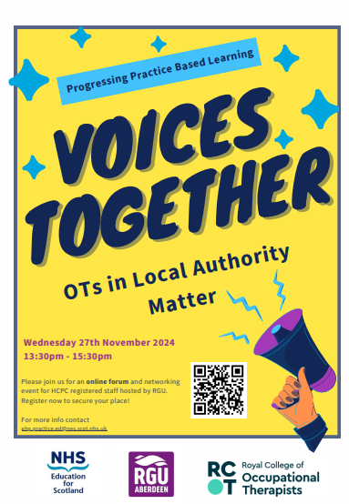
Figure 1 Poster Advertising an event
Figure 2 Owen LA OT

Educational Impact
Post evaluation surveys of OT practice educators who attended the face to face and online workshops reported increased confidence and motivation towards PrBL.

Performance Impact
Differing alignment of the NES funding cycle for the PrBL project and apportionment mean it is too early to state whether there has been a change in placement offers from LA settings. Glasgow Caledonian University hosted a bespoke PE training in February 2025 and reported a placement offer from one area that has not engaged recently and new offers from another.

Lessons Learned
Many lessons have been learned. The importance of using inclusive understandable language that supports participation has been key. OT students have shared that they highly value the learning that they gain in a local authority setting. LA OT practice educators recognise that offering PrBL opportunities supports future recruitment and enhances both their own and their teams learning and development.

This work is still in it’s infancy and many practice educators feel isolated and ‘out of sync’ with their NHS AHP colleagues who are using ‘new models’ and have had more opportunities for training and support. Relationships across the sector need to be nurtured, LA OTs actively included in key NES PrBL stakeholder groups and assured that they are valued.

It is difficult to separate PrBL from the wider workforce issues that are experienced by LA OTs. New legislation and the changing landscape of health and social care provision mean that there is an increasing need to advocate for their key role in early intervention/prevention in social care. Building diverse PrBl opportunities for OTs, including local authority settings, is crucial for the future of health and social care.

Recommendations
- NHS Education Scotland (NES) actively seeks to build on the project gains, involves LA OTs in strategic groups, ensures language is inclusive and understandable and works to further highlight the unique contribution of LA OTs in relation to PrBL.
- NES creates a LA OT reference group to support the further role out of actions in relation to PrBL in LA settings.
- NES supports the AHP Practice Education Leads to understand and respond to the unique landscape of PrBL in LA settings.
- NES works with LA OT stakeholders and HEIs to develop LA OT PE spotlight training sessions that will highlight a team approach to PrBL (including involving service users) and explore the use of models.
- NES continues to identify where cross directorate work will support LA OTs in relation to PrBL but also wider workforce pressures.

Appendix D1 – Fishbone Cause and Effect Tool: A fishbone diagram is a visual way to look at cause and effect. The problem or effect is displayed at the head or mouth of the fish. We used this tool to identify the drivers that impact PrBL in LA OT settings

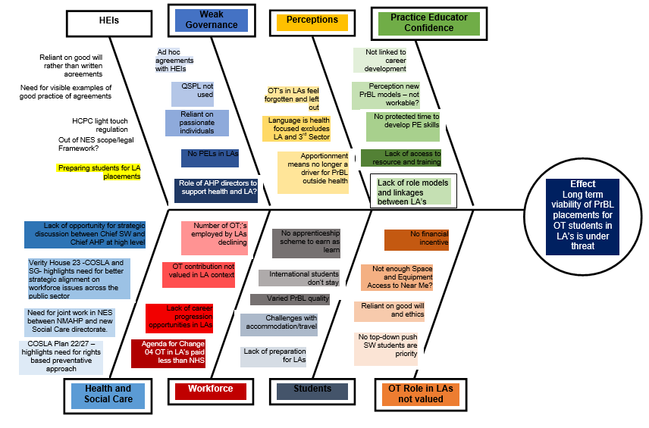
Appendix E: AHP PrBL Capacity (Long Arm Supervision) Report

Situation /Background to project
The Long Arm Supervision (LAS) practice-based learning model has been in existence for some time, but its implementation remains inconsistent across the health and social care sectors. Despite its significant potential to support the first three of the 2019 Allied Health Professions (AHP) Practice-based Learning Consensus Statements , the model has not yet been fully integrated into routine practice. As a result, its full benefits have not been realised, and there remains a need for more comprehensive integration into service plans and infrastructure to ensure its effectiveness.
The AHP Practice-based Learning (PrBL) Recovery Workstream (2023) has underscored the necessity for continued work to raise awareness, build knowledge, and enhance confidence surrounding the LAS model. This project is guided by the principles set out in the 2023 AHP Principles of Practice-based Learning, the AHP PrBL Consensus Statements, and the AHP Education and Workforce Review . This initiative also aligns with the AHP Quality Standards for Practice Learning (QSPL), which were highlighted in the 2023 AHP Education and Workforce Review and subsequent PrBL recommendations.
By advancing opportunities for LAS, the project seeks to improve the quality and consistency of PrBL across the AHP sector, ultimately leading to more effective service delivery and enhanced professional development.
Purpose
This project aims to raise awareness of LAS in PrBL for AHPs across all professions, sectors, and settings. It seeks to align with policy frameworks and the consensus statements which highlight the need for diverse, sustainable, and modern approaches to practice education. By increasing awareness of LAS, this project aims to increase use of this model of placement in the future and thus build a highly skilled workforce capable of adapting to diverse clinical environments and working autonomously.

The broader adoption of LAS will also help make placement opportunities more sustainable for busy clinicians. It supports roles that face challenges with traditional placement models, including nonclinical roles, part-time staff, middle management, remote workers, and those in geographically isolated areas. Furthermore, considering LAS placements in future-focused areas for AHPs, where there is a strong link between positive placement experiences and career choices, can further strengthen the workforce.

Objectives
- An increase in practice educators (PEs) from a range of AHP professions and settings expressing interest in learning more about or offering a LAS placement.
- PEs (from diverse AHP professions, settings, and geographical areas) will demonstrate increased awareness, knowledge, and confidence regarding LAS placements, including benefits, preparation, delivery, and evaluation.
- PEs will show engagement with resources supporting LAS placement planning, delivery, and evaluation.

Scope of project and identification of stakeholders
The project aimed to consolidate existing resources and focused on engaging learners, PEs, Higher Education Institutions (HEIs), and National Working Groups (NWGs), raising awareness, and dispelling myths. The initiative prioritsed early adopters and groups interested in exploring this model, while collaborating with AHPs across all professions, sectors, and settings.

Task
The scoping phase focused on reviewing existing resources, including those on the AHP Turas Learn site, engaging with HEIs, PEs, and collaborating with NWGs to assess LAS in practice-based learning.

This revealed limited LAS use, with PEs lacking confidence and understanding of what this model was, how to implement it and where to source resources. AHP students had insufficient access to LAS, and PEs struggled with setting up and evaluating LAS placements. LAS placements were often individual efforts, with inconsistent recognition of its value.

Given LAS’s different position compared to models such as Peer Assisted Learning (PAL), the focus was on raising awareness and building a foundation for future engagement through resources like the Turas Learn page and case study podcasts. The project identified key challenges and laid the groundwork for broader LAS adoption through centralised resources and targeted educational initiatives.

Actions
- Collaboration with NWGs
Worked with the Models and Capacity National Working Group and LAS experts to address barriers and promote LAS adoption.
- Turas Learn Page Creation
A dedicated AHP Long Arm Supervision Turas Learn Page was created to consolidate resources and support practice educators.
- Bite-Size CPD Sessions
A CPD Event on Long Arm Supervision session was developed to raise awareness of LAS benefits and resources including the podcast series and hosted on the Scottish AHP Practice-based Learning Virtual Community. A recording of this CPD event is available for community members and information about how to become a member is available at AHP PrBL Virtual Community Sway
- Podcast Series Development
A podcast series called Long Arm Supervision: Shaping Practice-Based Learning was created with interviews from HEIs, NHS Education for Scotland (NES), practice educators, and learners. An interview-based podcast was selected for its ability to provide real-life perspectives from diverse stakeholders. This format fosters engagement through authentic, conversational content, making it accessible for listeners on-the-go. The series was published on both Podbean and Spotify. Interviews help address misconceptions, showcase the flexibility and benefits of LAS, and offer diverse insights on its implementation across different settings. The format supports both in-depth learning and casual exploration, ensuring the content resonates with a wide range of listeners. The podcast aimed to dispel myths, build confidence, and signpost resources. Feedback survey and links to the Turas Learn page were embedded in the podcast description.

Impact
The project has increased awareness, understanding, and engagement with the Long Arm Supervision (LAS) model.
- Cultural Shift in LAS Perception
The project is shifting LAS perceptions, laying the foundation for broader adoption, with ongoing data collection to inform future efforts. This has been evidenced through ‘free text’ responses from both CPD Bitesize questionnaire and Podcast Survey.
- Bite-Size CPD Sessions
Polls showed familiarity with LAS increased from 33% to 88% of respondents, and awareness of resources rose from 25% to 90% of respondents. 96% of respondents expressed interest in learning more, with 96% of respondents reporting that they were satisfied with the session and 80% of attendees reporting increased knowledge because of the session.
- Podcast Engagement
As of 21st March 2025 there have been 343 podcast downloads between Podbean and Spotify. This demonstrates strong engagement, and feedback indicates that the podcasts are meeting expectations and supporting practice changes. There is equal split of the podcast being accessed via a computer verses a mobile device and mainly listened to during working hours. There is a clear correlation with increased promotion with listening numbers, but people are tending to start with the first episode irrespective of which one has been promoted.
- Educational and Behavioural Impact
The project increased interest in LAS placements, with polls showing greater awareness. Pre- and post-learning questions showed improved confidence and understanding among educators.
- Resource Accessibility
Clear guidance on accessing resources led to increased views and engagement, with educators reporting the materials as more relevant. Since the creation of the page in January 2025, 65 users accessed the Turas AHP Long Arm Supervision Page with 153 views.

Summary of Impact
The project has boosted LAS awareness and engagement, increased educator confidence, and supports greater adoption of LAS placements in the future, setting the stage for continued success.

Learning / Recommendations
This project is beginning to shift the perception of LAS, laying the foundation for future change and greater adoption. Key priorities moving forward include raising awareness, dispelling myths, and providing accurate LAS information. Data collection and impact measurement of the podcast series are ongoing, with insights informing future iterations. Supporting practice educators in adapting LAS to their settings remains central, and streamlining access to resources will empower and support effective implementation. Future recommendations are found below.

Update LAS Guidance and Resources and Embed in Practice:
- Collate and develop LAS resources including a LAS handbook, resources infographic, and continued development of the LAS page on the AHP Turas Learn site.
- Review and consider existing resources, including the AHP LAS Practice-based Framework, to support and embed the LAS supervision model. Update or remove resources as required.

Ongoing Collaboration with AHPs to Raise Awareness and Embed LAS as a PrBL Model:
Continue collaborating with AHPs to raise awareness of LAS as an effective PrBL model, integrating it across various practice settings. This can be achieved through:
- Gathering and sharing examples of LAS in practice to inspire adoption in different sectors.
- Promoting the podcast series to further disseminate LAS benefits Long arm supervision: Shaping practice-based learning podcast | NHS Education for Scotland
- Exploring and testing mentorship and coaching opportunities to increase LAS adoption in PrBL placements.
- Building support networks to mentor and share "lived experiences" of practice
educators, fostering ongoing learning and adaptation.
- Further education sessions for PEs highlighting how LAS can be used flexibly and in combination with other PrBL models such as peer assisted learning and project-based PrBL.

By focusing on these actions, LAS will continue to expand as a successful model of PrBL, benefiting practice educators and learners across sectors.

Appendix F: AHP PrBL Capacity (Peer Assisted Learning) Report

Situation / Background to project
This project continued to implement and embed Peer-Assisted Learning (PAL) placement models into practice to support the growth of capacity of student Practice-Based Learning (PrBL) for Allied Health Professionals (AHPs) in Scotland.

The project builds on the Peer-Assisted Learning project carried out in 2023 as part of the AHP Practice-based Learning Recovery projects. It follows the recommendations from this work, namely:
- Review and evaluation of PAL resources to ensure they meet the needs of AHP Practice Educators
- Continued delivery and evaluation of PAL workshops
- Identification of gaps and opportunities in existing resources to expand PAL delivery.
This project responds to recommendation 3 of the 2023 AHP Education and Workforce Policy Review:

“Build on current and previous work to embed, transform and further develop modern, inclusive and sustainable practice-based learning models into practice through a learning culture, process changes and collaboration between NHS Boards, other sectors and HEIs.”

Task
The NHS Education for Scotland Survey of AHP Student Practice Education 2024 received 824 responses from registered AHPs and support workers and identified that AHP Practice Educators would benefit from time to plan and prepare for PAL placements, and signposting to appropriate resources to support delivery. Therefore, this project was comprised of two workstreams:

- PAL Digital Education Package - Supporting the update and delivery of the NHS Education for Scotland Peer-Assisted Learning digital education package to enable practice educators to gain knowledge, skills and confidence in the planning and provision of a peer-assisted learning practice placement.
- PAL Guidance Documents – Review and redesign of guidance documents for Allied Health Professionals (AHPs) and students undertaking PAL placements in Scotland to ensure they best support AHP Practice Educators and students implement this model.

Actions
PAL Digital Education Package
Three national PAL interactive workshops were delivered on Microsoft Teams between January and March 2025. 62 AHP staff attended, representing a range of NHS Boards and local authority.

Table F1: PAL Workshop Attendance Data
Number of Attendees  by Profession | Workshop One 13/01/25 | Workshop Two 10/02/25 | Workshop Three 03/03/25 | Total
AHP-wide Role | 0 | 1 | 0 | 1
Diagnostic Radiography | 1 | 0 | 0 | 1
Dietetics | 0 | 1 | 6 | 7
Healthcare Support Worker | 1 | 0 | 0 | 1
Occupational Therapy | 7 | 7 | 3 | 17
Orthoptics | 2 | 2 | 3 | 7
Orthotics | 1 | 0 | 1 | 2
Paramedic | 0 | 1 | 0 | 1
Physiotherapy | 3 | 2 | 5 | 10
Podiatry | 1 | 0 | 0 | 1
Speech and Language Therapy | 4 | 5 | 5 | 14
Total | 20 | 19 | 23 | 62

Connections were established with other stakeholders from the PrBL Models (Capacity) National Working Group to enhance knowledge around PAL and to understand the progress made so far, thereby supporting the sharing of PAL case studies and experiences. From there, AHP staff with experience of developing and facilitating PAL placements across Scotland were contacted. To date, a bank of seven new best practice and case studies with both Practice Educators and Students has been created.
It is anticipated these best resources will help to market and support embedding of PAL as a placement model.

PAL Guidance Documents
Current AHP and Student PAL guidance documents were reviewed in consultation with stakeholders in the National Working Group for PrBL Models (Capacity) and a small focus group of higher education institute (HEI) staff. The following key recommendations followed from these discussions:

  - AHP and Student guidance documents were too long – at 64 and 9 pages respectively – which was a barrier to engagement.
  - Generic information found in the PAL guidance could be linked to or stored elsewhere; guidance could be made more PAL-specific.
  - Other formats including poster or video may be effective to spread awareness and information.
Draft documents were created, with significant revision to condense and refine information to support AHPs and students with PAL placements. The drafts of the new guidance documents and poster were sent out twice for feedback to National Working Group and HEI colleagues and changes made in response to feedback.

Stakeholders reported that the new guidance documents were easier to read, that colours and visuals made them more user-friendly and that new shortened lengths were more accessible. Streamlined guidance documents were shared with the NES Design team to develop into accessible, user-friendly websites on the Umbraco platform.

PAL Guidance for AHP Practice Educators resource launched early March 2025 and PAL Guidance for AHP Students launched in April 2025. A poster for students with graphics aligned to website materials and branding is in development and will be launched in 2025.

Impact
- Interactive workshops
  - 45 out of 61 (74%) of PAL workshop attendees completed the workshop evaluation, which included questions about how confident staff feel planning, delivering and evaluating a PAL placement, pre-reading course work, what worked well, and areas for improvement.

  - Overall, feedback from the PAL interactive workshops has been positive, highlighting the benefits of having the opportunity to share experience and ideas with others:
“Good to meet AHPs from other Health Boards.”
“Great session, and good to meet everyone.”
“I like how interactive it was with the breakout rooms.”

“Thanks, it was helpful and feeling bit more confident about delivering a PAL placement.”

- Guidance documents
  - Initial feedback reports that the resources have improved, and celebrates streamlined information and design to make resources more accessible:
“Love the graphics and how the content has been streamlined.”

“Very user friendly and concise.”

“Very visual, nicely broken up and easy to follow.”

“It works well that the student and practice educator guidance documents are laid out in the same format and there is consistent messaging with them having similar content.”

  - Further feedback and evaluation can be carried out following launch and promotion of guidance resources, which has not been possible during the timeframe of this work.

- PAL Turas page
  - Following promotion of existing PAL resources during this project, the Turas Peer-Assisted Learning page has received 51% more visitors January to March 2025 than this period of time the previous year.

- Future projected impact for project
  - The work carried out by this project aims to support AHP clinicians to adopt PAL in the future and increase PrBL capacity by:
    - Increasing knowledge of what is required to plan, implement and evaluate a PAL placement.
    - Making resources streamlined, more easily accessible, and more sharable.
    - Facilitating sharing of best practice and experience between AHPs.

Learning and Recommendations
The following recommendations are proposed following learning gained during this project:

- Continue national interactive AHP PAL training
- Continued delivery of AHP PAL workshops to meet demand and increase confidence amongst AHPs in delivering PAL placements. Delivery will be led by the AHP PrBL Models (Capacity) National Working Group.
- Deliver follow-up session and/or questionnaire 6 months post-workshops to support clinicians from a range of Allied Health Professions to troubleshoot PAL implementation and receive support on an ongoing basis.
- Explore and test mentorship and coaching opportunities to increase PAL adoption in PrBL placements.

- Review, update and share AHP PAL resources
- Promote new PAL Guidance for AHP Practice Educators, and new PAL guidance for students.
- Produce and share a poster summarising key messages for students on the PAL model. Consider development of short video(s) to explain PAL to students/AHPs in quick, accessible way and signpost to new resources and to support spread of information and awareness.
- Ongoing review and evaluation of PAL resources to ensure they remain fit for purpose and are aligned with new guidance documentation.

- Sharing good practice and case studies
- Disseminate case studies gathered from this project and embed in resources to share perspectives and experiences of learners and practice educators.
- Continue to develop PAL case studies from a range of Allied Health Professions and settings across Scotland to share learning about PAL implementation.

Appendix G: Orthoptics Report

Situation / Background to project
There is a positive trend in the increasing number of orthoptic undergraduate students studying in Scotland, with intakes at Glasgow Caledonian University (GCU) of 8 students in 2022/23, 28 in 2023/24 and 35 in 2024/25. There is an ongoing need to ensure sufficient placement capacity and practice educator capability through using different models of Practice-based Learning (PrBL) to provide high quality clinical education for the increasing numbers of students.

Purpose
To increase orthoptic PrBL capacity in Scotland through the implementation and spread of different models of placement delivery and demonstrate the impact of different models of PrBL on orthoptic students practice-based learning.

Scope of project
In Scope | Out of Scope
- PrBL experiences in Scotland for GCU orthoptic undergraduates  - Practice educators in NHS Scotland  - Simulation models of PrBL  - Different modes of PrBL, e.g. Blended, digital and face to face | - PrBL experiences out with Scotland  - Practice educators out with NHS Scotland  - Models of practice-based learning other than those in scope

Identification of stakeholders
- Orthoptic PrBL Stakeholder Group
- Glasgow Caledonian University BSc (Hons) Orthoptics Programme Lead and Placement Lead
- Scottish Orthoptic Heads of Service Group (SOHOS)
- NES AHP PrBL Practice Education Leads (PELs)
- 4th year Orthoptic undergraduates

Task
To build on the successes of the Orthoptic PrBL Project Phases 1 and 2, implementing and spreading specific models of PrBL within orthoptic undergraduate education in Scotland.

Objectives
- Develop and incorporate the simulation elements of the Stroke PrBL Programme tested in Phase 2 of the Orthoptic PrBL Project, into a 4-week Peer Enhanced e-Placement (PEEP).
- Build the capability of orthoptic practice educators, through education and training, to effectively deliver simulation and facilitate learning of orthoptic students on the PEEP.
- Demonstrate the impact of the use of the simulation model of PrBL on orthoptic student’s learning.
- Explore the use of simulation PrBL for other complex ocular motility conditions.

Key achievements
- Developed and tested a 6-session programme of simulation-based learning, providing an additional 126 hours of clinical education for a cohort of 4th year orthoptic students.
- Recruited a team comprising appropriate clinical and educational expertise to deliver simulation-based learning events.
- Established and maintained a psychologically safe learning environment for students throughout the duration of the programme.
- Designed a 4-week PEEP programme which can incorporate simulation-based learning events as required.

Actions
- Designed and delivered a programme of simulation-based learning ensuring:
  - Learning opportunities encompassed a range of technical and non-technical clinical skills (Appendix G1).
  - Recognised structure and tools for simulation-based learning were used.
  - Clear links to the clinical practice education and relevant academic modules of the GCU BSc (Hons) Orthoptics programme.
- Recruited a multi-professional team of educators comprising orthoptic practice educators (NHS Greater Glasgow and Clyde – South Sector and NHS Lanarkshire); NES AHP PEL (Orthoptics); GCU Programme Lead (Orthoptics) and GCU lecturer (Optometry).
- Identified educational resources for educators to increase their knowledge and skills in simulation-based education prior to delivering the programme.
- Identified existing self-assessment, reflective practice and evaluation tools for students and educators.
- Designed a 4-week PEEP programme, blending with the simulation programme for future use.
- Shared the learning from the orthoptic project with orthoptic and AHP stakeholders.

Impact
The orthoptic project objectives have been met and the impact of actions are:
Service Impact
- 100% (n7) of 4th year orthoptic students had access to a newly designed programme of simulation-based learning, providing an additional 126 hours of clinical practice education.
- 86% of students attended the full programme.
Performance Impact
- A 6-session simulation programme was delivered in November/December 2024 by a multi-professional team of orthoptic practice educators, vision science lecturers and service users.
- Increased student’s exposure to both people with complex ocular motility disorders and NHS board orthoptic practice educators with specialist knowledge and advanced practice in such areas.
- Increased student’s exposure to a range of learning covering both technical and non-technical clinical skills.
Education impact
100% (n7) of students responded to the simulation programme evaluation.
- 100% reported increased confidence in their technical and non-technical clinical skills following the programme.
- 100% identified new knowledge and skills acquired from the programme.
- 100% agreed the programme complemented the clinical practice education and relevant academic modules of the GCU BSc (Hons) Orthoptics programme.

75% (n 3) of orthoptic educators responded to simulation programme evaluation and of these:
- 67% reported an increase in confidence to deliver a simulation-based learning event.
- 100% reported they are motivated or very motivated to participate in future simulation-based learning programmes for orthoptic undergraduates.
- Acquisition of new knowledge and skills was reported by 100% of practice educators delivering simulation-based learning events.
- 100% reported receiving direct feedback from the students and self-evaluation using the Debriefing Assessment for Simulation in Healthcare (DASH) | Center for Medical Simulation can be used for their own personal and professional development.
Engagement impact
100% (n7) of students responded to the simulation programme evaluation.
- 100% agreed that their learning from non-technical clinical skills simulation-based learning events (SBLE’s) can be applied on clinical placement.
- 86% agreed that their learning from technical clinical skills SBLE’s can be applied on clinical placement.
- 100% agreed working with orthoptic practice educators from NHS boards helped their learning.
- The programme received a rating of 4.9/5 stars and 100% of students would recommend it to others.

75% (n3) of orthoptic educators responded to the simulation programme evaluation and of these:
- 100% agreed the programme supports student practice-based learning needs when on placement.
- 100% would recommend participating in simulation-based learning to other practice educators.
- 100% of educators involved in the design and delivery of the simulation programme completed relevant modules of the NES Clinical Skills Managed Education Network (CSMEN) learning programme: Becoming a simulation-based educator.
At the end of each SBLE student opinions were gathered on whether a psychologically safe learning environment had been maintained during the event.
- 100% (n7) of students answered YES for 3 out of 4 SBLEs.
- For the remaining SBLE, 83% answered YES and 16% answered MAYBE.

Learning / Recommendations
- Embed simulation-based learning into orthoptic undergraduate education in Scotland as a bridge between academic and practice-based learning.
- Spread technical and non-technical clinical skills simulation-based learning to encompass both Years 2 and 3 orthoptic undergraduate education.
- To be responsive to placement capacity challenges in the future, GCU to develop their simulation-based orthoptic educator resource and NHS Boards to work collaboratively with GCU, releasing orthoptic practice educators to deliver simulation-based learning events at GCU.
- Simulation-based learning events:
  - Are designed and delivered collaboratively by a multi-professional team of academic and practice educators with relevant clinical subject-matter and educational expertise
  - Have service-users with lived-experience as core participants
  - Link clearly with academic and clinical practice education modules on the GCU BSc (Hons) Orthoptic course
- Upskilling orthoptic practice educators in the design and delivery of simulation-based learning, using the NES resources Becoming a Simulation based educator, Tiers 1 and 2 and the AHP Practice Educator Development Framework.

Appendix G1: Programme of simulation-based learning events (SBLE)

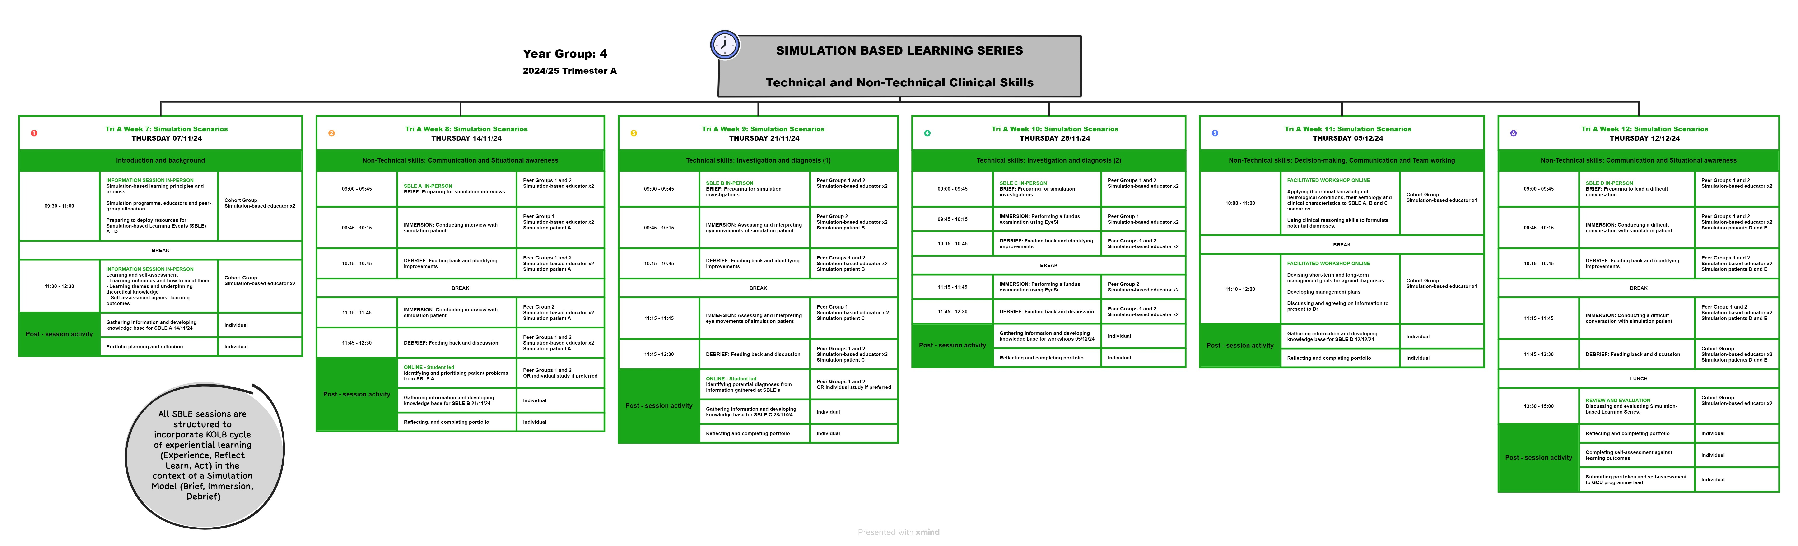

Appendix H: Arts Psychotherapies Report

Situation / Background to project
This project is part of the NHS Education for Scotland (NES) Allied Health Professions
(AHP) Projects Progressing Practice-based Learning (PrBL), commissioned and funded by the Scottish Government. The Arts Psychotherapies were identified to benefit from continued investment to support the development of PrBL in Scotland. For clarity, Arts Psychotherapies is the collective name for Dramatherapy, Art Psychotherapy, Music Therapy and Dance Movement Psychotherapy. This is a group of psychological therapies that use different creative modalities within their therapeutic process. Currently in Scotland there are PrBL opportunities for art, music and dramatherapy.

Arts Psychotherapies PrBL Context

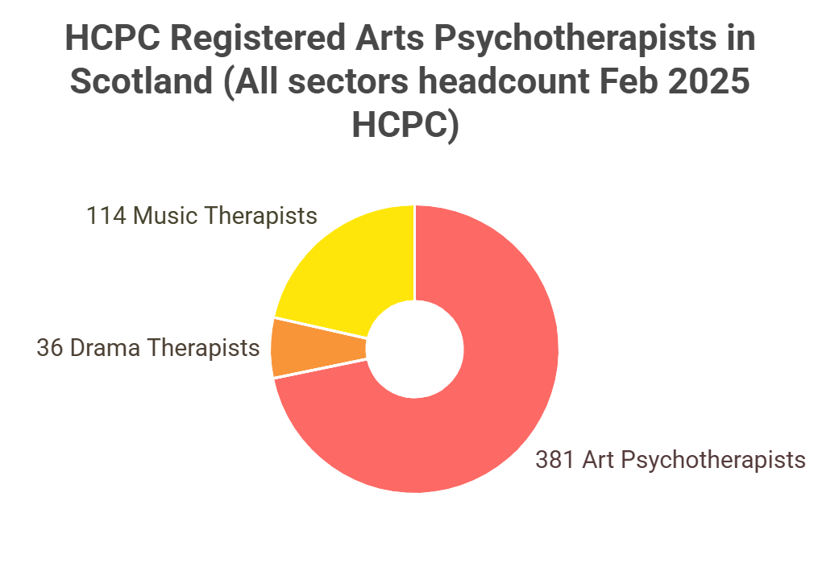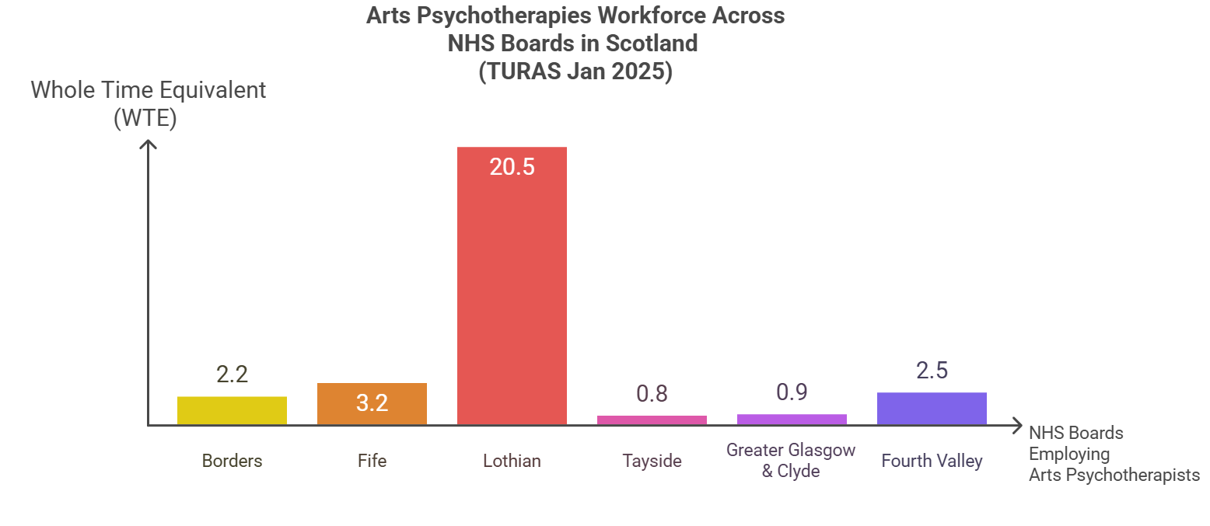
Figure H1 Figure H2

HCPC data highlights that the Arts Psychotherapies are a group of smaller AHP professions in Scotland. Turas data shows variable numbers employed across NHS health boards and highlights that most Arts Psychotherapists work out with the NHS in Scotland. There are no Dramatherapists employed by NHS health boards currently, but there are Dramatherapy trainees (students).

Key placement requirements relevant to PrBL landscape:
- All Arts Psychotherapies training in Scotland is post-graduate (MSc) at Queen Margaret University (QMU), with full time and part time options.
- All trainees are required to undertake 2x 6-month placements (full time two days a week, part time 1 day per week).
- There are different PrBL requirements across the years and modalities.
- All placements could be described as long-arm supervision as students are supervised weekly through Queen Margaret University (Dramatherapy Year 2 trainees are required to find external Dramatherapy supervisor).
- Trainees are expected to attend QMU in person once a week which poses challenges to development of placements outside the central belt, there is no current funding for travel.

There are a lack of placement offers in NHS territorial boards beyond the central belt which could equate to a lack of Arts Psychotherapies positions within the workforce of those boards. PrBL is essential to developing the future Arts Psychotherapies workforce nationally and there is a need to increase numbers and confidence of practice educators across sectors and geographical locations so that placements are available when required.

Task April 2024- March 2025

The Arts Psychotherapies PrBL project focus was capability and capacity. The tasks for this project were based on recommendations from Phase 1 found here:
AHP PrBL Recovery Arts Therapies Report 2023.

Phase 2 Objectives
- Increase awareness and engagement with Arts Psychotherapies specific PrBL resources including the Practice-based Learning Support Package for NHS Placements hosted on Art Psychotherapy | Practice Based Learning Website | Queen Margaret University Music Therapy | Practice Based Learning | Queen Margaret University, Edinburgh, national PrBL resources (NES and Turas) and CPD opportunities for Arts Psychotherapists working across sectors.
- Increase placement opportunities for arts psychotherapies trainees.
- Complete the Quality Standards for Practice Learning (QSPL) Section 3 Audit by November 2024 in collaboration with stakeholders: quality_standards_for_practice_learning_qspl.pdf
- Explore NES PrBL PEL role in supporting integration between the modalities and facilitate national peer support networks (Art/Drama/Music Therapy). Develop a growing network of practice educators in NHS boards who are ready to take on learners by September 2025.

Stakeholders
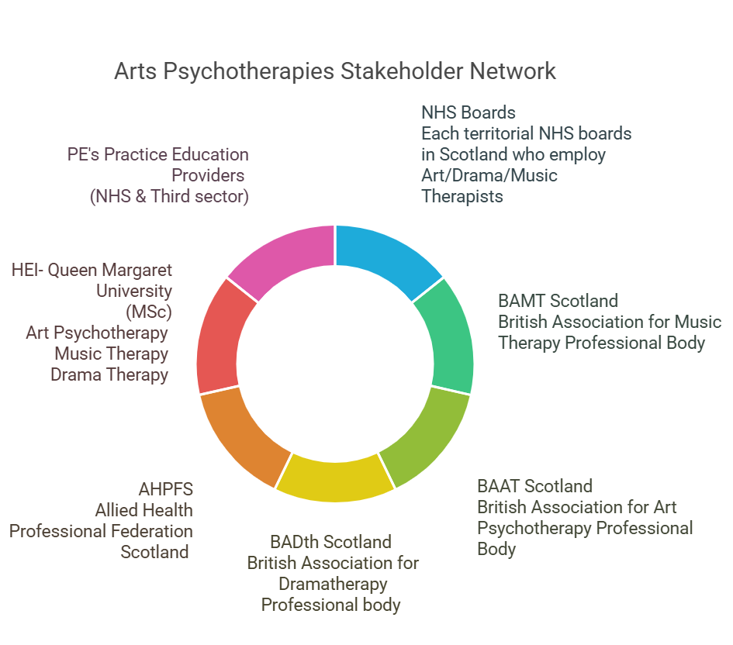
Figure H3
Engagement with stakeholders has been essential to ensure working collaboratively towards project objectives. Varied methods such as surveys, scoping activities, feedback questionnaires and CPD events have been used to establish effective communication channels. It is important to note that due to the small numbers within the Arts Psychotherapies NHS workforce, it was felt that no separate PrBL group was required and the project lead engaged utilising existing infrastructure in the form of NHS strategic groups and forums.

Actions/ Outputs

Actions | Intervention
Scoping | Refining understanding of challenges facing the Arts Psychotherapies in Scotland through stakeholder engagement highlighted in phase 1 recommendations.
Engaging with stakeholders | PrBL agenda items discussed at meetings of existing Arts Therapies strategic groups and forums with representation from territorial boards/employers of Arts Psychotherapists, representatives from AHP Federation Scotland (AHPFS) and professional bodies of each modality.
Arts Psychotherapies PrBL networking development | Robust communication strategy and joined up thinking between Arts Psychotherapies project lead and stakeholders to enable links to be made between new placement providers and higher education institute (HEI).
Arts Psychotherapies PrBL Resource engagement | PrBL resources hosted on QMU PrBL zone for Art and Music Therapy (Dramatherapy website still in development). Shared with new placement providers prior to their learners arriving and gathered feedback.
CPD Event (Engagement with resources) | British Association of Music Therapy (BAMT), British Association of Art Therapists (BAAT) and Dramatherapy Scotland Building the DAM: Progressing Practice Based Learning for Arts Therapies in Scotland online event. Signposting to AHP Practice Development Framework, introduction to Turas and the virtual community.
Quality Standards for Placement Learning (QSPL) section 3 audit | Collaboratively gathered and collated evidence from placement providers of Arts Psychotherapies and the Higher Education Institute representatives to better understand adherence to the QSPL section 3 standards.

Impact

Capability
Qualitative data gathered through evaluation of the Arts Psychotherapies PrBL support package continues to highlight an increase in:
- Confidence and preparedness to become a practice educator (PE)
- Colleagues accessing and using resources with learners in practice (NHS)
- Reporting by Arts Therapies Practice educators that they feel more connected to the national PrBL landscape and strategic picture

Feedback from Arts Therapies practice educators:
‘I have found the resource very helpful and it offered my a greater sense of reassurance that I was following a recognised and approved standard of student support. Prior to accessing the resource I spent considerable time gathering information and making up my own induction process for students- to have this collated for me in one easy to access location was wonderful.’

‘I have found the resource to be very helpful- I wish I had known about it sooner. I have downloaded all the individual elements of the resource and anticipate making regular use of the resources with all future students from arts background. I like how it keeps referring back to HCPC Standards’

In addition, the CPD event ‘Building the Dam’ outcomes and feedback highlighted appetite from clinicians from across the modalities to come together, share experience and learning in relation to PrBL and to connect to the bigger strategic picture across Scotland. Particpants reported increased motivation and confidence to support student learners following the session:
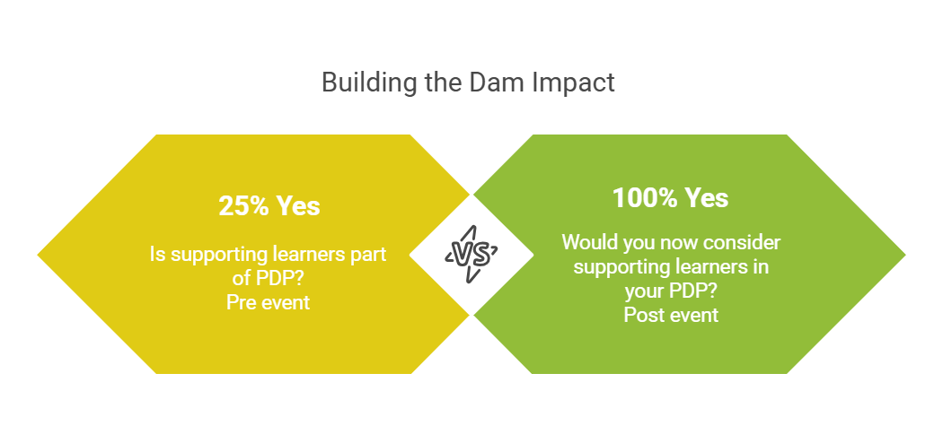
Figure H4
QSPL Audit Section 3
It is significant that this has been completed in a collaborative way with stakeholders. This will encourage a more strategic and coordinated approach that promotes consistency in governance, shared understanding of requirements, and acts as a shared quality assurance mechanism across NHS, HEI and between the modalities.
Key recommendations from the audit include:
- PrBL to remain a permanent agenda item at strategic group
- Develop standardised process for receiving and reviewing feedback from students- aligning with AHP PrBL Qualtiy and Governance workstream within QSPL Section1
- Include PrBL CPD opportunities within personal development plans for practice educators

Capacity
There has been growth of the Arts Psychotherapies PrBL network within NHS boards and connections made to offer new placements. In the period 2024- 2025, three new placements were developed. This included NHS Highland and NHS Forth Valley supporting Dramatherapy trainees, and NHS Lanarkshire hosting an Art Psychotherapy trainee for the first time. These placements utilised a long arm supervision model. NHS Ayrshire and Arran and NHS Fife are looking to support placements for 2025-2026 in varied clinical settings, some role emerging. Barriers around location and travel have been overcome through dynamic collaboration between the HEI and NHS boards, and with consideration to students’ base. I.e. trainee in NHS Highland could complete placement there due to their home base being there.

Integration between the modalities and facilitate national peer support networks
Although small, there has been growth of Arts Psychotherapists within the AHP PrBL Virtual Community, increasing from 7 to 15 members across 2024-2025 Quarters 1-3. It is hoped that this space will function to continue to support, nurture, celebrate best practice and maintain PrBL agendas for Arts Psychotherapists across sectors.

Learning / Recommendations

Collaboration between the existing Arts Therapies strategic groups and forums, NES and other stakeholders is key to supporting ongoing progress for PrBL development and quality improvement within the Arts Psychotherapies. To strengthen the PrBL focus within the Arts Psychotherapies workforce this projects recommendations are as follows:

- Stakeholders to progress collaborative actions agreed in the QSPL Section 3 Audit and explore the role of NES AHP practice education programme in supporting facilitation of future audits.
- The Scottish AHP wide PrBL infrastructure including Turas learn and the AHP PrBL Virtual Community should continue to enhance inclusion of the CPD needs of Arts Psychotherapies educators across all sectors. This remains highly relevant within the Arts Psychotherapies professions where the majority of the workforce are employed outside the NHS.
- To continue to increase PrBL capacity, including out with the central belt, it is recommended to explore opportunities for collaboration with AHP colleagues where they arise to develop more diverse PrBL models such as Peer assisted learning (PAL) and role emerging placements. This, along with the national apportionment work ongoing, may assist inovercoming challenges around geographical location and help to progress towards a more equitable Arts Psychotherapies workforce across NHS Scotland health boards.
- Practice-based Learning Support Package for NHS Placements to continue to be evaluated and developed through use in 2025-2026 placements,with particular attention to dramatherapy requirements.
- Aim to continue to increase the visibility of the Arts Psychotherapies within wider AHP networks and NHS Education for Scotland to support Arts Psychotherapies inclusion in national PrBL strategy and strategic development in Scotland. There have been significant benefits for the Arts Psychotherapies having a PEL to highlight additional considerations and complexities for PrBL in these professions.
Appendix I: Dietetics Report

Situation/Background to project
The 2023 AHP Practice Based Recovery Dietetic report outlined key recommendations for Dietetic practice-based learning (PrBL). With 12 months of Scottish Government funding, this project aims to enhance and expand future opportunities.

Purpose
The purpose is to cultivate high-quality diverse PrBL for Dietitians of the future.

Objective
The objective is to review and advance recommendations from the 2023 AHP PrBL Recovery Dietetic report. These focused on building capacity via peer-assisted learning, a digital module for specialist areas and cross-sector PrBL.

Scope of project
The project scope will focus on enhancing Dietetic PrBL learning across various sectors, embedding Peer Assisted Learning (PAL), and developing digital modules for specialist areas, especially where recruitment and opportunities are lacking. In scope, is the learning recommendations from 2023 AHP PrBL recovery dietetic work, noting constraints of influence, within timescales of the project. Out of scope is post-registration Dietetic education, British Dietetic Association (BDA) UK Common Assessment Tool, and the NHS Education for Scotland PrBL partnership agreements and apportionment .

Identification of stakeholders
The 2023 PrBL Dietetic stakeholder group had not been maintained. A launch event in July 2024 brought together Dietitians across Scotland to identify key stakeholders and their role.

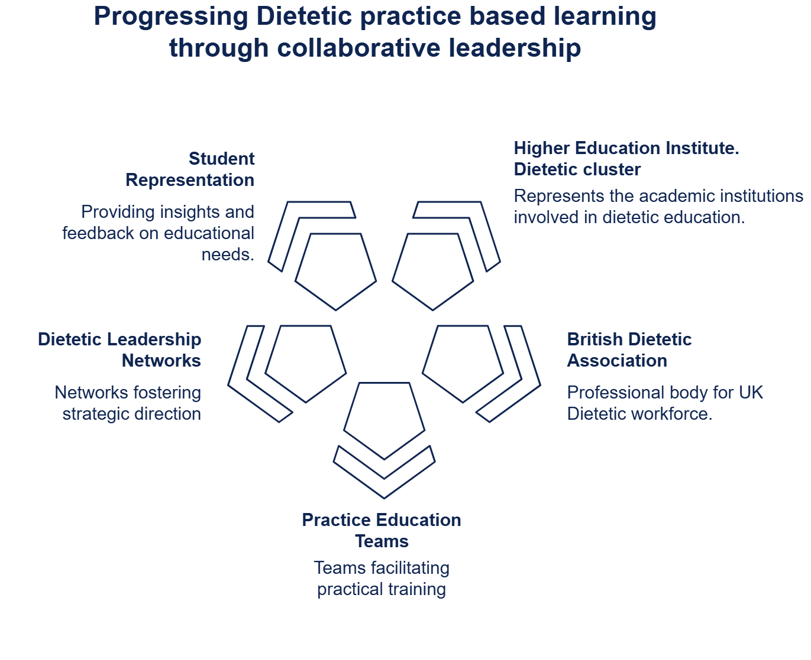
Figure I1- Identification of stakeholders

Task
Scoping
Scoping, illustrated by Figure I2, involved literature reviews, data analysis and appreciative inquiry. Quality improvement tools, such as a fishbone diagram, were used to theme and report findings.

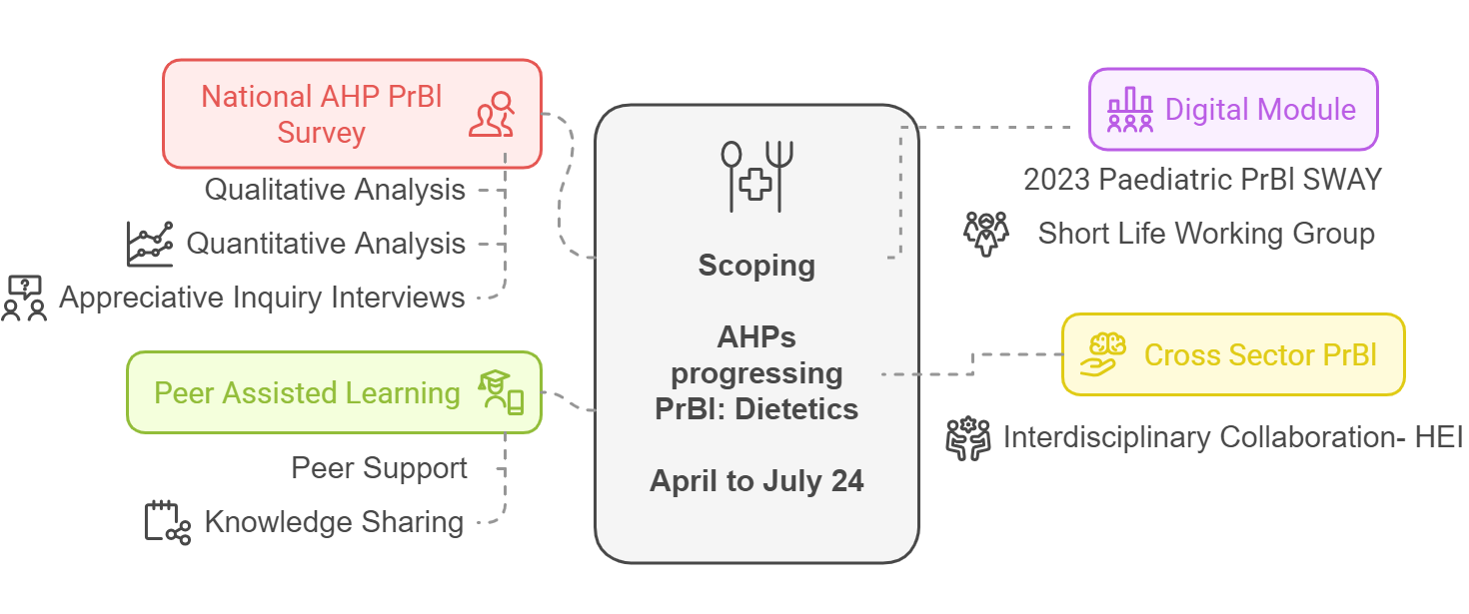
Figure I2: Scoping focus
Key findings
Scoping identified the need to build high-quality diverse PrBL opportunities for future Dietitians. A project charter, co-created with stakeholders, identified objectives and goals.

Objectives
- Supporting educational needs for PrBL models, including digital and PAL.
- Scoping approaches for cross-sector PrBL experiences.
- Ensuring equitable PrBL provision for specialist areas.
- Sustaining communication across higher education institutes (HEIs), NHS boards, and other sectors.

Goals: By March 2025
- Implement a digital module for paediatrics, co-produced by an expert group.
- 10% of Dietetic workforce to attend a bitesize education session on PrBL models.
- Implement a test of change PAL ‘champion’ model within one health board.
- Explore requirements for a national forum to support PrBL.
- Develop a resource, sharing cross-sector PrBL models.

Actions/Outputs
The digital module for specialist areas, Paediatric Dietetics was co-produced, tested and launched in February 25. The Scottish Paediatric leads group will support annual review of the resource.
The growth of the virtual community's membership evidenced collaboration and communication. Dietetic membership increased by 318% from April 24 to March 25. Approximately 10% of the Dietetic profession in Scotland are members, with representation from 14 territorial boards. Polls within the Dietetic forum for Practice-Based Learning indicated a positive shift to recommend the community.

Educational needs of the profession were met, with 10% attending bitesize training on PrBL. This was defined as attendance at PrBL virtual community spotlight sessions held between April 2024 to March 2025. The development of a cross-sector long arm supervision PrBL podcast was showcased at the national forum, with a dietetic case study in episode 3. The BDA campaign on PrBL utilised the September 2024 Dietetics Today article written by Joanna Teece.

Impact
Engagement
- National PrBL Survey- 15% response from Dietetics. 9, 1:1 follow up interviews.
- 10% of the Dietetic workforce in Scotland attended education session on models, including the national PAL workshops and the launch of the AHP practice education development framework. The BDA campaign on PrBL utilised the September 2024 Dietetics Today article and the AHP Practice Education Development framework within BDA platforms, forums and social media.
- Stakeholder forum met 5 times. All 14 boards, Dietetic HEI cluster and BDA education committee representatives attended at least one meeting. Representation included 2 national boards (Health Improvement Scotland and NHS Education for Scotland), 3rd Sector organisation (Food Train), and student representative from Glasgow Caledonian University.

Education impact
- Dietitians attending the forum focusing on PAL reported increased knowledge and confidence.
- Final forum evaluation polls demonstrated positive shifts in knowledge of PAL and the net promotor score for the virtual community. The value of collaboration was acknowledged and strengths of current and future Dietetic PrBL.

Performance impact
Stakeholder discussion at the February 2025 Dietetic forum highlighted the desire to integrate data and an action plan for sustainability and maintenance of increased collegiate working across HEIs, Board Practice Educators and the BDA.

Learning / Recommendations
Next steps with timeline and partners
2023: Phase 1 recommendations | 2024: AHPs progressing PrBl: Actions completed | 25/26: Recommendation for Next steps
 |  | Report publication: Dissemination to key stakeholders via NES AHP Practice education team as appropriate. Share findings in AHP PrBL Virtual Community.
Stakeholder group should be sustained to ensure continued engagement and collaboration via an ongoing programme of work that recommends next steps for the profession. | Stakeholder forum  Supported by NES support. Bi-monthly national meetings, recorded with spotlight sessions on PAL, LAS and Cross sector PrBL | Promote integration of Scottish Dietetic PrBL forum members into existing forums such as the AHP PrBL Virtual Community. Scottish members to engage in BDA UK-wide resources.
Guidance for cross/third sector placement could be built upon and strengthened with student/ practice educator stories. | Cross-sector scoping  Literature review.  HEI Placement A and C examples.  Podcast see Episode 3. Learning across landscapes: student stories from long arm supervision | Long arm supervision: shaping practice-based learning podcast | Consider future funding opportunities in partnership with HEI/ NES/ Practice educators to enable Cross sector PrBL Evaluation  Assess feasibility of scale and spread with Alzheimer Scotland across 8 centres. Continue to gather practice educator / learner stories. Launch and promote Long Arm Supervision podcast.
2023: Phase 1 recommendations | 2024: AHPs progressing PrBl: Actions completed | 25/26: Recommendation for Next steps
Peer Assisted Learning, PAL, should be embedded and promoted within the profession so it becomes business as usual | Peer Assisted Learning (PAL)Forum focused on PAL, and partnership training with board PELs, including consideration of interdisciplinary PAL, review of 2010 workbook and PAL talking heads. | PAL talking heads initiative  NES AHP Practice Education Team, and AHP PrBL Models National Working Group (NWG) to launch and promote Dietetic PAL case studies via the AHP PrBL Virtual community and networks as appropriate.  Consider via NWG how to share and evaluate the impact on Dietetic PrBL PAL.
The digital module for specialist areas could be developed further, e.g mental health where recruitment is challenging and PrBL opportunities are inconsistent across the profession | Learning programme  Evidence-based and developed within Turas for equitable access and evaluation. | National Dietetic Paediatric Leads Group to consider PrBL Paeds learning programme evaluation. For example;  Collaborate with national leads for integration and feedback.  Consider use of this resource alongside common assessment tools.  Expand to further areas of Dietetic PrBL.
Placement models and timetables should continue to be evaluated and refreshed to reflect the Dietitian of the future . | National forum discussion  Consideration of PAL, LAS.  Expansion into public health.  Digital innovation. | In collaboration with the AHP Practice Education network, AHP PrBL Models NWG, and the AHP PrBL Virtual Community consider placement opportunities to innovate and diversify placements.  Consider the driver of BDA UK Common Assessment Tool.  Raise awareness and consider implementation of the AHP Practice Educator Development Framework.

Appendix J: Prosthetics and Orthotics Report

Situation and Background to project
Prosthetics and Orthotics (P and O) were identified as professions with ongoing capacity issues for Practice-based Learning (PrBL) in Scotland through the Allied Health Professions (AHP) PrBL Recovery Project 2023.The report identified that PrBL capacity is not optimised in Scotland, and that practice educators (PEs) can benefit from collaboration across services and shared development opportunities.

In Scotland, there is a sole Higher Education Institution (HEI) provider, The University of Strathclyde (UoS), delivering a P and O undergraduate programme. Programme completion requires two 18-week placements within years three and four, one in each profession. Placement allocation is decided upon in part through a student selection model. PrBL for these students is sought in Scotland, internationally and from other parts of the UK. P and O Students from UoS are eligible to apply to Student Awards Agency Scotland (SAAS) for accommodation and travel costs outside of Scotland, in the UK. This is a unique position for P and O and Orthoptics.

In the UK, there are four education providers (UoS and three HEIs based in England) that supply the P and O workforce. The English HEIs are supported by the English PrBL financial tariff. This adds challenge for UoS to obtain PrBL offers from outside of Scotland to ensure all students complete PrBL requirements as no financial tariff exists in Scotland.

Workforce Context
In Scotland at the time of writing:
- 5 health boards provide Prosthetic services
- 14 health boards provide Orthotic services
- There are approximately 81.1 whole time equivalent (WTE) Orthotists and 27.6 WTE Prosthetists in NHS Scotland
- WTE varies widely between boards. Of the health boards who have orthotic or prosthetic services, 5/14 have one or less WTE
- A number of services employ staff through contracted service, comprising of 10.6 staff who are indirectly employed by the NHS
Project Purpose (2024-25)
This project aimed to increase capacity for P and O PrBL provision in Scotland and support the capability of PEs to provide good quality learning experiences.

Objectives
Build on and develop recommendations from the 2023 AHP PrBL Recovery Project to:
- Increase P and O PrBL opportunities in Scotland
- Increase variety of models of PrBL delivery
- Support use of a range of models of PrBL
- Provide opportunities for development and collaboration of PEs

Stakeholders
Project stakeholders included UoS, registered P and Os, students, healthcare support workers (HCSWs) as clinical assistants and technicians, and the British Association of Prosthetists and Orthotists (BAPO). A stakeholder group was not established given time constraints of the project, service pressures and workforce size. Instead, regular communication was held over a range of platforms and within established groups such as Scottish Clinical Orthotic Leads (SCOL).

Task
Scoping
Scoping activities were carried out between April-July 2024 to gather opinions, PE learning needs, and data relating to different aspects of PrBL capacity in Scotland. Across the project, 50 hours of engagement were carried out. There was lower Prosthetic engagement, possibly due to small size of profession. Capacity was measured through number of health boards offering PrBL, PrBL weeks provided in Scotland, diversity of PrBL models used, and collaborative activity amongst PEs.

Scoping highlighted that students are offered a choice of placement locations, both internationally and within the UK, from the BAPO website and internal UoS databases: This does not include all services in Scotland. P and O does not currently adopt a co-ordinated approach toward student PrBL allocation. In Scotland, an estimated 10 Prosthetic and 20 Orthotic placements were allocated in the 2023/24 academic year, and 8 Prosthetic and 22 Orthotic placements were allocated in the 2024/25 academic year.

Semi-structured interviews
A key finding from the stakeholder engagement through 26 interviews indicated the need for PEs within the professions to be able to connect and access support for PrBL:
“We would welcome a shared resource hub” (NHS Prosthetics lead)
“A space for P and O specific resources would be good” (Orthotic PE)
“Training needs have increased around neurodiversity” (Prosthetic PE)

Survey Development
An AHP Survey on Student Practice Education 2024 was circulated to practitioners, service leads, and managers in Scotland in June 2024. The survey identified PE learning needs, knowledge of different PrBL models and awareness of available AHP resources. The survey was repeated in March 2025 when it was also disseminated to P and O PEs who provide PrBL to UoS across the UK. Key findings indicated the need to:
- Increase awareness of existing PrBL resources
- Increase understanding of different PrBL models
- Diversify range of PrBL models used in Scotland
- Enhance the PrBL infrastructure to enable PEs to collaborate and provide peer support
- Increase the number of active services and PEs providing PrBL across Scotland
- Raise visibility and prioritisation of Scottish PrBL opportunities

Actions

Analysis of survey results
A total of 21 Orthotists and 7 Prosthetists completed the AHP-wide survey in July 2024. Peer assisted learning (PAL) was reported as the most well-known model of PrBL with most willingness to trial this model. March 2025 survey responses comprised of 33 Orthotists, 7 Prosthetists and 1 dual qualified practitioner. The results from both were compared to demonstrate impact. Key findings were comparable between P and O and so the results are grouped in this report.

Supporting practice educators / providers to increase use of different PrBL models
Providers were supported to increase Peer Assisted Learning (PAL) provision. UoS introduced two additional Orthotic placements in 2024/25. PEs hosting these additional PrBL hours were supported with resource and facilitation of peer support for the introduction of the placement. This included support with timetables, provision and direction to resources which support implementation of PAL. New Orthotic PE and student videos were also created for the TURAS platform demonstrating use of PAL.

Creation of Virtual Community Channel, provision of opportunities for development and collaboration
A P and O specific community channel within the Scottish AHP PrBL Virtual Community was also created in response to the findings from the scoping activities. This was available to all PEs providing a mechanism to increase peer support, share resources, and Continued Professional Development (CPD) for PEs. Seven key AHP PrBL resources were promoted through the channel and five short recorded CPD sessions were delivered to address areas of reported lower confidence. These sessions related to:
- New reports: opportunity to provide feedback to the HEI
- Using the AHP Practice Education Development Framework
- Supporting an underperforming student
- Providing a PAL PrBL model
- Supporting reasonable adjustments
Workforce analysis and Mapping PrBL provision
Orthotic workforce data was gathered from the SCOL group. This data set identifies contracted clinical staff and separates HCSW and technician roles who are Agenda for Change (AfC) bands 5-8c, thereby accurately recording registered clinical staff. Of the 81.1 WTE Orthotists in NHS Scotland, 10.6 WTE staff are employed by contracted providers. Prosthetic data is only available through the Turas Data Intelligence platform, meaning that technician AfC bands 5-8c staff are included in the recorded 27.6 WTE Prosthetists within NHS Scotland. In terms of vacancy rates, the prosthetic profession reports 3.5%, for registered Orthotists it is 6%, whereas across AHPS in Scotland the average is 3% as reported on Turas Data Intelligence.

PrBL capacity modelling was carried out (see Appendix J1) to demonstrate projected figures for Scotland to be self-sufficient. Based on 25 students per year, a total of 900* placement weeks is required (*18-week placement x 2 per student, one in each profession); revealing that each of the five Prosthetic services would need to provide 90 placement weeks per year for Scotland to be self-sufficient. Similarly, for the Orthotic profession, each of the 14 services would need to provide 32.1 placement weeks. Given that some services have one WTE or less and considering the vacancy rate, the available number of PrBL providers is less than the number of health boards with P and O provision.

Impact
PrBL Capacity building has been addressed through a focus on PrBL models, peer support, available resources, and awareness raising CPD.
Engagement impact
- Increased opportunity to connect and share resources between PEs virtually
- P and O membership of the AHP virtual community has risen from 7 to 79 members
Education impact
- Orthotic specific PAL video resources were created for the Turas platform
- Five new online CPD sessions were recorded and now hosted on the P and O
community channel
- PEs indicated an increase in confidence within key areas as shown in Table 1

Table 1: Selected results from Practice Educator Surveys
How confident are you... |  | Initial Practice Educator Results  (n=28)  July 2024 | Follow up survey  (n=41)  March 2025
in your skills and knowledge of facilitating student practice education |  | 4.2/5 | 4.4/5
to support a student at risk of failing on placement? |  | 3.3/5 | 3.8/5
to support reasonable adjustments in the practice setting? |  | 3.5/5 | 3.8/5
Respondents indicating they would consider models of placement | PAL | 57.1% | 70.7%
 | Combination of models | 42.9% | 61.0%

Performance impact
- Two providers implemented four PAL placements for the first time in 2024/25 (total of 72 placement weeks)
- Two new Orthotic verbal offers of PrBL were made for future academic cycles (total of 36 placement weeks)

Learning / Recommendations
With the current PrBL structure used in Scotland, the modelling of placement weeks to WTE (Appendix J1) highlights that P and O services in Scotland cannot fully meet UoS PrBL needs. Therefore, provision out with Scotland is required to enable students to meet the programme requirements. There is ongoing competition due to increasing UK HEI demand, and the English tariff system attracting English PrBL for English HEIs. For Scotland to be more self-sufficient, prioritisation of Scottish PrBL would be required.

Spread and scale for capacity
Practice Educators
- A mechanism to identify Scottish PEs that have completed PrBL training
- The P and O community channel membership sustained and managed by its members as a community of practice to allow continued peer support
- The NES AHP Practice Education Programme to continue its approach to be more accessible to, and inclusive of PEs within smaller professions and contracted staff. This offers an opportunity to increase PrBL capacity, requiring innovative approaches to PrBL models, whilst addressing the duration of placement, geographical locations, and small or single person teams.

PrBL offers
- Scottish PrBL offers ought to be prioritised by the HEI and made visible to students
- New and existing PrBL offers to be followed through and sustained to optimise Scottish PrBL for academic year 2025/2026 and beyond, particularly Prosthetics
- A diverse and modern range of models of PrBL ought to be promoted. PAL should be prioritised to sustain the momentum of the uptake. PAL should be combined with cross board adoption with digital elements to create blended models
Appendix J1: Placement Week Modelling
Table A1 shows prospective numbers of placement weeks required in Scotland based on WTE staff per Profession for Scottish PrBL to be self-sufficient. Students requiring PrBL refers to the number of students beginning year three ready to commence PrBL and not the HEI total number of enrolled students.

Table A1: Required placement weeks per WTE (Band 5-8c) staff in Scotland
**Profession | WTE staff in Scotland | 25 students requiring PrBL | 30 students requiring PrBL | 35 students requiring PrBL
Orthotics | 81.1 | 5.5pw | 6.7pw | 7.37pw
Prosthetics | 27.4 | 16.4pw | 19.7pw | 23.0pw

Care should be taken when interpreting these figures. This data does not reflect that multiple health boards have less than 1 WTE meaning supporting PrBL would have a high risk of non-completion, particularly given the 18 week duration. Within the Orthotic WTE figures, 10.6 WTE are not directly employed by the NHS and may work across more than one health board and significant geographical spread. Prosthetic workforce data includes non HCPC registered technicians who work within AfC bands 5-8c who can contribute to PrBL but cannot lead on the required assessments.

*Whole time equivalent (WTE) data in Scotland was obtained through TURAS Data Intelligence for Prosthetics for December 2024 and through the Scottish Clinical Orthotic Leads group March 2025.

**The structure of the dual qualification undergraduate programme and the tandem nature means students must complete one 18 week placement in each profession to obtain the qualification. Given P and O placements run concurrently, available Scottish PrBL to UoS based on WTE and sustainability in Scotland alone, are dictated by the smaller of the two professions. As such, PrBL capacity in Scotland should be calculated on Prosthetic WTE.


NHS Education for Scotland
Westport 102
West Port
Edinburgh EH3 9DN
tel: 0131 656 3200
www.nes.scot.nhs.uk
© NHS Education for Scotland 2025. You can copy or reproduce the information in this resource for use within NHSScotland and for non-commercial educational purposes. Use of this document for commercial purposes is permitted only with the written permission of NES.

This resource may be made available, in full or summary form, in alternative formats and community languages. Please contact us on 0131 656 3200 or email altformats@nhs.scot to discuss how we can best meet your requirements.

