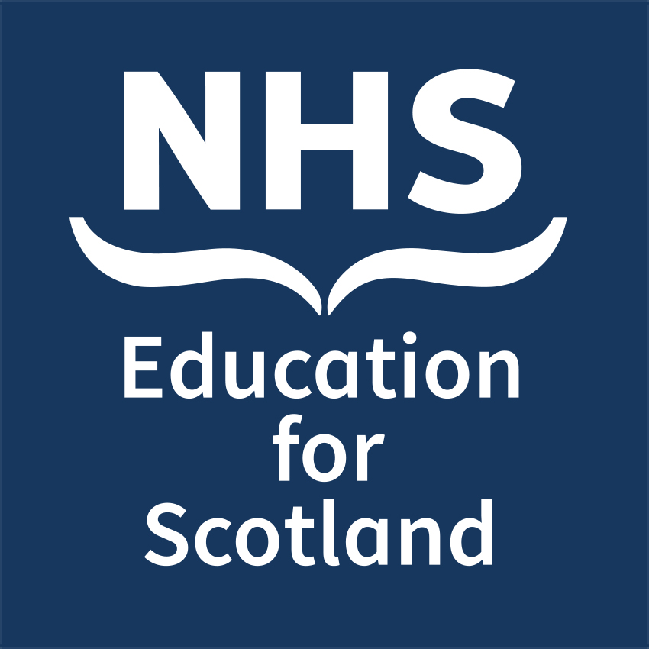

**NES Annual Conference 2026 - Collaborate. Innovate.**

**Transform: Delivering change towards improving health,**

**social care and other public services in Scotland  
 Thursday 23 and Friday 24 April 2026**

**Open Paper Session & Poster Abstract Submission Form**

**Title of Abstract:**

**Name of presenting author:**

**Email of presenting author:**

**Name(s) of co-author(s):**

**Institution(s) where work carried out:**

Do you work for NHS Education for Scotland

**Abstract category (please select one):**

Careers – Structure & Support

Interprofessional Education

Miscellaneous

New Perspectives & Novel Methods in Education & Training

Online Learning

Simulation

Training Delivery

**Submission for consideration as:**

Open Paper Session: 12 min Presentation Poster only

**Abstract text (300-word limit) please use the following structure: Introduction, Methods,**

**Results/Discussion, Conclusion. The objectives of your poster presentation should be related to the theme of the conference.**

Please email your completed form to: [nes.conference@nhs.scot](mailto:nes.conference@nhs.scot)

**Deadline for submission:** **23:59, 1 February 2026**