

**Annual Employment Equality and Diversity Monitoring Report 2023/24**

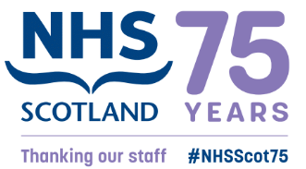

**NHS Education for Scotland - 2024**

CONTENTS

1. INTRODUCTION 3

2. WORKFORCE COMPOSITION 4

2.1 Sex 4

2.2 Ethnic Origin 6

2.3 Disability 9

2.4 Age 11

2.5 Religion or Belief 12

2.6 Sexual orientation 13

3. RETENTION 14

4. STAFF DEVELOPMENT 17

4.1 Promotions 17

4.2 Training 18

5. RECRUITMENT AND SELECTION 18

5.1 Attraction 18

6. PAY GAP 19

7. Progress on recommendations 22

8. Recommendations 23

# INTRODUCTION

Gathering and analysing equality and diversity information on the workforce is important to inform our work to progress equality, tackle discrimination and harassment and address prejudice in the workplace. We have a specific duty as part of the Public Sector Equality Duty in Scotland to gather information on the composition of our workforce and information on the recruitment, retention, and development of our employees by each of the protected characteristics. We gather and analyse this data annually.

Good employee information helps us to meet the Public Sector Equality Duty by, for example, identifying key issues for us as an employer to progress equality and identify any actions to avoid discrimination and harassment. Analysis of our workforce data informs areas for improvement and allows us to monitor our progress. Knowing your workforce through data is one of four areas of focus identified in the [Scottish Government’s Anti-Racist Employment Strategy](https://www.gov.scot/publications/fairer-scotland-anti-racist-employment-strategy/pages/2/), published in December 2022.

This report includes an update on progress with actions we are taking as a result of our employee equality and diversity monitoring. We collect and analyse data on the protected characteristics of age, disability, race, gender reassignment, marriage and civil partnership, pregnancy and maternity, religion or belief, sex, and sexual orientation.

The report relates to employees who are directly employed by or on secondment to NES for the financial year 1 April 2023 to 31 March 2024[1]. The report will set out the following by protected characteristic:

* Workforce composition
* Staff retention
* Staff development
* Recruitment and selection
* Gender, Disability and Ethnicity pay gaps

You can see the previous year's report on our website at [Employment equality monitoring and equal pay | NHS Education for (scot.nhs.uk)](https://www.nes.scot.nhs.uk/about-us/equality-diversity-and-human-rights/employment-equality-monitoring-and-equal-pay/)

Data on Doctors and Dentists in Training (DDiT) analysed in this report is limited to the trainees employed by NES. NES is one of four lead employers for trainee doctors in Scotland.

# WORKFORCE COMPOSITION

As well as our core[2] staff, NES is the lead employer for Doctors in Training in General Practice, Public Health, and Occupational Health speciality training. In 2021, NHS Education for Scotland (NES) also became the lead employer for Dental Core (DCT), Specialty Training (STRs) and, in August 2022, Vocational Dental Practice (VDP) trainees. As of 31 March 2024, we employed 1216 core staff and 1991 Doctors and Dentists in Training (DDiT). DDiT’s work in placement settings across NHS Scotland and are recruited through national recruitment processes. Unless otherwise noted, this report will record data on NES employed DDiT separately from our core staff[3].



## Sex

As of 31 March 2024, 66% of the total employed workforce at NES are female. This comprises:

* 74% of NES Core Staff
* 62% of DDiT

NES collects data on gender reassignment, a protected characteristic under the Equality Act (201). This allows an individual to identify themselves as Trans. We do not have sufficient numbers to allow reporting of these figures. Findings from Scotland’s most recent census report that 0.44% of people identified as Trans or having a Trans history[4].

The breakdown by Sex and Grade is set out below in Figure 1.

Figure 1: Sex by grade (Core and DDiT staff)

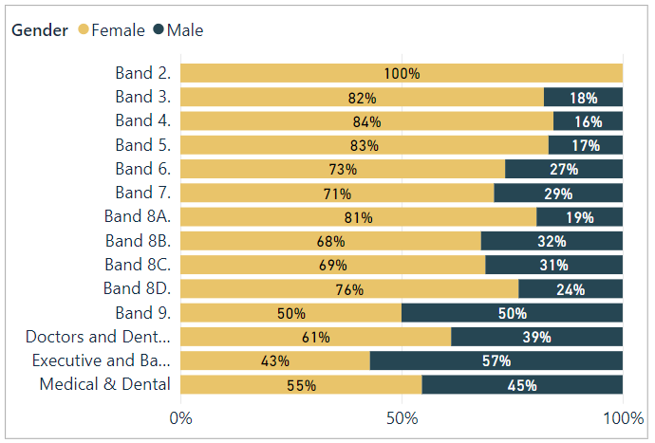

Figure 2: Working pattern by grade and sex for Males (Core and DDiT staff)

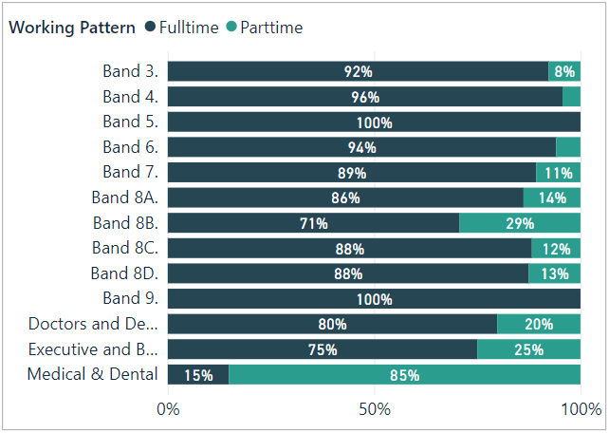

Figure 3: Working pattern by grade and sex for Females (all staff) 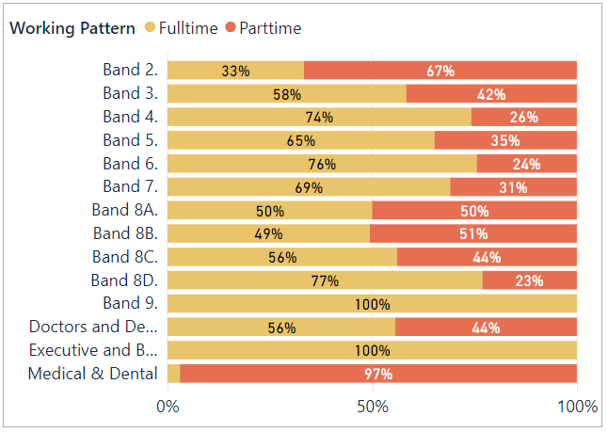

* For core staff, 36% of the workforce work part-time, and a higher proportion of women (83% or 359 members of staff) work part-time compared to men (17% or 76 members of staff).
* Part-time workers are represented across most grades.
* 97% of staff on Medical and Dental terms work part-time. However, this is due to sessional staff who work part-time for NES in an educational capacity but who also have clinical roles.
* Full-time work is most common at bands 4, 6, 8D and 9.
* The Executive Cohort of staff are all full-time.
* The Directorates with the fewest part-time workers are in Workforce, Finance and NES Technology.

## Ethnic Origin

Our core staff are primarily white (92.3%) with 5.3% of staff identifying as being from Black, Asian, Other ethnic backgrounds, or mixed ethnic background. Of the 92.3% who identified as White, 76.3% are White Scottish and 16.4% are Other British.

The ethnic origin of 1.70% (1.77%) of NES core staff is unknown. This is slightly improved from 2023 and is due to better completion rates of data upon joining NES. Unknown data is where individuals have not disclosed this information or data is unavailable. For certain types of workers, we do not have full data e.g. those on secondment agreements where we only have sex and age for payroll purposes, and staff on agency contracts.

* 37.7% of Minority Ethnic staff are represented in bands 5 to 7.
* 29% of Minority Ethnic staff are represented in bands 2 to 4.
* 17.7% of Minority Ethnic staff are on Medical and Dental contract.
* In Bands 8A-D, 8.1% report to be from a Minority Ethnic background.
* 100% of the Executive cohort are White.

Figure 4: Ethnicity (core staff)

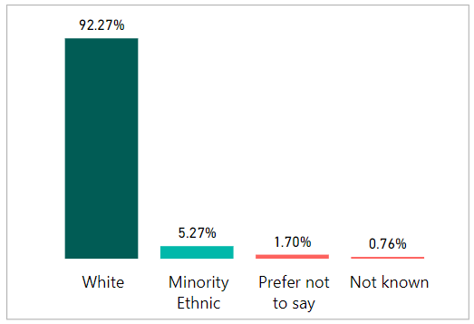

Figure 5: Ethnicity by Grade (Core and DDiT staff)

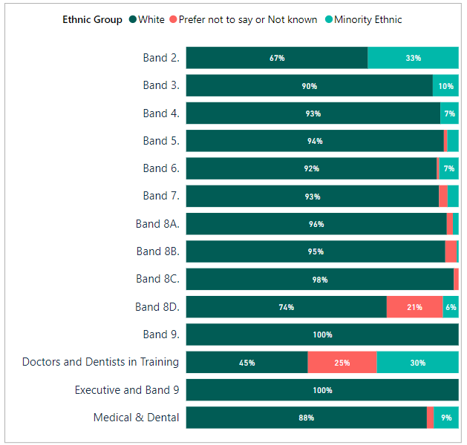

30% of DDiT have disclosed to be from Black and Minority Ethnic, mixed or other ethnic backgrounds. This has increased from 22% in 2022. 23% have not provided data on ethnicity (‘Prefer not to say’ and ‘Not known’) and this is a pattern that is seen across the protected characteristics in this cohort of staff. This information is provided to us from the national recruitment system for DDiT.

Figure 6: Ethnic origin (DDiT)

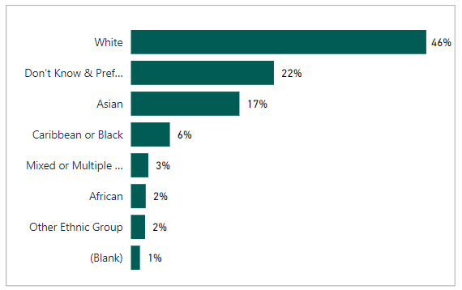

To put our workforce ethnicity data in context we set out below the most recent census data for the Scottish population and the wider NHS Scotland ethnicity profile.

According to the 2022 census[5] Scotland's population was 87.1% white and 12.9% are from a minority ethnic background. The working age minority ethnic background population in Scotland is estimated to be around 5% of the overall working-age population[6].

NHS Scotland’s workforce ethnicity[7] as of March 2023 is:

* 70.08 % - White
* 3.3% - Asian, Asian Scottish or Asian British
* 1.6 % - African, Caribbean or Black
* 1% - Mixed, Multiple or Other ethnicity
* 23.4% declined to answer or are not known.

However, these figures vary across job roles and Health Board areas with varying levels of completion rates across NHS Boards. You can access this data at [NHS Scotland workforce (phase one) | Turas Data Intelligence](https://turasdata.nes.nhs.scot/data-and-reports/official-workforce-statistics/all-official-statistics-publications/04-june-2024-workforce/dashboards/nhs-scotland-workforce-phase-one/?pageid=11804).

## Disability

As shown in Figure 7,

* 3.8% of core staff identified themselves as disabled
* 90.4% identified as nothaving a disability
* 5.8% preferred not to answer or data was unavailable.

Figure 8 shows the percentage of disabled staff in each age cohort, showing higher disability in age cohorts 25-54. We have reason to believe that our disability data reflects under-reporting. Over 24% of the working-age population as of 2021 are disabled.[8] We will encourage staff to update their equality and diversity employment information as this may have changed since taking up employment in the organisation. NHS Scotland equality and diversity monitoring questions have been updated in April 2024 and we are waiting on changes to the national system so we can encourage staff to update their personal details.

Figure 7: Disability (core staff)

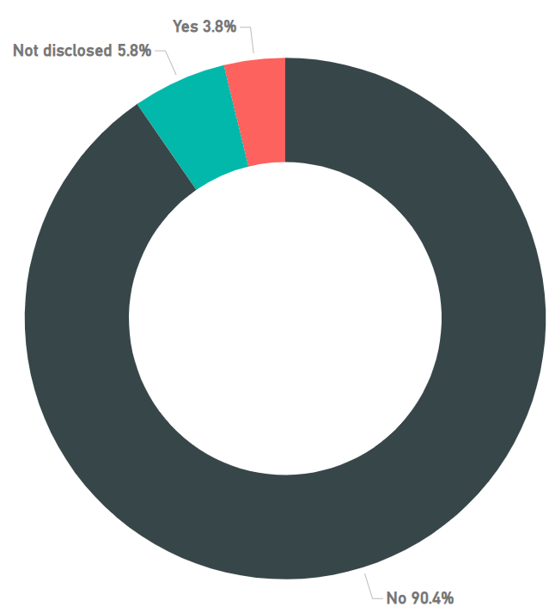

Figure 8: Disability by Age Group (core staff)

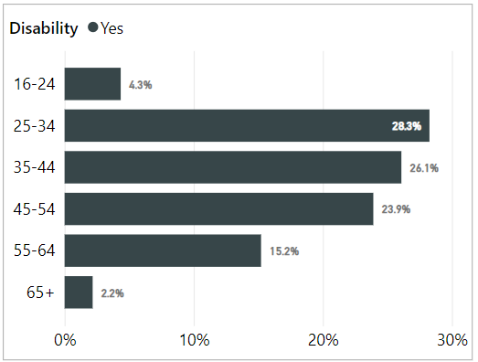

For NES employed DDiT, 1.4% identify themselves as disabled. The actual figure is likely to be higher given that 53.1% of DDiT have not provided information about disability status. This is higher than non-disclosure about ethnicity.

Our Specialist Lead for Disability has a specific role to support our staff, including DDiT where we are the Lead Employer, with reasonable adjustments in the workplace.

## Age

* 81% of core staff are aged between 35 and 64
* The highest % of core staff are aged 45-54 at 32.5%
* The lowest % of core staff are aged 16-24 at 1.3%
* 66.9% of DDiT are aged 25-34

NES has a high number of posts requiring specialist skills or knowledge across various professional fields which may be a factor in low numbers under age 35.

Figure 9a: Age (core staff)

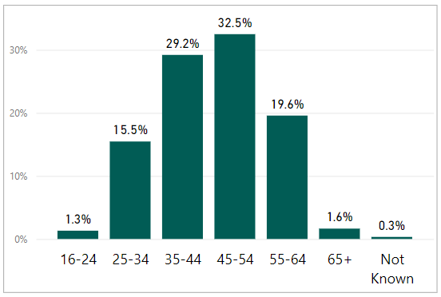

Figure 9b: Age (DDiT)

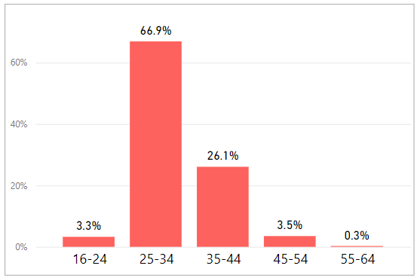

## Religion or Belief

Figures 10a (core staff) and 10b (DDiT) set out our employee data on religion and belief. NES’s core staff reflects a range of religious affiliations, although 'No religion' is the most common identification at 48.3%. This reflects the recent publication on Scotland’s census data on religion, with 51.1% of people having no religion[9].

Figure 10a: Religion (core staff) 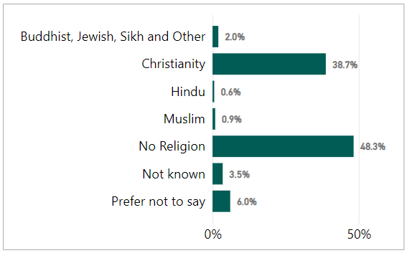

Figure 10a: Religion (DDiT)

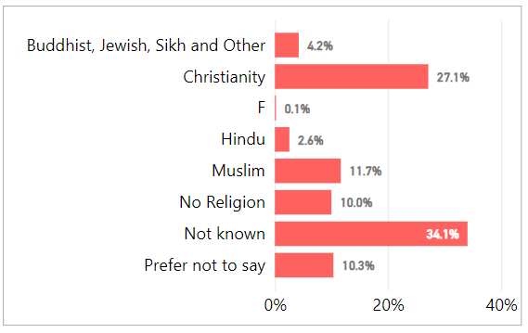

## Sexual orientation

* 5.4% of core staff identify as Lesbian, Gay or Bisexual.
* 4.5% of DDiT identify as Lesbian, Gay or Bisexual.
* The non-disclosure (Preferred not to answer or not known) rate for core staff is 8.1%. This has decreased from 13.3% in 2023. For DDiT this is 28.1%, again a slight decrease from 30.5% in 2023.

Scotland’s census asked about sexual orientation and Trans status for the first time in 2022. The findings were published in June 2024[10] and reported 4% of the population identified as Lesbian, Gay or Bisexual.

Figure 11a: Sexual orientation (core staff)

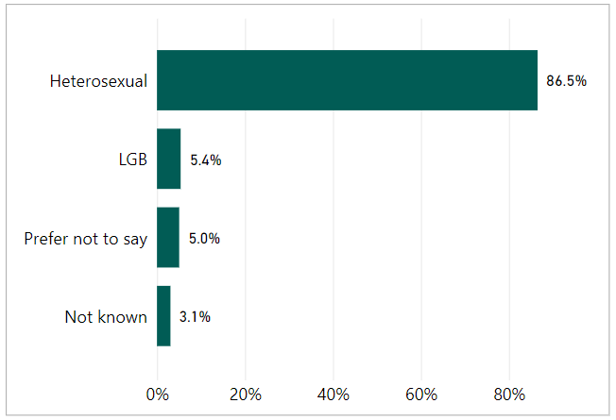

Figure 11b: Sexual orientation (DDiT)

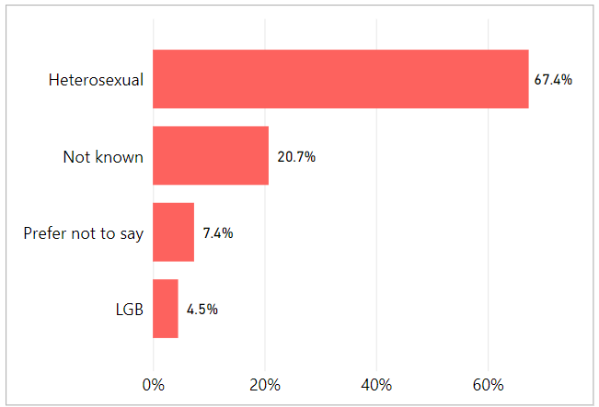

# RETENTION

We monitor employment policy related casework, disaggregated by protected characteristics, and the profile of staff who leave the organisation during the year, in case of any patterns emerging. We also carry out a thematic analysis of exit interviews.

Employment related casework is classified as formal management of a range of employee relations activities, including attendance management, disciplinary, grievance, bullying and harassment, capability and dismissal. We collect and analyse data on a range of activities.

There were four formal employee relations casework events recorded for core NES staff: one for conduct/disciplinary, one for grievance and two for bullying and harassment. Six formal cases were recorded for DDITs: five for conduct/disciplinary, one for grievance. The number of formal cases is too small to permit disaggregated reporting by protected characteristics.

Our approach is to support early and informal resolution of issues where possible. We record informal employee relations support, which may involve advice to staff or managers around specific issues or policies. Informal support is not recorded against individuals and thus is not analysed by protected characteristics.

Between 1 April 2023 and 31 March 2024, 162 employees left NES and 78 completed the exit questionnaire. Of the leavers, 46.91% (76 staff) were on permanent contracts, and 59.88%, (97 staff) were on fixed-term contracts. See Appendix 1 for a breakdown of our leavers profile.

We collect and analyse data on NES core staff who leave the organisation. In the exit questionnaire, leavers are asked a range of questions concerning their experience working for NES. This includes the reasons for leaving (see Figure 11). As part of exit interviews, we also ask how fairly the respondents felt they were treated, how respected they felt, what the attitude to diversity was like in NES and their satisfaction with the organisation when leaving.

* 82% of respondents did not feel that they had been disadvantaged on account of a protected characteristic.

The attitudes of people leaving NES remain largely positive towards the organisation. 65.4% of staff said they were either very satisfied (34.6%) or fairly satisfied (30.8%) towards the end of their employment with NES. 19.2% said they were fairly or very dissatisfied. Of those who said they were fairly or very dissatisfied:

* 54% were female (N=9) (N=15)
* None were disabled
* 6.7% were from a minority ethnic background
* 40% were 25-34 and 40% (N=6) were 55-64
* 53.3% (N=8) were Band 5-
* 46.7% (N=7) were on fixed term contracts and 53.3 %(N=9) were on permanent contracts

We have looked at leavers who reported dissatisfaction upon leaving the organisation by protected characteristic to ensure there are not patterns that highlight wider issues.

Figure 11: Leaving reasons (core staff)

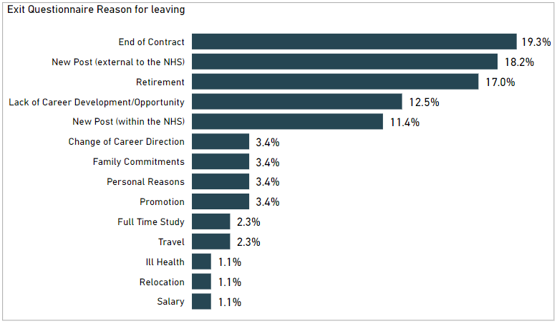

Those leaving the organisation represent just under 10% of the core workforce. See Appendix 1.

* Males as a proportion of the workforce are more likely to leave the organisation than females (34.2%).
* There is a higher proportion of staff in age groups 25-34 (34%) leaving the organisation. This may reflect the stage in career in these age brackets.
* 11.7% of leavers are from a minority ethnic background.
* 60.2% of the leavers were on temporary contracts.
* 3.7% of LGB staff left the organisation, which is a lower proportion than in the workforce.
* 37.7% of staff who left the organisation advised they are Christian with the largest proportion of leavers advising they have no religion at 46.3%.

As we seek to increase the diversity of our workforce and progress equality for under-represented population groups, analysis of the proportion of staff who leave the organisation by protected characteristic to investigate possible reasons for this is important.

# STAFF DEVELOPMENT

This section relates to our core staff only. Education for DDiT is governed through their foundation, core or higher specialty training programmes and follows the curricula written by the Medical Royal Colleges and the Faculty of Dental Surgery and is approved and published by the General Medical Council and General Dental Council.

We analyse access to development for core staff by reviewing data on promotions, secondment or internal attachment, 'acting up' or temporary promotion and data on training. Although our systems enable us to disaggregate all of the data by protected characteristics, some datasets (promotions, secondment/internal attachment, acting up) are quite small and permit only limited analysis.

## Promotions

A promotion within NES is defined as a staff member moving to a higher grade/band on a permanent contract. This report also includes temporary arrangements which provide a development opportunity for staff. By looking at promotions by protected characteristic we can identify if any groups are not experiencing equity in opportunity for career progression. This section does not include DDiT.

From April 2023 to March 2024, there were 79 promotions. Promotions were distributed across the organisation, with at least one in each directorate. A breakdown of promotion by protected characteristics is illustrated in Appendix 2.

* 70.9% of promoted staff were female. This reflects the higher proportion of females in the organisation (74% of NES Core staff are female).
* Females progressed more quickly than males with an average of 6.8 years' service, compared to 8 years for males. This is a change from previous years where males progressed more quickly.
* Staff aged between 35-44 accounted for 32.9% of promotions. Employees aged 55-64 account for 11.4% of the promotions and employees aged 16-24 account for 1.3%.
* 2.5% of staff promoted were from a minority ethnic background. This is lower than the proportion of staff in the workforce who have advised they are from a minority ethnic background (5.9%).
* 58% identified as 'no religion'.
* 6.3% of the employees promoted identified as being disabled. This is higher than the proportion of staff currently declaring a disability in the workforce (3.8%).
* 6.3% of employees promoted identified as LGBT, which is higher than the proportion of LGBT staff in the workforce (5.4%).

## Training

We provide a range of staff development opportunities including work-based learning, e-Learning, attendance at conferences, staff panels and specialist learning events alongside a range of development courses and mandatory (essential) learning via our digital learning platform, Turas Learn. All courses housed on this system provide attendance/completion data and this is summarised in Appendix 3. We also provide a range of self-directed learning as well as webinars and other digital learning offered directly to staff members via Microsoft Teams. These sessions are currently not logged against the individual learning record in Turas and we do not monitor rate of participation by protected characteristics.

We also have a Workforce Development Fund to support staff with funding for learning and development. The fund is promoted to all staff across the organisation and priority is given to staff in Bands 2-6. We currently do not undertake equality monitoring of applications to the fund and will look to introduce this should it continue next year to ensure there is equity in opportunity.

# RECRUITMENT AND SELECTION

The outcomes for recruitment and selection of core staff are analysed in this section. DDiT are recruited through a national recruitment process for appointment to training posts across NHS Scotland (excludes Locum Appointments for Training). The standards and criteria for this process are set at UK level. Outcomes from this process are analysed separately at a national level. This is available at [Equality and diversity 2023 recruitment data | Medical Hub (hee.nhs.uk)](https://medical.hee.nhs.uk/medical-training-recruitment/medical-specialty-training/equality-and-diversity/equality-and-diversity-2023-recruitment-data)

Appendix 4 summarises the overall number of applications and number of individuals shortlisted, interviewed and appointed to our core staff and applications by protected characteristic during the period 202/24.

## Attraction

Our vacancies will continue to be considered for internal advert in the first instance (i.e. to existing NES workers, including agency and secondments) before consideration is given to advertise externally. All vacancies pass through a robust corporate establishment control approval process prior to advertising, with data monitored at each stage of the recruitment cycle.

We received 1899 (34.4%) from a total of 5547 applications from applicants from Black, Asian and minority ethnic backgrounds. This is an increase from 2022/23 which was 24.1%. The diversity of applicants for posts varies across the organisation, with the greatest diversity of applicants for posts in the Technology Services, Workforce and Medical Directorates. Applicant ethnic diversity was lower for posts in the Dental and Planning & Corporate Resources Directorates.

Applicants from Black, Asian and minority ethnic backgrounds have a differential likelihood relative to those of white ethnicity of progressing from interview to appointment (11.1% vs. 19.4%). In 2022/23, it was 18% compared to 26.6%. From application to appointment, the percentage of applicants from a Black, Asian and Minority ethnic background was 0.84% (1.87%) compared to 4.25%. Of the 1899 applicants, 1172 (61%) advised that they required a work permit which may mean that many of the applicants were not eligible to take up a post. We will continue to monitor this.

8% of applicants identified themselves as disabled. As over 24% of the working-age population in Scotland have a disability we would expect this to be higher. We have renewed our Disability Confident Employer Status and will promote this on our website and as part of our recruitment materials.

8.2% of applicants identified as LGB or ‘other’ which compares with Stonewall Scotland's estimate of LGB people in the working age population. The success rate for LGB applicants to appointment is 4.2% compared to 3.6% of applicants that are heterosexual.

Our applications represent a range of religious backgrounds and those identifying with no religion are most prevalent (40.5%). We attract a similar percentage of applications from those identifying as Roman Catholic or Church of Scotland in the overall total number of applications. There is no significant difference in appointment rates between those identifying as Roman Catholic (9.9%) or Church of Scotland (7.6%). The number of individual applications in most of the minority religions is too small for statistical analysis (less than 10%). 6% of applicants chose 'Prefer not to say' and 39.9% chose ‘No religion’.

63% (70%) of our appointments in 2023/24 were women, which is a reduction from 70% last year. Women formed most appointments across the organisation and at most grades. Appendix 4 illustrates the age distribution of applications for core NES posts. 16.6% of applicants did not complete information on age.

# PAY GAP

The Equality Act 2010 (Specific Duties) (Scotland) Regulations 2012[11] specify that public authorities must report the gender pay gap in the form of ‘information on the percentage difference among its employees between men’s average hourly pay (excluding overtime) and women’s average hourly pay (excluding overtime)’. The specific formula used for this calculation is the formula for the average pay gap set out in the guidance published by Close the Gap[12]. The specific formula is (A – B)/A X 100, where A = average hourly rate of pay of men and B = average hourly rate of pay of women.

Using this method of analysis, as of 31 March 2024 NES’s overall gender pay gap is 4.30%. The average hourly pay for women is £25.42 and for men is £26.56. Our current gender pay gap is below the Scottish public sector average of 10.4%[13].

TABLE 1: Gender pay gap

|  |  |  |  |  |  |  |  |
| --- | --- | --- | --- | --- | --- | --- | --- |
| This table provides a summary of the hourly pay rate and the gender pay gap for each contract group. The figures reported in this table show a comparison between women’s and men’s average hourly pay within the specific contract group. | | | | | | | |
| **Pay scale** | **As of March 2018** | **As of March 2019** | **As of March 2020** | **As of March 2021** | **As of March 2022** | **As of March 2023** | **As of March 2024** |
| Agenda for Change | 1.25% | 6.58% | 9.62% | 8.43% | 6.02% (893) | 5.60%  (1069) | 9.66% (1084) |
| Executive Managers Cohort | -30.07% | -3.29% | -1.39% | -2.19% | -6.99% (7) | -2.34%  (7) | -6.04% (7) |
| GP/GDP Eds, CRUMP and Consultants | 13.52% | 8.12% | 0.72% | 5.67% | 1.85% (121) | 2.72%  (130) | 2.70% (130) |
| DDiT | -2.00% | -1.54% | 4.73% | -1.26% | -1.30% (1727) | -2.63%  (1926) | -1.96% (1855) |
| **Pay Gap** | **27.6%** | **13.3%** | **7.9%** | **7.0%** | **5.4%** | **2.70%** | **4.30%** |
| Hourly Rate is calculated as ('Contracted Hours' x 52.179) / (Annual Salary * WTE) | | | | | | | |

In presenting the gender pay gap information, the nature of the calculations (based on average pay figures) means that the data is very susceptible to being skewed by large numbers of outlying pay levels. This is very relevant for the profile of the NES workforce. Over the course of the last two years NES has employed a large number of DDiT, which has contributed to reducing the gender pay gap.

If we extract DDiT from the pay gap calculations (given recruitment is undertaken at a UK level rather than by NES), NES’s gender pay gap is 17.9%. When looking at the data this year, this is due to recruitment of men into higher-graded posts. .

We have used the same method to calculate our Disability and Ethnicity Pay Gaps. These are set out below in Table 2 and Table 3. This is the first time we have published these pay gaps. We now also report to the Board on our Gender, Disability and Ethnicity Pay Gap as part of the Board’s Key Performance Indicators.

TABLE 2: Disability pay gap as of 31 March 2024

|  |  |  |
| --- | --- | --- |
| **Payscale** | **As of**  **March 2023** | **As of**  **March 2024** |
| Agenda for Change | 16.7% | 9.63% |
| Executive Managers Cohort | - |  |
| GP/GDP Ed's,CRUMP and Consultants | 2.5% | -0.31% |
| Doctors and Dentists in Training | 0.9% | -2.31% |
| **Disability pay gap** | **9.19%** | **6.36%** |

The overall disability pay gap is 6.36%, a reduction from 2023. If we extract DDiT from the pay gap calculations NES’s disability pay gap is 15.96%, a reduction from 2023 which was 19.4%. We recognise that under-reporting of disability from staff will affect our disability pay gap calculation.

TABLE 3: Ethnicity pay gap as of 31 March 2024

|  |  |  |
| --- | --- | --- |
| **Payscale** | **As of March 2023** | **As of March 2024** |
| Agenda for Change | 17.2% | 18.20% |
| Executive Managers Cohort | - | - |
| GP/GDP Ed's,CRUMP and Consultants | -1.5% | -0.26% |
| Doctors and Dentists in Training | 4.20% | 4.42% |
| **Ethnic Origin pay gap** | **11.11%** | **9.50%** |

As of March 2024, the Ethnicity pay gap is 9.50%, a reduction from 2023. If we extract DDiT, the pay gap for NES Core Staff is 5.90%, a reduction from 6.6% in 2023, The higher pay gap at Agenda for Change pay grades may be due to an increase in staff joining NES on entry-level pay banding. The latest estimate show that Scotland's ethnicity pay gap was estimated to be 10.3% in 2019.[14] The Disability pay gap is has been calculated to be 16.2% in Scotland in 2019.[15]

# Update on Actions 2023 and Recommendations

Employee monitoring is part of wider work at NES to progress equality, tackle discrimination and create an inclusive workplace for our staff. We have a specific Equality Outcome to improve recruitment outcomes for younger candidates, minority ethnic candidates and disabled candidates. We will continue to provide progress reports through our Staff Governance Committee and to our Board on our Equality Outcomes.

7.1 The following actions were identified in our analysis from last year and an update is provided:

|  |  |  |
| --- | --- | --- |
| **Action 2023-24** | **Progress** | **Continue to 2024/5** |
| Deliver a campaign to improve our workforce equality and diversity data following relevant system changes being done nationally following approval of new monitoring questions. This data will follow through if appointed for new recruits, but we recognise that data may change for staff in post e.g., disabilities may develop over time in the organisation | This action is remaining as the national system has not been updated. A blog to promote the new questions for new recruits is available on the NHS Scotland careers website at [Recruiting and supporting a diverse workforce: equality and (nhs.scot)](https://www.careers.nhs.scot/blog/recruiting-and-supporting-a-diverse-workforce-equality-and-diversity-monitoring/) | Yes – campaign will be launched once the eESS system has been updated. |
| Evaluate the new recruitment e-learning modules, ensuring panel members undertake training. | This has not been undertaken due to capacity issues in the HR team. However, we have promoted the learning and the Equality and Diversity Team developed a resource to consider bias in recruitment which has been promoted across NES. We also held a learning session for over 140 staff on ‘Conscious Inclusion’ in June 2024. | Yes |
| Revise NES website on equality, diversity and inclusion to promote our work as inclusive employer and our Disability and Carer Positive Awards. | Completed | No |
| Annual reporting and trend analysis on pay gaps as part of Board Strategic Key Performance Indicators. | Complete. | This will continue. |
| Explore how to introduce equality monitoring of applications to the Workforce Development Fund. | Not progressed. | This is dependent upon funding in 2024/25 for the fund. |

**8.2 Actions for 2024/5**

* Deliver a campaign to improve our workforce equality and diversity data following relevant system changes being completed nationally following approval of new monitoring questions. This data will follow through if appointed for new recruits, but we recognise that data may change for staff in post e.g., disabilities may develop over time in the organisation.
* Explore how NES can improve Doctors and Dentists in Training workforce diversity data (UK national data) via Turas TPM.
* Evaluate the uptake of recruitment e-learning modules, continue to promote the ‘bias in recruitment’ resource for panel members and ensure recruiting line managers are trained appropriately.
* Continue to report annually on Gender, Disability and Ethnicity pay gap as part of Board strategic KPI reporting.

APPENDIX 1: Leavers profile (core staff)

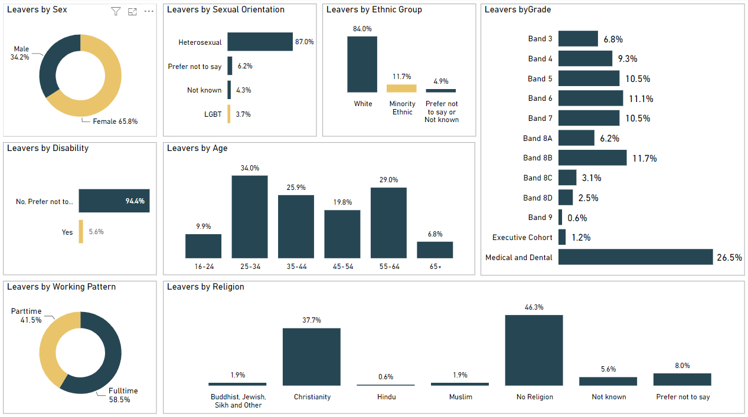

APPENDIX 2: Promotions profile (core staff)

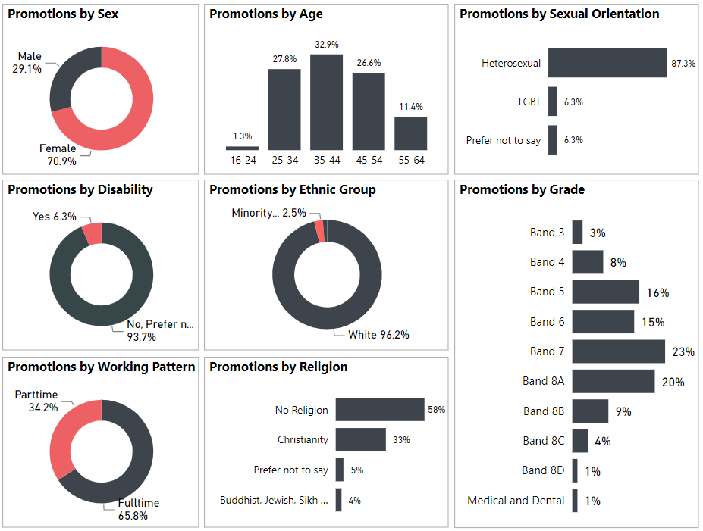

APPENDIX 3: Training completed on Turas Learn application (core staff)

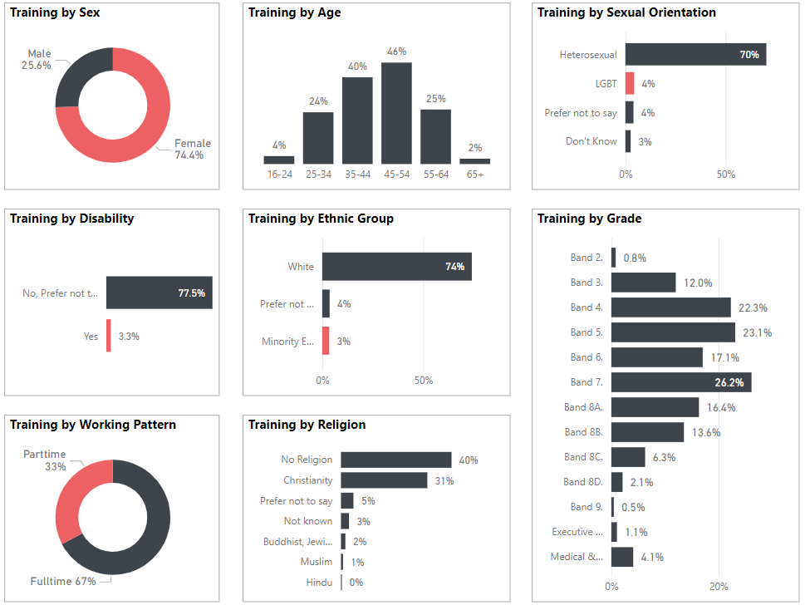

APPENDIX 4: Recruitment - Candidate profile (core staff)

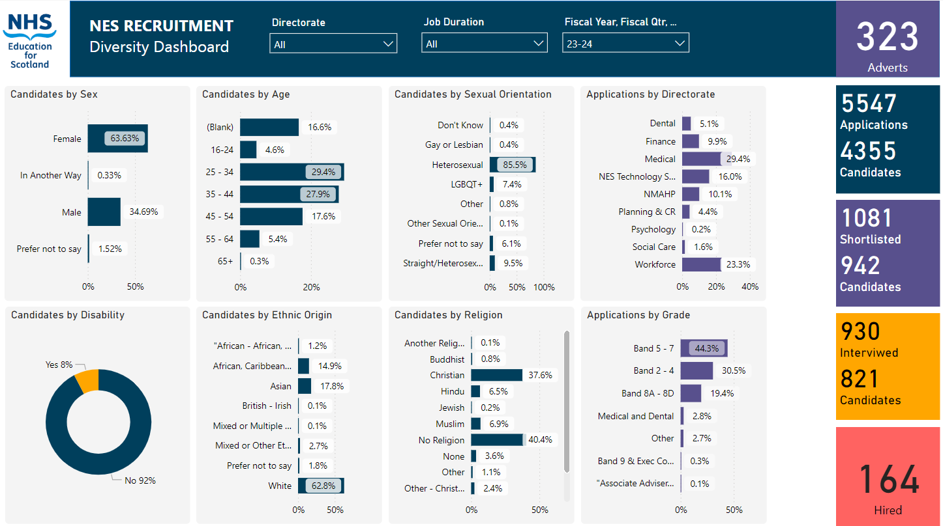

© NHS Education for www.nes.scot.nhs.uk Scotland [2023]. You can copy or reproduce the information in this resource for use within NHSScotland and for non-commercial educational purposes. Use of this document for commercial purposes is permitted only with the written permission of NES

**NHS Education for Scotland**

**Westport 102**

**West Port**

**Edinburgh**

**EH3 9DN**

This resource may be made available, in alternative formats and community languages. Please contact us on **0131 656 3200** or email **altformats@nes.scot.nhs.uk** to discuss how we can best meet your requirements.

1. For Data Protection reasons we are not allowed to report on any categories if there are under five staff present in that category.
2. We refer to all staff employed by NES who are not employed as Doctors or Dentists in Training and working in NHS Boards as part of their training as core staff. This includes a variety of roles across our organisation.
3. NES is one of four Lead Employers across NHS Scotland that employ Doctors and Dentists (DDiT) in training. We only include data on those trainees where NES is the employer.
4. [Scotland’s Census – Sexual orientation and trans status or history | Scotland's Census (scotlandscensus.gov.uk)](https://www.scotlandscensus.gov.uk/news-and-events/scotland-s-census-sexual-orientation-and-trans-status-or-history/#:~:text=27%20Jun%202024-,Scotland's%20Census%20%E2%80%93%20Sexual%20orientation%20and%20trans%20status%20or%20history,people%20aged%2016%20and%20over.)
5. [Scotland’s Census 2022 - Ethnic group, national identity, language and religion | Scotland's Census (scotlandscensus.gov.uk)](https://www.scotlandscensus.gov.uk/2022-results/scotland-s-census-2022-ethnic-group-national-identity-language-and-religion/)
6. [Anti-racist employment strategy - A Fairer Scotland for All - gov.scot (www.gov.scot)](https://www.gov.scot/publications/fairer-scotland-anti-racist-employment-strategy/pages/4/)
7. https://turasdata.nes.nhs.scot/data-and-reports/official-workforce-statistics/all-official-statistics-publications/04-june-2024-workforce/dashboards/nhs-scotland-workforce-phase-one/?pageid=11804
8. [Guest blog – Disability Employment in Scotland: Initial Findings – SPICe Spotlight | Solas air SPICe (spice-spotlight.scot)](https://spice-spotlight.scot/2023/09/26/guest-blog-disability-employment-in-scotland-initial-findings/#:~:text=In%202014%2C%20around%2018%25%20of,of%202021%20(Chart%202a).)
9. [Scotland’s Census – religion, ethnic group, language and national identity results | Scotland's Census (scotlandscensus.gov.uk)](https://www.scotlandscensus.gov.uk/news-and-events/scotland-s-census-religion-ethnic-group-language-and-national-identity-results/)
10. [Scotland’s Census 2022 - Sexual orientation and trans status or history | Scotland's Census (scotlandscensus.gov.uk)](https://www.scotlandscensus.gov.uk/2022-results/scotland-s-census-2022-sexual-orientation-and-trans-status-or-history/#section3)
11. [The Equality Act 2010 (Specific Duties) (Scotland) Regulations 2012 (legislation.gov.uk)](https://www.legislation.gov.uk/sdsi/2012/9780111016718/contents)
12. <https://www.closethegap.org.uk/content/resources/Gender-pay-gap-statistics-paper-2022.pdf>
13. [Gender-pay-gap-statistics-paper-2023.pdf (closethegap.org.uk)](https://www.closethegap.org.uk/content/resources/Gender-pay-gap-statistics-paper-2023.pdf)
14. [Analysis of Labour Market Outcomes of Scotland’s Minority Ethnic Population (www.gov.scot)](https://www.gov.scot/binaries/content/documents/govscot/publications/strategy-plan/2022/12/fairer-scotland-anti-racist-employment-strategy2/documents/analysis-labour-market-outcomes-scotlands-minority-ethnic-population/analysis-labour-market-outcomes-scotlands-minority-ethnic-population/govscot%3Adocument/analysis-labour-market-outcomes-scotlands-minority-ethnic-population.pdf)
15. [Disability Pay Gap - Labour Market Statistics for Scotland by Disability: January to December 2022 - gov.scot (www.gov.scot)](https://www.gov.scot/publications/labour-market-statistics-for-scotland-by-disability-january-to-december-2022/pages/disability-pay-gap/)