Annual Employment Equality and Diversity Monitoring Report 2022/23

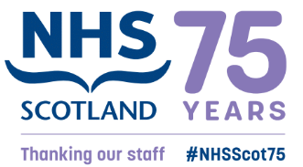

NHS Education for Scotland - 2023
CONTENTS

1. INTRODUCTION 3
2. WORKFORCE COMPOSITION 4
2.1 Sex 4
2.2 Ethnic Origin 6
2.3 Disability 9
2.4 Age 10
2.5 Religion or Belief 11
2.6 Sexual orientation 12
3. RETENTION 13
4. STAFF DEVELOPMENT 15
4.1 Promotions 15
4.2 Training 16
5. RECRUITMENT AND SELECTION 17
5.1 Attraction 17
6. PAY GAP 18
7. Progress on recommendations 21
8. Recommendations 22

INTRODUCTION
Gathering and analysing equality and diversity information on the workforce is important to inform our work to progress equality, tackle discrimination and harassment and address prejudice in the workplace. We have a specific duty as part of the Public Sector Equality Duty in Scotland to gather information on the composition of our workforce and information on the recruitment, retention, and development of our employees by each of the protected characteristics. We gather and analyse this data annually.

Good employee information helps us to meet the Public Sector Equality Duty by for example, identifying key issues for us as an employer to progress equality and identify any actions to avoid discrimination and harassment. Analysis of our workforce data informs areas for improvement and allows us to monitor our progress. Knowing your workforce through data is one of 4 areas of focus identified in the Scottish Government’s Anti-Racist Employment Strategy, published in December 2022.

This report includes an update on progress with actions we are taking as a result of our employee equality and diversity monitoring. We collect and analyse data on the protected characteristics of age, disability, race, gender reassignment, marriage and civil partnership, pregnancy and maternity, religion or belief, sex, and sexual orientation.

The report relates to employees who are directly employed by or on secondment to NES for the financial year 1 April 2022 to 31 March 2023.The report will set out by relevant protected characteristic:
- Workforce composition
- Staff retention
- Staff development
- Recruitment and selection
- Gender, Disability and Ethnicity pay gaps
The data in this report relates to employees who are directly employed by or on secondment to NES. It summarises key findings from our workforce equalities data as of 31 March 2023 and, unless otherwise noted, refers to the financial year 1 April 2022 to 31 March 2023.

Data on Doctors and Dentists in Training (DDiT) analysed in this report is limited to the trainees employed by NES. NES is one of four lead employers for trainee doctors in Scotland.

WORKFORCE COMPOSITION
As well as our core staff, NES is the lead employer for Doctors in Training in General Practice, Public Health, and Occupational Health speciality training. In 2021, NHS Education for Scotland (NES) also became the lead employer for Dental Core (DCT), Specialty Training (STRs) and, in August 2022,Vocational Dental Practice (VDP) trainees. As at 31 March 2023, we employed 1167 core staff and 1918 DDiT. DDiT’s work in placement settings across NHS Scotland and are recruited through national recruitment processes. Unless otherwise noted, this report will report data on NES employed DDiT separately from our core staff.

Sex
As of 31 March 2023, women comprised 66% of the total employed workforce at NES.
- 72% of NES Core Staff are female
- 61% of DDiT are female

NES collects data on gender identity, which would enable an individual to identify themselves as trans. We do not have sufficient numbers to allow reporting of these figures. The breakdown by Sex and Grade is set out below in Figure 1.

Figure 1: Sex by grade (all staff)
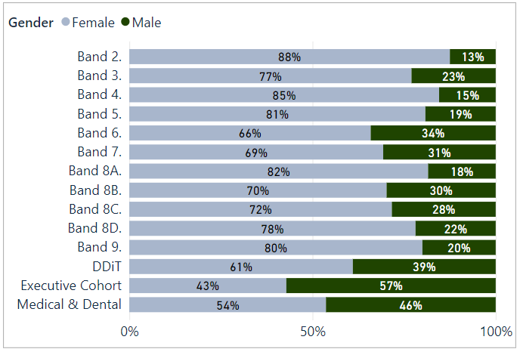
Figure 2: Working pattern by grade and sex for Males (all staff)
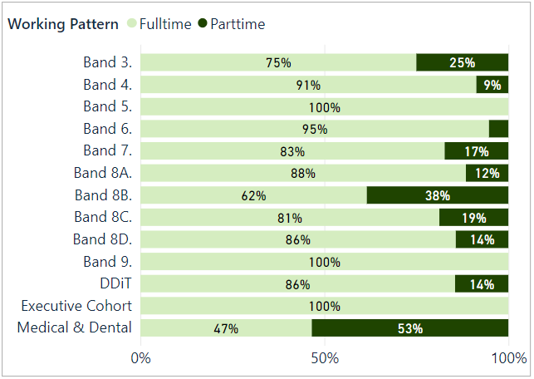

Figure 3: Working pattern by grade and sex for Females (all staff) 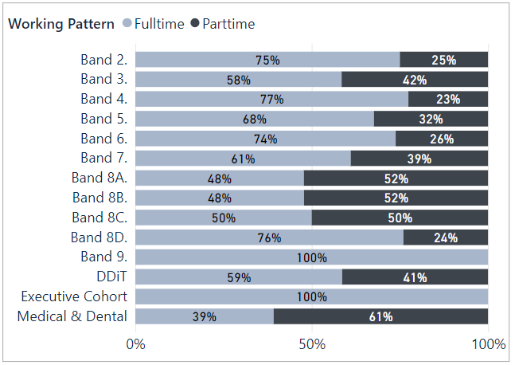

- For core staff, 36% (447) of the workforce work part-time, and a higher proportion of women (81%, 363 members of staff) work part-time compared to men (19%, 84 members of staff).
- Part-time workers are represented across most grades.
- The highest ratios of part-time working are on Medical and Dental terms and conditions, followed by bands 8B, 8A and 8C. . These include sessional staff who work part-time for NES in an educational capacity but often have clinical roles in NHS Scotland.
- Full-time work is more common at bands 4, 6, 8D and 9.
- The Executive Cohort of staff are all full-time.
- At less than 20% the Workforce, Finance and NES Technology Directorates have the fewest part-time workers.

Ethnic Origin
Our core staff are primarily white (92.84%), with 5.39% of staff identifying as being from a Black, Asian, Other ethnic backgrounds, or mixed ethnic background. This is an increase from 4.8% in 2022. Of the 92.84% who identified as White, 71.64% are White Scottish and 13.87% are Other British.
The ethnic origin of 1.77% of NES core staff is unknown which is a reduction from 7% unknown in 2022. This is due to better completion rates of data upon joining NES. Unknown data is where individuals have not disclosed this information or data is unavailable. For certain types of workers we do not have a full data e.g. those on secondment agreements where we only have gender and age for payroll purposes, and staff on agency contracts.
- 44.25% of Minority Ethnic staff are represented in bands 5 to 7
- 26.23% of Minority Ethnic staff are represented in bands 2 to 4.
- 16.39% of Minority Ethnic staff are on Medical and Dental contract
- In Bands 8A-D, 1.92% report to be from a minority ethnic background.
- 100% of the Executive cohort are White

Figure 4: Ethnicity (core staff)
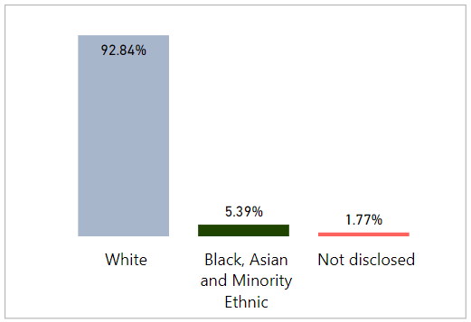
Figure 5: Ethnicity by Grade (all staff)
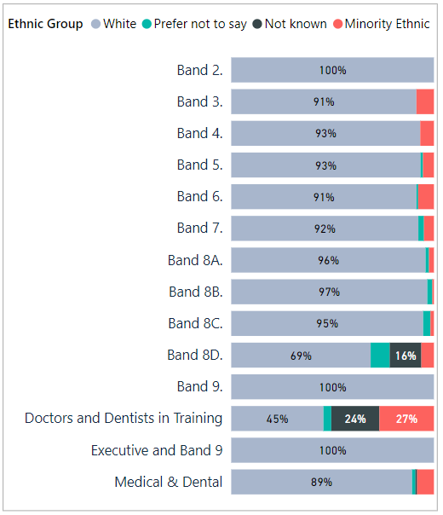

27% (22% in 2022) of DDiT have disclosed to be from Black and Minority Ethnic, mixed or other ethnic backgrounds. 26% have not provided data on ethnicity (‘Prefer not to say’ and ‘Not known’) and this is a pattern that is seen across the protected characteristics in this cohort of staff. This information is provided to us from the national recruitment system for DDiT.
A lack of equality and diversity data for DDiT (and the wider workforce) is an issue for other Health Boards and parts of the system. For example, the Scotland Deanery in NES, which works with Health Boards and GPs to provide training for all DDiT has undertaken a campaign to encourage all trainees to provide up to date equality and diversity information through the Turas platform. This led to an increase in completion of data and will be repeated in 2023. This data is in relation to NES’s training role and covers all trainees, rather than NES in its employment function as a Lead Employer.

Figure 6: Ethnic origin (DDiT)
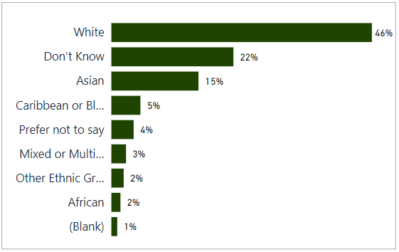
To put our workforce ethnicity data in context we set out below the most recent census data for the Scottish population and the wider NHS Scotland ethnicity profile.

According to the 2011 census:
- Scotland's population was 96.02% white, 2.66% of Scotland's population identified as Asian, Asian Scottish or Asian British.
- African Caribbean or Black groups comprised just over 1% of Scotland's population.
- Under 1% of Scotland's population identified as having a Mixed, Multiple or Other ethnicity.
As of 31 March 2023, NHS Scotland ethnic diversity:
- 71.20% identified as White
- 2.87% identified as Asian, Asian Scottish or Asian British
- 0.79% identified as African, Caribbean or Black
- 0.50% identified as having Mixed, Multiple or Other ethnicity

However, these figures vary across job roles and Health Board areas with varying levels of completion rates across NHS Boards.

Disability
Figure 7 shows that
- 3.7% of core staff identified themselves as disabled
- 86.7% as advised they did not have a disability
- 9.6% preferred not to answer or data was unavailable.
Figure 8 shows the percentage of disabled staff in each age cohort showing higher disability in age cohorts 25-54. We have reason to believe that our disability data reflects under-reporting. Over 24% of the working-age population as of 2021 are disabled. We will encourage staff to update their equality and diversity employment information as this may have changed since taking up employment in the organisation. This was an action identified in our 2021/2022 report and an update is included in this report.

Figure 7: Disability (core staff)
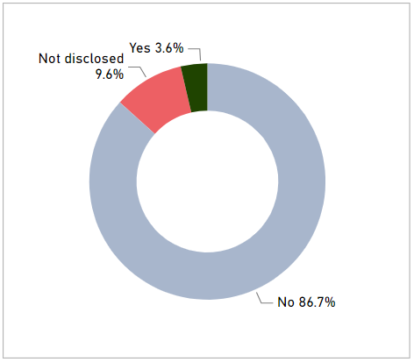

Figure 8: Disability by Age Group (core staff)
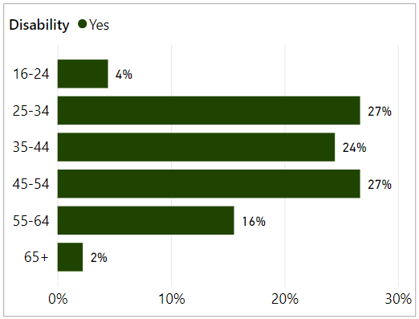

For NES employed DDiT, 1.2% identify themselves as disabled. The actual figure is likely to be higher given that 49.8% of DDiT have not provided information about disability status. This is higher than non-disclosure about ethnicity.
Our specialist lead for Disability has a specific role to support our staff, including DDiT where we are the Lead Employer, with reasonable adjustments in the workplace. As identified above, work by NES is required to encourage DDiT to complete equality and diversity monitoring to improve data and importantly the actions that we can take to progress equality for disabled people in the workplace.

Age
- 78% of core staff are aged between 35 and 64
- The highest % of core staff are aged 45-54 at 30.79%
- The lowest % of core staff are aged 65 or over at 1.13%
- Just under 70% of DDiT are aged 25-34
NES has a high number of posts requiring specialist skills or knowledge across various professional fields which may be a factor in low numbers under age 35.

Figure 9a: Age (core staff) insert
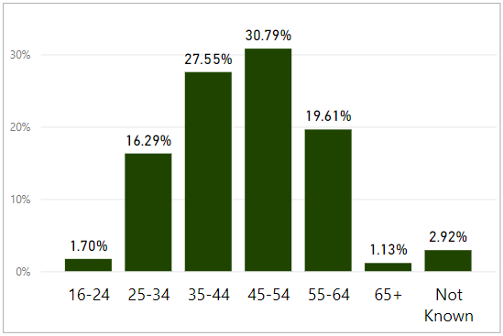
Figure 9b: Age (DDiT)
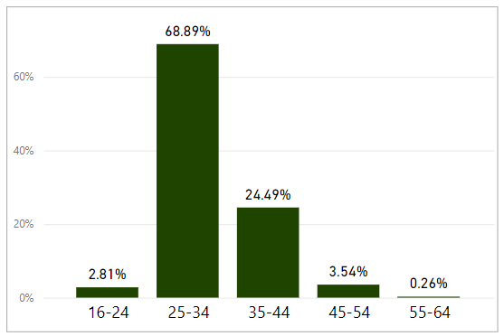

Religion or Belief
Figure 10a (core staff) and 10b (DDiT) sets out our employee data on religion and belief . NES’s core staff reflects a range of religious affiliations, although 'No religion' is the most common identification at 46%.
Figure 10a: Religion (core staff)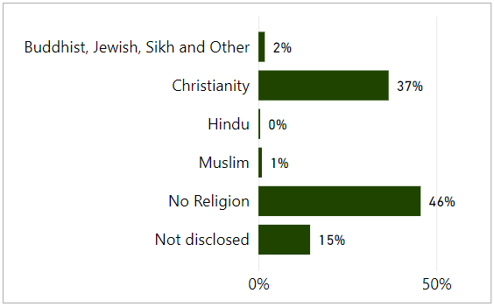
Figure 10a: Religion (DDiT)
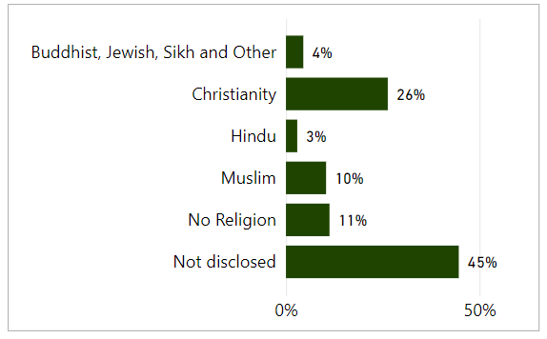

Sexual orientation
- 82.1% of core staff reported their sexual orientation to be heterosexual.
- 4.6% of core staff identify as Lesbian, Gay or Bisexual, an increase from 3.9% in 2022.
- 3.7% of DDiT identify as Lesbian, Gay or Bisexual, also a slight increase from 2022. 65.8% report to be hetersexual.
- The non-disclosure (Preferred not to answer or Not known) rate for core staff is 13.3% and for DDiT is 30.5.
A UK-wide Annual Population Survey in 2020 found that 3.1% of Scottish participants identified as gay, lesbian or bisexual. Scotland’s 2022 census survey will report information on sexual orientation in 2024.

Figure 11a: Sexual orientation (core staff)
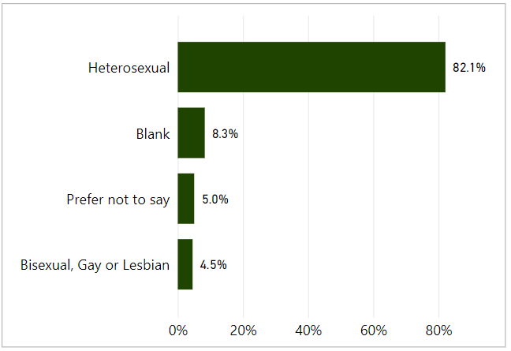
Figure 11b: Sexual orientation (DDiT)
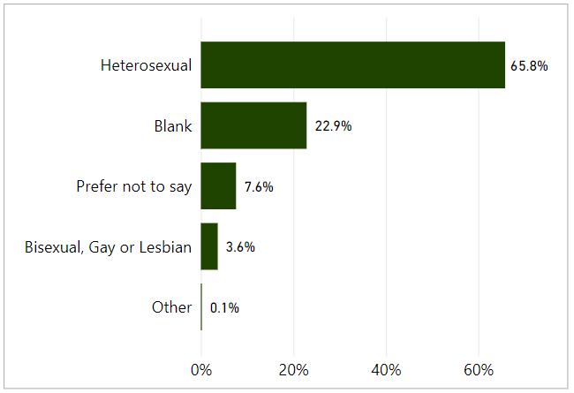

RETENTION

We monitor employment policy related casework, disaggregated by protected characteristics, and the profile of staff who leave the organisation during the year, in case of any patterns emerging. We also carry out a thematic analysis of exit interviews.
Employment related casework is classified as formal management of a range of employee relations activities, including attendance management, disciplinary, grievance, bullying and harassment, capability and dismissal. We collect and analyse data on a range of activities.
There were 6 formal employee relations casework events were recorded for core NES staff: 2 for conduct/disciplinary, 2 for capability and 2 for attendance. The same figures for DDiT were 6 for conduct/disciplinary, 2 for bullying and harassment, 1 for grievance. The number of formal cases is too small to permit disaggregated reporting by protected characteristics.
Our approach is to support early and informal resolution of issues where possible. We record informal employee relations support, which may involve advice to staff or managers around specific issues or policies. Informal support is not recorded against individuals and thus is not analysed by protected characteristics.
Between 1 April 2022 and 31 March 2023, 141 employees left NES and 73 completed the exit questionnaire. Of the leavers, 70.21%, N=99 were on permanent contracts, and 29.79%, N=42 were on fixed-term contracts. See appendix 1 for a breakdown of our leavers profile.
We collect and analyse data on NES core staff who leave the organisation. In the exit questionnaire, leavers are asked a range of questions concerning their experience working for NES. This includes the reasons for leaving (see Figure 11). As part of exit interviews, we also ask how fairly the respondents felt they were treated, how respected they were, what the attitude to diversity was like in NES and their satisfaction with the organisation when leaving.
- 83.5% of respondents did not feel that they had been disadvantaged on account of a protected characteristic.
- Further work is required to understand those who did not respond positively to this question as part of the exit interview to enable issues to be addressed through workforce policies and procedures and the personal development and review process.
The attitudes of people leaving NES remain largely positive towards the organisation. 64.33% of staff said they were either very satisfied (34.2%),) or fairly satisfied (30.1%), towards the end of their employment with NES. 24.7% said they were fairly or very dissatisfied. Of those who said they were fairly or very dissatisfied:
- 89% were female (N=15)
- 5.6% (N= under 5) were disabled
- 11.1% (N= under 5) were from a minority ethnic background
- 33.3% (N=6) were 55-64 and 27.8% were 25-34 (N=under 5),
- 55.6% (N=10) were Band 5-7,
- 33.4%(N=6) were on fixed term contracts and 66.7%(N=12) were on permanent contracts
We have looked at leavers who reported dissatisfaction upon leaving the organisation by protected characteristic to ensure there are not patterns that highlight wider issues.
Figure 11: Leaving reasons (core staff)N=73
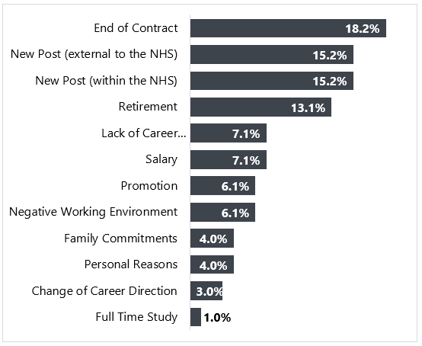

Those leaving the organisation represent just under 10% of the core workforce. See Appendix 1.
- Males as a proportion of the workforce are more likely to leave the organisation than females (31.7%, N=45)
- There is a higher proportion of staff in age groups 25-34 leaving the organisation. This may reflect the stage in career in these age brackets.
- 10.6% (N=15) of leavers are from a minority ethnic background. This is higher than the 5% figure in 2022 and a higher proportion than the percentage of staff in the workforce from a minority ethnic background. Half of leavers were on a fixed term contract. The numbers are however small.
- 3.5% (N=under 5) of LGBT staff left the organisation, which is a lower proportion than in the workforce (4.5%) and lower than the figure in 2022.
- 39% (N=55) of staff who left the organisation advised they are Christian with the largest proportion of leavers advising they have no religion at 47.5% (N=67)
As we seek to increase the diversity of our workforce and progress equality for under-represented population groups, analysis of the proportion of staff who leave the organisation by protected characteristic to investigate possible reasons for this is important.

STAFF DEVELOPMENT
This section relates to our core staff only. Education for DDiT is governed through their foundation, core or higher specialty training programmes and follows the curricula written by the Medical Royal Colleges and the Faculty of Dental Surgery and is approved and published by the General Medical Council and General Dental Council.
We analyse access to development for core staff by reviewing data on promotions, secondment or internal attachment, 'acting up' or temporary promotion and data on training. Although our systems enable us to disaggregate all of the data by protected characteristics, some datasets (promotions, secondment/internal attachment, acting up) are quite small and permit only limited analysis.

Promotions
A promotion within NES is defined as a staff member moving to a higher grade/band on a permanent contract. This report also includes temporary arrangements which provide a development opportunity for staff. By looking at promotions by protected characteristic we can identify if any groups are not experiencing equity in opportunity for career progression. This section does not include DDiT.
From April 2022 to March 2023, there were 75 promotions. Promotions were distributed across the organisation, with at least one in each directorate. A breakdown of promotion by protected characteristics is illustrated in Appendix 2.
- Almost 80% (60 members of staff) of promoted staff were female. This reflects the higher proportion of females in the organisation (72% of NES Core staff are female)
- While males progressed more quickly than females overall with an average of 8.1 years service (8.2 years service for women) this was reduced from last year where the gap was 6.4 years for men compared to 8.2 years for women.
- Staff aged between 25-54 accounted for 86.3% of promotions. Employees aged 55-64 account for 14.7% of the promotions. There were no promotions for employees aged 16-24.
- 2.7% of staff promoted were from a minority ethnic background. This is lower than the proportion of staff in the workforce who have advised they are from a minority ethnic background (5.39%)
- Just under half identified as 'no religion'
- 4% of the employees promoted identified as being disabled. This is higher than the proportion of staff currently declaring a disability in the workforce (3.6%).
- 5.3% of employees promoted identified as LGBT, which is higher than the proportion of LGBT staff in the workforce (4.5%)

Training
See Appendix 3. We provide a range of staff development opportunities including work-based learning, e-Learning, attendance at conferences, staff panels and specialist learning events alongside a range of development courses and mandatory (essential) learning via our digital learning platform, Turas Learn. All courses housed on this system provide attendance/completion data. We also provide a range of self-directed learning as well as webinars and other digital learning offered directly to staff members via Microsoft Teams. These sessions are currently not logged against the individual learning record in Turas and we do not monitor rate of participation by protected characteristics.
We also have a Workforce Development Fund to support staff with funding for learning and development. The fund is promoted to all staff across the organisation and priority is given to staff in Bands 2-6. We currently do not undertake equality monitoring of applications to the fund and will look to introduce this should it continue next year to ensure there is equity in opportunity.

RECRUITMENT AND SELECTION
The outcomes for recruitment and selection of core staff are analysed in this section. DDiT are recruited through a national recruitment process for appointment to training posts across NHS Scotland (excludes Locum Appointments for Training). The standards and criteria for this process are set at UK level. Outcomes from this process are analysed separately at a national level. This is available at Equality and diversity 2021 recruitment data | Medical Hub (hee.nhs.uk)
Appendix 4 summarises the overall number of applications and number of individuals shortlisted, interviewed and appointed to our core staff and applications by protected characteristic during the period 2022/23

Attraction
We have revised and refined our approach to advertising posts, adopting a model which offers clearer and more precise information about the post and the skills and knowledge required in the person specification. A new style advert and job pack has been successfully piloted in 2022 and will now be rolled out across NES vacancies by end of March 2023.
Our vacancies will continue to be considered for internal advert in the first instance (i.e. to existing NES workers, including agency and secondments) before consideration is given to advertise externally. All vacancies pass through a robust corporate establishment control approval process prior to advertising, with data monitored at each stage of the recruitment cycle.
Data for 2022/23 indicates that 24.1% of applications were made by candidates from Black, Asian and Minority ethnic candidates, which is an increase from 21% in 2021/22. The diversity of applicants for posts varies across the organisation, with the greatest diversity of applicants for posts in the Medical, Workforce and Technology Services Directorates.
Applicant ethnic diversity was lower for posts in the fields of Finance and Planning & Corporate Resources. It was slightly below average in the Psychology and Dental Directorates, although there were a small number of applicants in comparison to other directorates.
We received 1880 (from a total of 7787) applications from applicants from Black, Asian and minority ethnic backgrounds. Applicants from Black, Asian and minority ethnic backgrounds have the most significant differential likelihood relative to those of white ethnicity of progressing from interview to appointment (16% vs. 27%). In 2022/23, it was 18% vs. 26.6%. From application to appointment, the % of applicants from a Black, Asian and Minority ethnic background was 1.87% compared to 5.36% for White applicants. Of the 1880 applicants, 1238 (66%) advised that they required a work permit which may mean that many of the applicants were not eligible to take up a post. We will continue to monitor this.
8% of applicants (627) for all posts identified themselves as disabled. As over 24% of the working-age population in Scotland have a disability we would expect this to be higher. We have renewed our Disability Confident Employer Status and will promote this on our website and as part of our recruitment materials.
6.7% of applicants identified as LGB and 0.74% identified as 'other' which compares with Stonewall Scotland's estimate of LGB people in the working age population. There is no significant difference between appointment rates of people who identify as LGB and those who identify as heterosexual.
We also monitor the protected characteristic of gender reassignment but numbers are too small to report.
Our applications represent a range of religious backgrounds and those identifying with no religion are most prevalent. We attract a similar percentage of applications from those identifying as Roman Catholic or Church of Scotland in the overall total number of applications. There is no significant difference in appointment rates between those identifying as Roman Catholic or Church of Scotland. The number of individual applications in most of the minority religions is too small for statistical analysis (less than 10%). 6% of applicants chose 'Prefer not to say' and 48% chose ‘No religion’.
70% of our appointments in 2022/23 were women, which is similar to the rate reported last year. Women formed most appointments across the organisations and at most grades. Appendix 4 illustrates the age distribution of applications for core NES posts. 23.6% of applicants did not complete information on age.

PAY GAP
The Equality Act 2010 (Specific Duties) (Scotland) Regulations 2012 specify that public authorities must report the gender pay gap in the form of ‘information on the percentage difference among its employees between men’s average hourly pay (excluding overtime) and women’s average hourly pay (excluding overtime)’. The specific formula used for this calculation is the formula for the average pay gap set out in the guidance published by Close the Gap. The specific formula is (A – B)/A X 100, where A = average hourly rate of pay of men and B = average hourly rate of pay of women.
Using this method of analysis, as of 31 March 2023 NES’s overall gender pay gap is 2.75%. The average hourly pay for women in the public sector in Scotland is £19.09 and for men is £21.31. Our current gender pay gap is below the Scottish public sector average of 10.4%

TABLE 1: Gender pay gap
This table provides a summary of the hourly pay rate and the gender pay gap for each contract group. The figures reported in this table show a comparison between women’s and men’s average hourly pay within the specific contract group.
Pay scale | As of March 2018 | As of March 2019 | As of March 2020 | As of March 2021 | As of March 2022 | As of March 2023
Agenda for Change | 1.25% | 6.58% | 9.62% | 8.43% | 6.02% (893) | 5.60%  (1069)
Executive Managers Cohort | -30.07% | -3.29% | -1.39% | -2.19% | -6.99% (7) | -2.34%  (7)
GP/GDP Eds, CRUMP and Consultants | 13.52% | 8.12% | 0.72% | 5.67% | 1.85% (121) | 2.72%  (130)
DDiT | -2.00% | -1.54% | 4.73% | -1.26% | -1.30% (1727) | -2.63%  (1926)
Pay Gap | 27.6% | 13.3% | 7.9% | 7.0% | 5.4% | 2.7%
Hourly Rate is calculated as ('Contracted Hours' x 52.179) / (Annual Salary * WTE)

In presenting the gender pay gap information, the nature of the calculations (based on average pay figures) means that the data is very susceptible to being skewed by large numbers of outlying pay levels. This is very relevant for the profile of the NES workforce. Over the course of the last two years NES has employed at large number of DDiT, which has contributed to reducing the gender pay gap.
If we extract DDiT from the pay gap calculations (given recruitment is undertaken at a UK level rather than by NES), NES’s gender pay gap is 15.5%. When looking at the data this is due to a difference in average hourly pay of £52.14 for men and £50.72 for women in the 130 staff employed on Medical and Dental Pay Grades.
We have used the same method to calculate our Disability and Ethnicity Pay Gaps. These are set out below in Table 2 and Table 3. This is the first time we have published these pay gaps. We now also report to the Board on our Gender, Disability and Ethnicity Pay Gap as part of the Board’s Key Performance Indicators.

TABLE 2: Disability pay gap as of 31 March 2023
Payscale | Average hourly rate for Disabled staff | Average hourly rate for all other staff | Pay gap | % Difference
Agenda for Change | £19.49 | £23.40 | £3.91 | 16.7%
Executive Managers Cohort | - | £61.25 | - | -
GP/GDP Ed's,CRUMP and Consultants | £50.16 | £51.42 | £1.26 | 2.5%
Doctors and Dentists in Training | £21.24 | £21.44 | £0.20 | 0.9%
Disability pay gap | £21.44 | £23.61 | £2.17 | 9.2%

If we extract DDiT from the pay gap calculations NES’s disability pay gap is 19.4%. This could be due to an increase in staff joining the organisation who disclose a disability and potential under-reporting of disability in the workforce e.g. staff who may have developed a disability since joining NES and data has not been updated to reflect this. There are also no staff declaring a disability in the Executive Managers cohort.
TABLE 3: Ethnic Origin pay gap as of 31 March 2023
Payscale | Average hourly rate for Minority Ethnic staff | Average hourly rate for all other staff | Pay gap | % Difference
Agenda for Change | £19.39 | £23.43 | £4.04 | 17.2%
Executive Managers Cohort |  | £61.25 | £61.25 | -
GP/GDP Ed's,CRUMP and Consultants | £52.12 | £51.32 | -£0.80 | -1.5%
Doctors and Dentists in Training | £20.93 | £21.85 | £0.92 | 4.2%
Ethnic Origin pay gap | £21.39 | £24.05 | £2.66 | 11.1%

If we extract DDiT, the pay gap for NES Core Staff is 6.6%. The higher pay gap at Agenda for Change pay grades may be due to an increase in staff joining NES on entry-level pay banding.

The latest estimate show that Scotland's ethnicity pay gap was estimated to be 10.3% in 2019. The Disability pay gap is has been calculated to be 16.2% in Scotland in 2019.

Progress on recommendations
We identified the following recommendations from our workforce data equality analysis, published in April 2023. An update on the actions is provided below.
Action | Progress
Deliver a campaign to improve our annual workforce equality and diversity data following approval of a revised Equality and Diversity Form for all applicants through Jobtrain. This data will follow through if appointed for new recruits, but we recognise that data may change for staff in post e.g., disabilities may develop over time in the organisation. | The revised questions (development led by Scottish Government) were approved for use across NHS Scotland in August 2023 and arrangements are being made to make the relevant changes to IT systems.  This will continue into 2023/24.
Deliver a specific campaign to encourage DDiT to update equality and diversity monitoring on Turas to improve our data collection and analysis for this cohort of staff. This will be undertaken following approval of the revised national Equality and Diversity Monitoring set of questions for NHS Scotland. It is dependent upon changes being made on Turas to reflect the new set of questions. | The new questions have been updated on Turas and information was sent to all trainees in August 2023. This action is reported via the Addressing Inequalities in Medical Education Group.
Roll out and evaluate the impact of newly developed eLearning modules for staff involved in recruitment and selection. This incorporates guidance on bias, values-based recruitment, and our role to create an inclusive and diverse workforce. | The modules have been finalised and are being promoted to staff in Quarter 3.
Analyse NES staff TURAS data by equality characteristic to improve our understanding of equity in opportunities for training and development in NES. | Complete. This data is included in this report in appendix 3.

Recommendations

Employee monitoring is part of wider work at NES to progress equality, tackle discrimination and create an inclusive workplace for our staff. We have a specific Equality Outcome to improve recruitment outcomes for younger candidates, minority ethnic candidates and disabled candidates. We will continue to provide progress reports through our Staff Governance Committee and to our Board on our Equality Outcomes.
We are taking forward a number of actions which will contribute to NES as an inclusive, equitable and diverse workplace. Specific actions as a result of analysis of our workforce data and trends this year are:
- Deliver a campaign to improve our workforce equality and diversity data following relevant system changes being done nationally following approval of new monitoring questions. This data will follow through if appointed for new recruits, but we recognise that data may change for staff in post e.g., disabilities may develop over time in the organisation.
- Evaluate the new recruitment e-learning modules, ensuring panel members undertake training.
- Revise NES website on equality, diversity and inclusion to promote our work as inclusive employer and our Disability and Carer Positive Awards.
- Annual reporting and trend analysis on pay gaps as part of Board Strategic Key Performance Indicators.
- Explore how to introduce equality monitoring of applications to the Workforce Development Fund.

APPENDIX 1: Leavers profile (core staff)
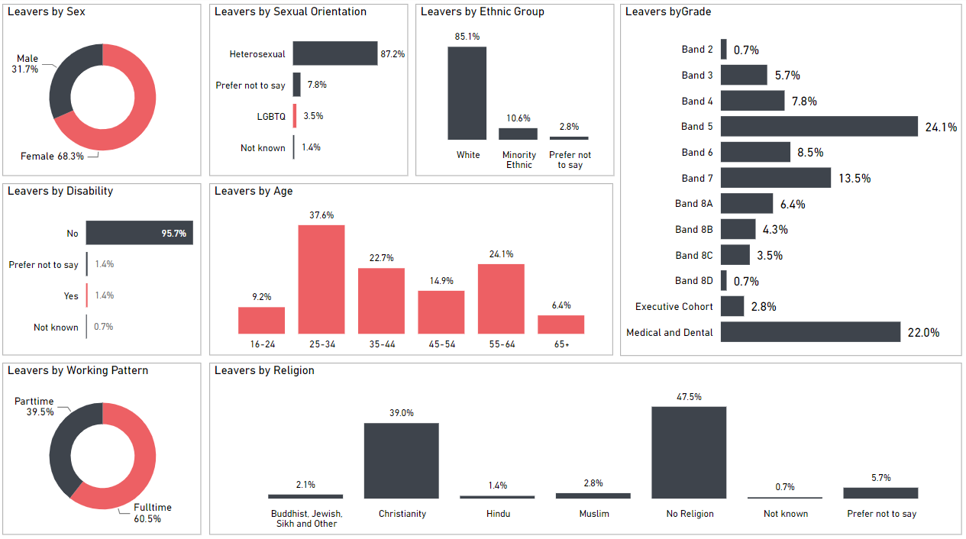

APPENDIX 2: Promotions profile (core staff)
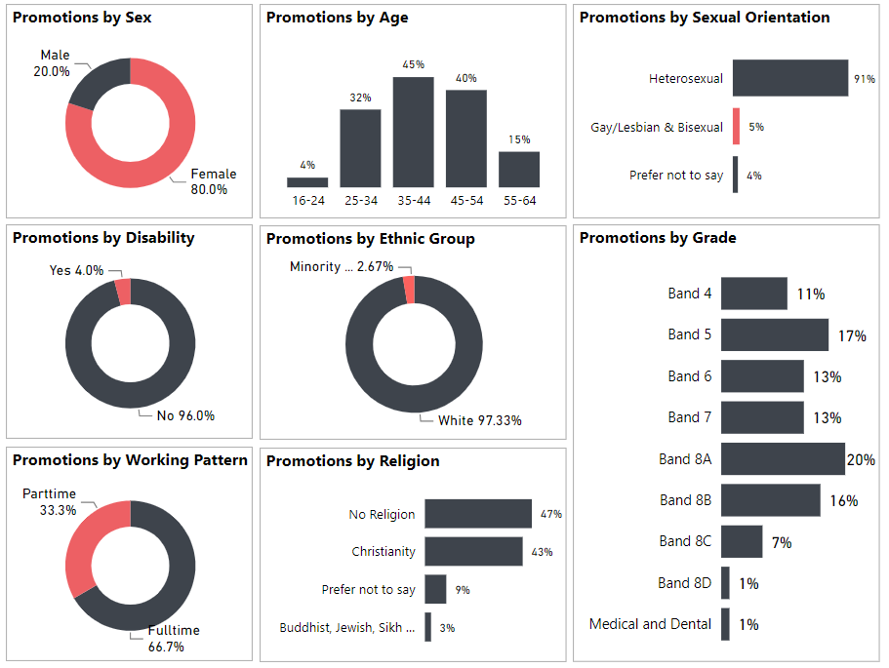

APPENDIX 3: Training completed profile (core staff)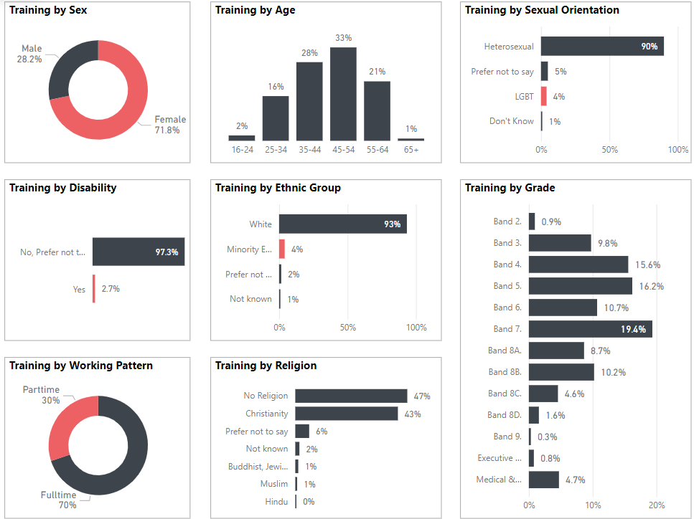

APPENDIX 4: Recruitment - Candidate profile (core staff)
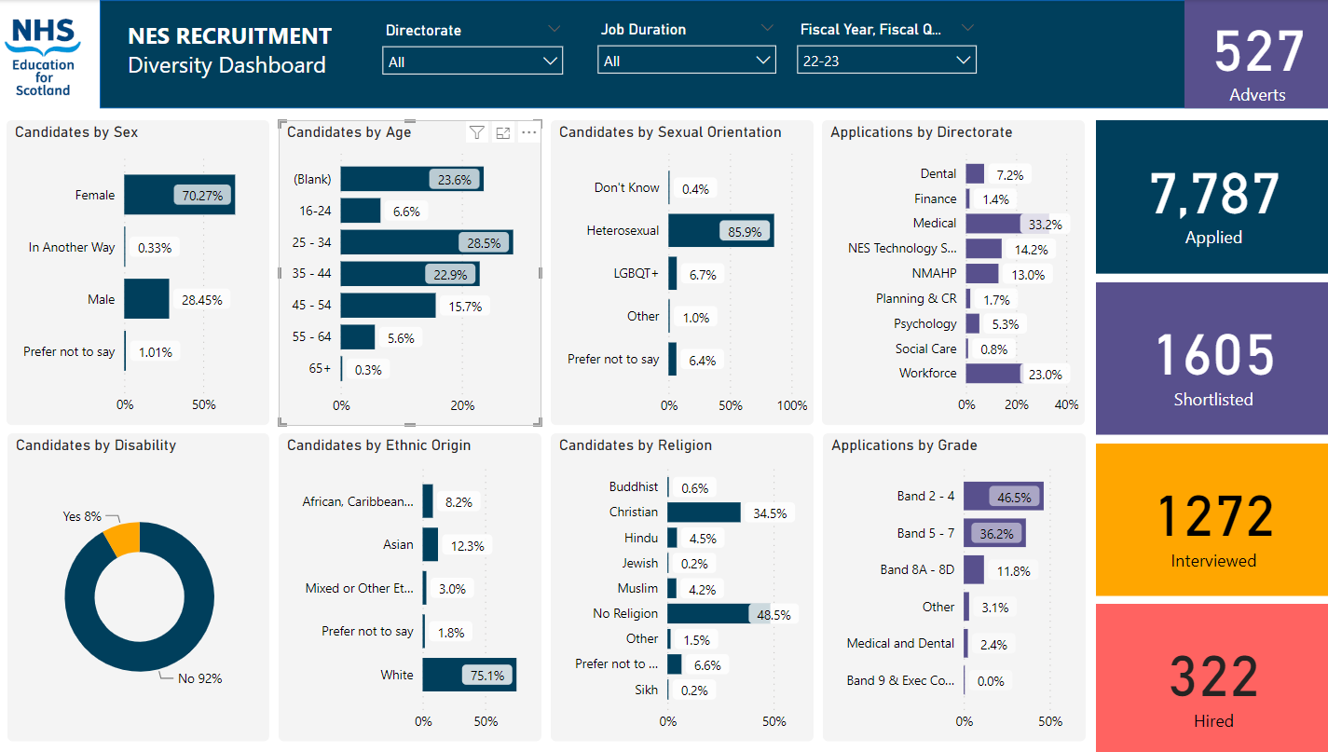

© NHS Education for www.nes.scot.nhs.uk Scotland [2023]. You can copy or reproduce the information in this resource for use within NHSScotland and for non-commercial educational purposes. Use of this document for commercial purposes is permitted only with the written permission of NES
NHS Education for Scotland
Westport 102
West Port
Edinburgh
EH3 9DN
This resource may be made available, in alternative formats and community languages. Please contact us on 0131 656 3200 or email altformats@nes.scot.nhs.uk to discuss how we can best meet your requirements.

For Data Protection reasons we are not allowed to report on any categories if there are under five staff present in that category
We refer to all staff employed by NES who are not employed as Doctors or Dentists in Training and working in NHS Boards as part of their training as core staff. This includes a variety of roles across our organisation.
NES is one of four Lead Employers across NHS Scotland that employ Doctors and Dentists (DDiT) in training. We only include data on those trainees where NES is the employer.
Data from the 2022 Census on ethnicity and other characteristics will be reported in 2024
Guest blog – Disability Employment in Scotland: Initial Findings – SPICe Spotlight | Solas air SPICe (spice-spotlight.scot)
ScotPHO Sexual Minorities
The Equality Act 2010 (Specific Duties) (Scotland) Regulations 2012 (legislation.gov.uk)
https://www.closethegap.org.uk/content/resources/Gender-pay-gap-statistics-paper-2022.pdf
Gender-pay-gap-statistics-paper-2023.pdf (closethegap.org.uk)
Analysis of Labour Market Outcomes of Scotland’s Minority Ethnic Population (www.gov.scot)
Disability Pay Gap - Labour Market Statistics for Scotland by Disability: January to December 2022 - gov.scot (www.gov.scot)

