Diabetes eLearning Programme for initial education/Update CPD

Aim
Learning materials and training for nurses working in general practice. Enabling delivery of effective person-centred care and support for adults living with diabetes, while also identifying, developing and engaging with diabetes services.

About Diabetes Training
The diabetes module has been developed collaboratively between CPD connect and NES pharmacy to enable nurses working in general practice to deliver effective person-centred care to adults living with diabetes. It is our hope that this module will help enhance interprofessional education (IPE) and improve collaborative interprofessional practice in the workplace, resulting in improved patient experiences and health outcomes.

The module is available as initial training for those with no previous education in diabetes who are looking to support those living with diabetes. Initial training consists of three parts:

- Successful completion of the eLearning module (all four units)
- Completion of the Learning Log diabetes by the learner with a supporting Practice Assessor who will complete a Statement of Competence to be forwarded to NHS Education for Scotland
- Submission and successful completion of a quality improvement project for appraisal

All three parts must be successfully completed to receive a completion certificate.

The module is also available to those who have previously undertaken diabetes education and would like to update their knowledge. The diabetes eLearning module consists of four individual units. A practitioner can continue to access the module whilst they hold a Turas Learn account.

All NES eLearning modules are written by subject matter experts, and then undergo peer and primary care review. They are written to Scottish academic level 9/10. All NES eLearning modules are current at the time of publication and undergo a periodic review process.
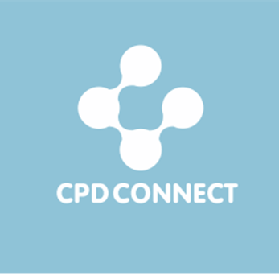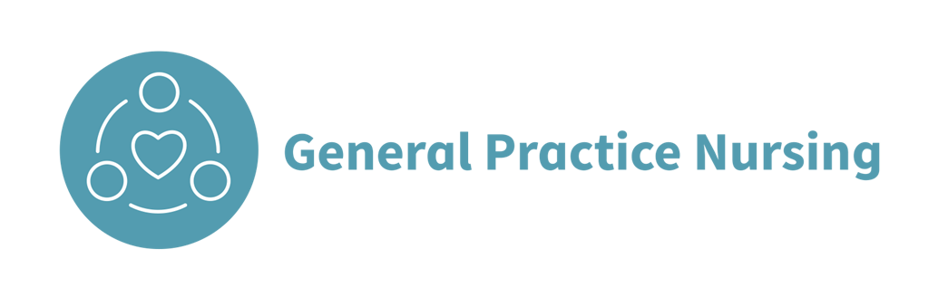

Learning Outcomes
On completion of the e-learning programme the registered practitioner should be able to:
- define diabetes
- recognise the clinical presentation and diagnostic criteria for a diagnosis of diabetes
- describe morbidity, mortality and economic impact of diabetes
- recognise factors that increase the risk of developing diabetes and when to offer preventative measures
- discuss forms of monitoring, the multiple health risks for people with diabetes, how this can impact on day to day life, and how healthcare professionals can support those living with diabetes
- recommend, prescribe and support appropriate treatments to help people manage their life with diabetes
- identify your own role in improving care for those living with diabetes within the context of multifaceted organisations, communities and opportunities

The eLearning does not:
- cover diagnosis or management of Gestational diabetes, LADA, MODY or other subtypes of diabetes mellitus (although we do give a brief overview of these in the first module)
- cover the treatment of children with diabetes.
- intend to replace a thorough understanding of current national guidelines on the diagnosis and management of diabetes.

Module overviews
Unit 1
- What is diabetes?
- Risk factors, prevention and early detection (type 2)
- Person-centred care
- Presentation and diagnosis
- Complications of diabetes
- Monitoring
- Hypoglycaemia
- Diabetic ketoacidosis (DKA)

Unit 2
- Pharmacological management of type 1 diabetes
- Pharmacological management of type 2 diabetes
- Pharmacological management of vascular risk
- Lifestyle advice and patient education (type 2)

Unit 3
- What should be part of a consultation?
- Case study 1
- Case study 2
- Case study 3
- Case study 4
- Case study 5

Unit 4
- Assessment

